#### 3.3.3 Unit Cell

The choice of the vectors

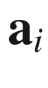

making up the lattice is not unique (Fig. [3.1](The_Physics_of_Semiconductors00001.docx#u116076_4_En_3_Chapter-Fig1)). The volume that is enclosed in the parallelepiped spanned by the vectors

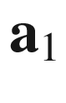

,

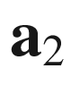

and

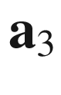

is called the *elementary cell*. A *primitive* elementary cell is an elementary cell with the smallest possible volume (Fig. [3.1](The_Physics_of_Semiconductors00001.docx#u116076_4_En_3_Chapter-Fig1)b). In each primitive elementary cell there is exactly *one* lattice point. The coordination number is the number of next-neighbor lattice points. A primitive cubic (pc) lattice, e.g. has a coordination number of 6.

The typically chosen primitive elementary cell is the *Wigner–Seitz* (WS) cell that reflects the symmetry of the lattice best. The Wigner–Seitz cell around a lattice point

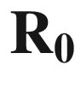

contains all points that are closer to this lattice point than to any other lattice point. Since all points fulfill such a condition for some lattice point

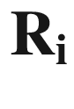

, the Wigner–Seitz cells fill the volume completely. The boundary of the Wigner–Seitz cell is made up by points that have the same distance to



and some other lattice point(s). The Wigner–Seitz cell around

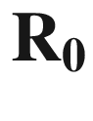

is constructed by drawing lines from

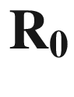

to the next neighbors

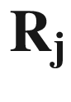

, taking the point at half distance and erecting a perpendicular plane at

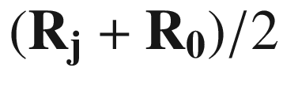

. The WS cell is the smallest polyhedron, circumscribed by these planes. A two-dimensional construction is shown in Fig. [3.8](#u116076_4_En_3_Chapter-Fig8).

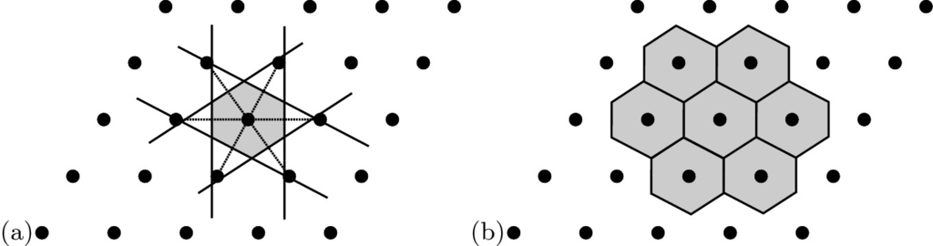

Fig. 3.8

**a** Construction of a two-dimensional Wigner–Seitz cell, **b** filling of space with WS cells

#### 3.3.4 Point Group

Besides the translations there are other operations under which the lattice is invariant, i.e. the lattice is imaged into itself. These are:

*Identity*. The neutral element of any point group is the identity that does not change the crystal. It is denoted as 1 (*E*) in international (Schönfließ) notation.

*Rotation*. The rotation around an axis may have a rotation angle of 2

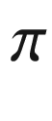

, 2



/2, 2

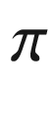

/3, 2

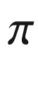

/4 or 2

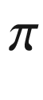

/6 or their integer multiples. The axis is then called

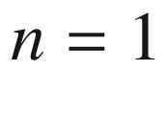

-, 2-, 3-, 4- or 6-fold, respectively[2](#u116076_4_En_3_Chapter-Fn2), and denoted as *n* (international notation) or

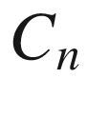

(Schönfließ). Objects with

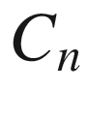

symmetry are depicted in Fig. [3.9](#u116076_4_En_3_Chapter-Fig9).

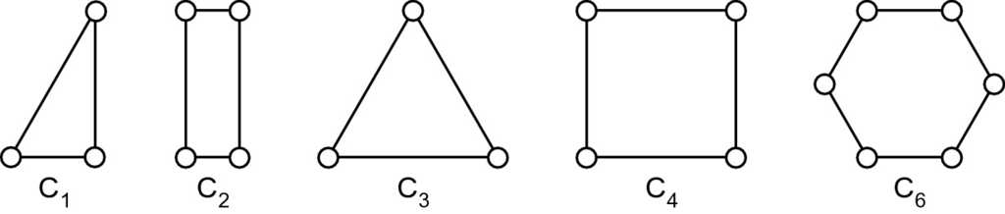

Fig. 3.9

Two-dimensional objects with perpendicular rotation axis

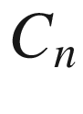

. Note that the circles do not exhibit

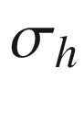

symmetry with respect to the paper plane, i.e. they are different on the top and bottom side

*Mirror operation* with respect to a plane through a lattice point. Different mirror planes are discerned (Fig. [3.10](#u116076_4_En_3_Chapter-Fig10)) (after Schönfließ)

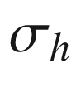

: a mirror plane perpendicular to a rotational axis,

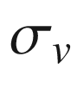

: a mirror plane that contains a rotational axis, and

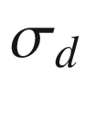

: a mirror plane that contains a rotational axis and bisects the angle between two

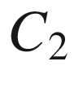

axes. The international notation is

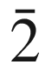

.

*Inversion*. All points around the inversion center

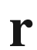

are replaced by

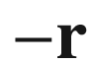

. The inversion is denoted

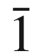

(*i*) in international (Schönfließ) notation.

*Improper rotation*. The improper rotation

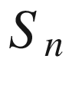

is a rotation



followed immediately by the inversion operation *i* denoted as

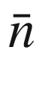

in international notation. There are

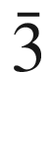

,

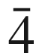

and

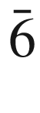

and their powers. Only the combined operation

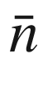

is a symmetry operation, while the individual operations

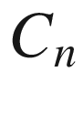

and *i* alone are not symmetry operations. In the Schönfließ notation the improper rotation is defined as

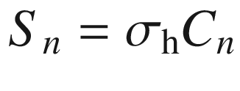

, with

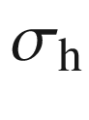

being a mirror operation with a plane perpendicular to the axis of the



rotation, denoted as

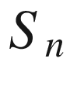

. There are

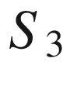

,

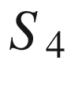

and

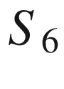

and

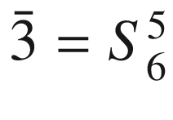

,

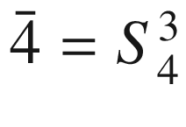

and

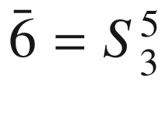

. For successive applications, the



yield previously known operations, e.g.

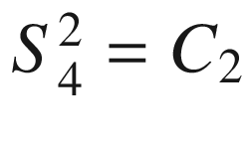

,

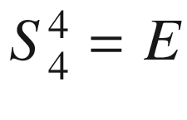

,

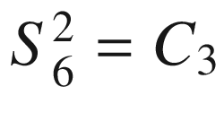

,

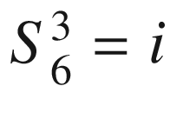

,

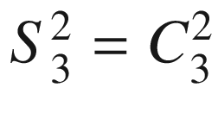

,

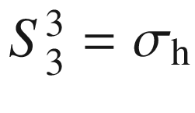

,

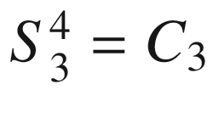

,

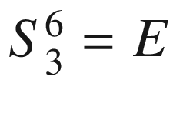

. We note that formally

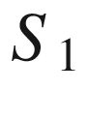

is the inversion *i* and

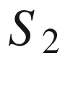

is the mirror symmetry

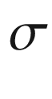

. Objects with

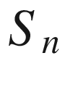

symmetry are schematically shown in Fig. [3.11](#u116076_4_En_3_Chapter-Fig11).

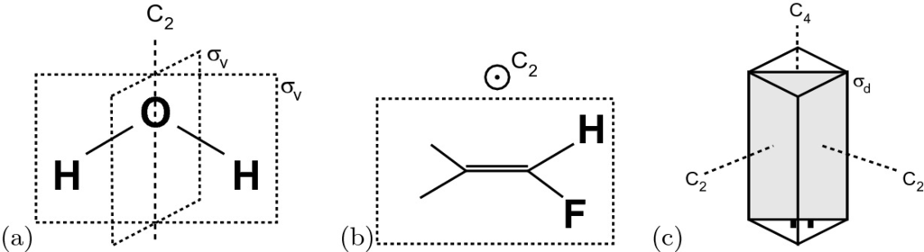

Fig. 3.10

Mirror planes: **a**

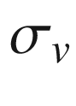

(at H

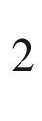

O molecule), **b**

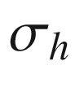

(at F

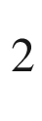

H

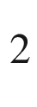

molecule) and **c**



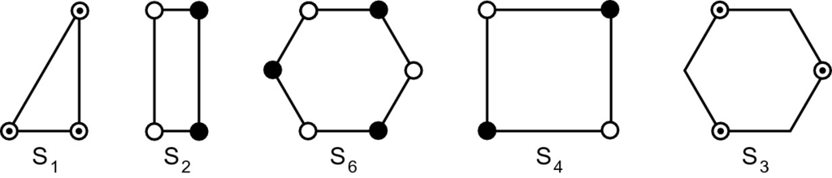

Fig. 3.11

Two-dimensional objects with perpendicular improper rotation axis



. Note that the white and black circles do not exhibit



symmetry with respect to the paper plane, i.e. they are white on the top and black on the bottom. The circles with a dot in the center exhibit

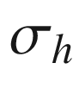

symmetry, i.e. they look the same from top and bottom

These symmetry operations form 32 *point groups*. These groups are shown (with their different notations and elements) in Table B.2. The highest symmetry is the cubic symmetry

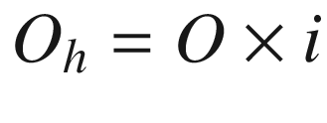

. The tetraeder group

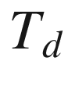

(methane molecule) is a subgroup of

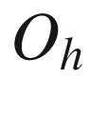

, lacking the inversion operation.

Important for surface symmetries, there are ten two-dimensional point groups (Sect. [11.​2](The_Physics_of_Semiconductors00005.docx#u116076_4_En_11_Chapter) and Table B.1).

#### 3.3.5 Space Group

The space group is formed by the combination of the elements of the point group with translations. The combination of a translation along a rotational axis with a rotation around this axis creates a screw axis

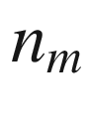

. In Fig. [3.12](#u116076_4_En_3_Chapter-Fig12)a, a so-called

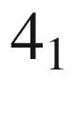

screw axis is shown. The first index *n* indicates the rotation angle, i.e.

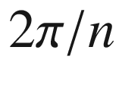

, the second index indicates the translation, i.e.

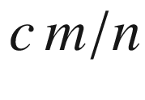

, *c* being the periodicity along the axis. There are eleven crystallographically allowed screw rotations.[3](#u116076_4_En_3_Chapter-Fn3)

The combination of the mirror operation at a plane that contains a rotational axis with a translation along this axis creates a glide reflection (Fig. [3.12](#u116076_4_En_3_Chapter-Fig12)b). For an axial glide (or b-glide) the translation is parallel to the reflection plane. A diagonal glide (or d-glide) involves translation in two or three directions. A third type of glide is the diamond glide (or d-glide). There are 230 different space groups, listed in Appendix B. A detailed treatment can be found in [195].[4](#u116076_4_En_3_Chapter-Fn4)

Important for surface symmetries, there are 17 two-dimensional space groups (Sect. [11.​2](The_Physics_of_Semiconductors00005.docx#u116076_4_En_11_Chapter)).

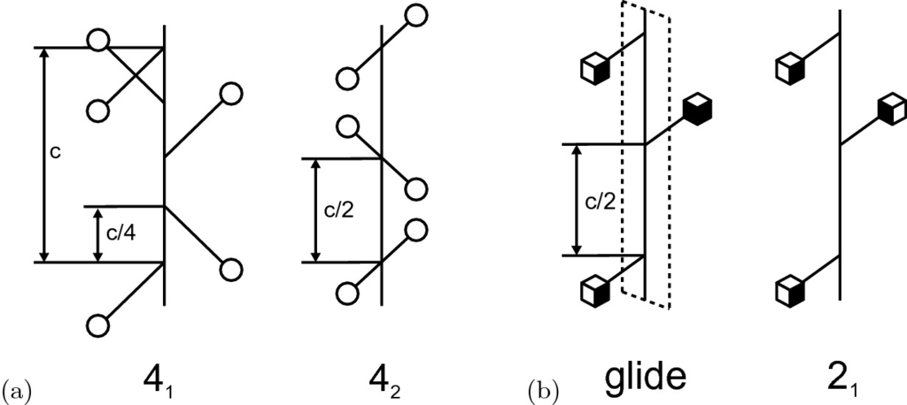

Fig. 3.12

**a** Schematic drawing of a

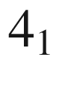

and

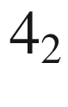

screw axis. **b** Schematic drawing of an axial glide reflection. The mirror plane is shown with dashed outline. Opposite faces of the cube have opposite color. For comparison a

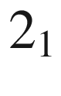

screw axis is shown

#### 3.3.6 Polycrystalline Semiconductors

A polycrystalline material consists of crystal grains that are randomly oriented with respect to each other. Between two grains a (large-angle) grain boundary (see also Sect. [4.​4.​3](#u116076_4_En_4_Chapter)) exists. An important parameter is the grain size and its distribution. It can be influenced via processing steps such as annealing. Polycrystalline semiconductors are used in cheap, large-area applications such as solar cells (e.g. polysilicon, CuInSe

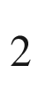

) or thin-film transistors (poly-Si) or as n-conducting contact material in MOS diodes (poly-Si) as shown in Fig. [3.13](#u116076_4_En_3_Chapter-Fig13) (see also Fig. [21.​29](The_Physics_of_Semiconductors00007.docx#u116076_4_En_21_Chapter-Fig29)). Polycrystalline material can be fabricated from amorphous material using annealing procedures as discussed in Sect. [24.​6.​1](The_Physics_of_Semiconductors00009.docx#u116076_4_En_24_Chapter) for silicon.

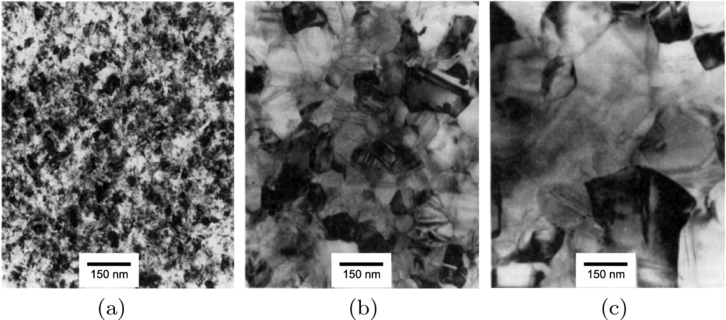

Fig. 3.13

Transmission electron micrographs of polycrystalline silicon (poly-Si). **a** As-deposited material from low-pressure chemical vapor deposition (LPCVD) at about 620

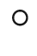

C, grain size is about 30 nm. **b** After conventional processing (annealing at 1150



C), average grain size is about 100 nm. **c** After annealing in HCl that provides enhanced point defect injection (and thus increased possibility to form larger grains), average grain size is about 250 nm. Adapted from [196]

#### 3.3.7 Amorphous Semiconductors

An amorphous material lacks the long-range order of the direct lattice. It is disordered on the atomic scale. Historically, amorphous Se (a-Se) has been investigated first; since the 1950’s amorphous chalcogenides and a-Ge [197] and since the late 1960s a-Si [198] are researched. The field of amorphous oxides started in the mid 1950s with vanadate glasses [199] and is currently very active with mixed-metal-based oxides [200] (cmp. Chap. [20](The_Physics_of_Semiconductors00007.docx#u116076_4_En_20_Chapter)).

The local quantum mechanics provides almost rigorous requirements for the bond length to next neighbors. The constraints for the bond angle are less strict. Covalently bonded atoms arrange in an open network with the next-neighbor distance essentially preserved and correlations up to the third and fourth neighbors (Fig. [3.14](#u116076_4_En_3_Chapter-Fig14)a). The short-range order is responsible for the observation of semiconductor properties such as an optical absorption edge and also thermally activated conductivity. In Fig. [3.14](#u116076_4_En_3_Chapter-Fig14)b a model of a continuous random network (with a bond-angle distortion of less than about 20%) of a-Si is depicted. The diameter

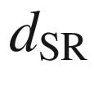

of the short-range order region is related to a disorder parameter

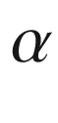

via [204]

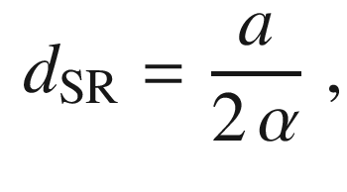

(3.7)

where *a* is the next-neighbor interatomic distance. For a diamond structure it is related to the lattice constant by

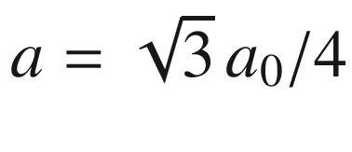

.

Typically, a significant number of dangling bonds exists. Bonds try to pair but if an odd number of broken bonds exists locally, an unsaturated, dangling bond remains. This configuration can be passivated by a hydrogen atom. Thus, the hydrogenation of amorphous semiconductors is very important, in particular for a-Si. A hydrogen atom can also break an overlong (and therefore weak) bond, saturate one side and eventually leave a dangling bond.

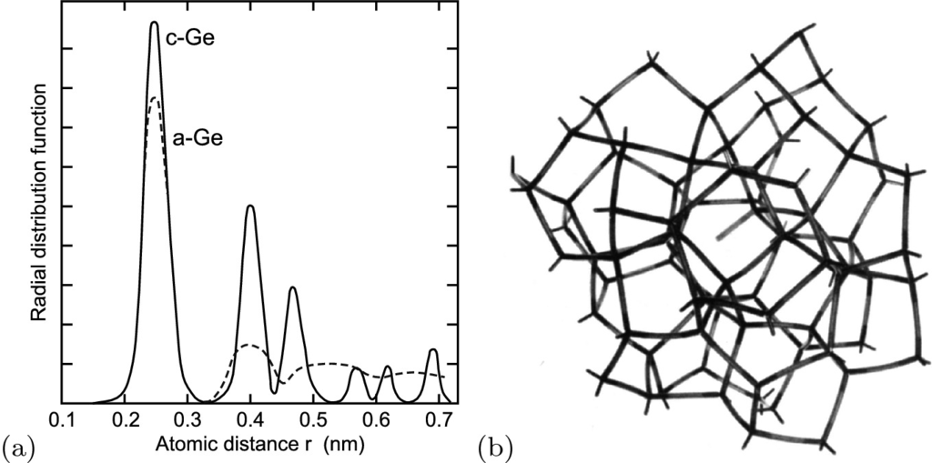

Fig. 3.14

**a** Radial atomic distribution functions of crystalline (c-Ge, *solid line*) and amorphous (a-Ge, *dashed line*) germanium, determined from EXAFS (extended X-ray absorption fine structure [201]). Adapted from [202]. **b** A continuous random network model of amorphous silicon containing a dangling bond in the center of the figure. Reprinted with permission from [203]

Amorphous material can be (re-)crystallized into crystalline, mostly polycrystalline material upon annealing. This is technologically very important for a-Si (see Sect. [24.​6.​1](The_Physics_of_Semiconductors00009.docx#u116076_4_En_24_Chapter)).

### 3.4 Important Crystal Structures

Now the crystal structures that are important for semiconductor physics will be discussed. These are mainly the rocksalt (PbS, CdO,

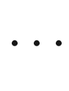

), diamond (C, Si, Ge), zincblende (GaAs, InP,

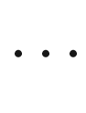

) and wurtzite (GaN, ZnO,

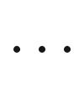

) structures.

#### 3.4.1 Rocksalt Structure

The rocksalt (rs, NaCl, space group 225, Fm

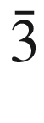

m) structure (Fig. [3.15](#u116076_4_En_3_Chapter-Fig15)a) consists of a fcc lattice with the period *a* and a diatomic base in which the Cl atom is positioned at (0,0,0) and the Na atom at (1/2,1/2,1/2)*a* with a distance

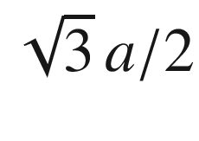

. Materials that crystallize (under normal conditions) in the rocksalt lattice are, e.g., KCl, KBr, PbS (galena), PbSe, PbTe, AgBr, MgO, CdO, MnO. AlN, GaN and InN undergo, under high pressure, a phase transition from the wurtzite into the rocksalt structure.

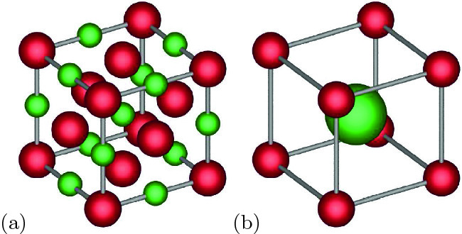

Fig. 3.15

**a** Rocksalt (NaCl) structure, **b** CsCl structure

#### 3.4.2 CsCl Structure

The CsCl structure (space group 221, Pm

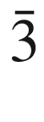

m) (Fig. [3.15](#u116076_4_En_3_Chapter-Fig15)b) consists of a simple cubic lattice. Similar as for the rocksalt structure, the base consists of different atoms at (0,0,0) and (1/2,1/2,1/2)*a*. Typical crystals with CsCl-structure are TlBr, TlI, CuZn (

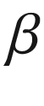

-brass), AlNi.

#### 3.4.3 Diamond Structure

The diamond structure (C, space group 227, Fd

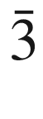

m) (Fig. [3.16](#u116076_4_En_3_Chapter-Fig16)a) has the fcc lattice. The base consists of two identical atoms at (0,0,0) and (1/4,1/4,1/4)*a*. Each atom has a tetrahedral configuration. The packing density is only about 0.34. The ABC-type stacking along the [111]-direction is visualized in Fig. [3.17](#u116076_4_En_3_Chapter-Fig17)a. The materials that crystallize in the diamond lattice are C, Ge, Si and

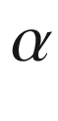

-Sn. Silicon as the most important semiconductor is particularly well researched [205].

The diamond structure (point group

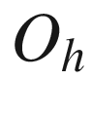

) has an inversion center, located between the two atoms of the base, i.e. at (1/8,1/8,1/8)*a*. The radii of the wavefunctions for various group-IV elements increases with the order number (Table [3.2](#u116076_4_En_3_Chapter-Tab2)), and accordingly the lattice constant increases.

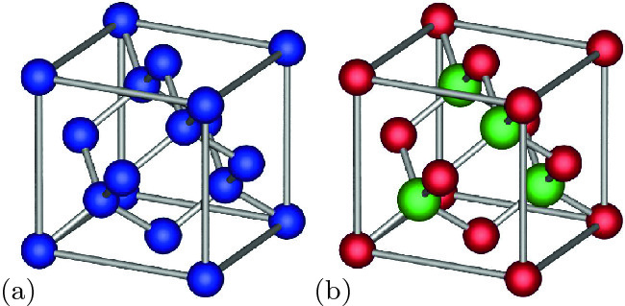

Fig. 3.16

**a** Diamond structure and **b** zincblende structure (*red spheres*: A atoms, *green spheres*: B atoms). The tetragonal bonds are indicated

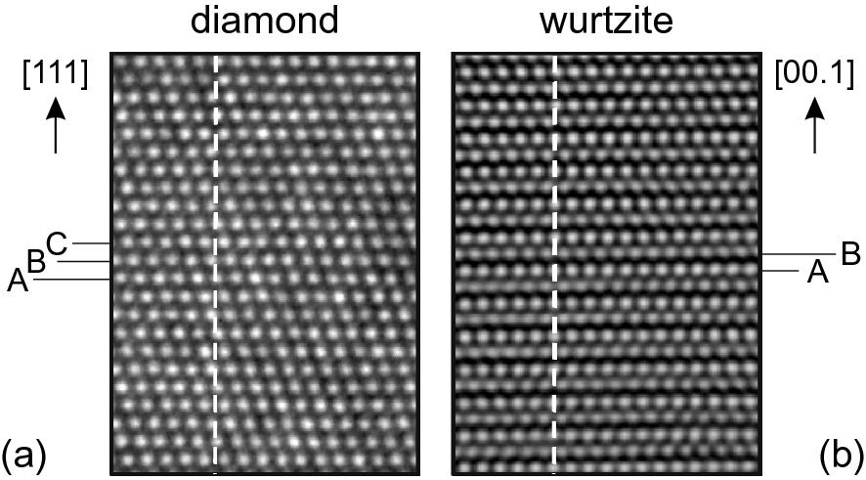

Fig. 3.17

HRTEM images of **a** diamond structure (Si,

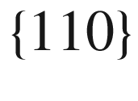

cross section) and **b** wurtzite structure (GaN,

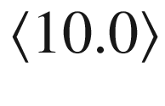

azimuth). The ABC and AB stacking is indicated

Table 3.2

Radii of the wavefunctions in the diamond structure,

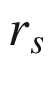

and

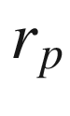

are related to s

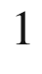

p

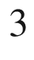

,

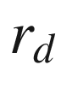

to s



p

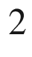

d

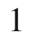

and lattice constant

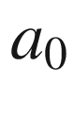

|  | $$r_s$$  (nm) | $$r_p$$  (nm) | $$r_d$$  (nm) | $$a_0$$  (nm) |
| --- | --- | --- | --- | --- |
| C | 0.121 | 0.121 | 0.851 | 0.3567 |
| Si | 0.175 | 0.213 | 0.489 | 0.5431 |
| Ge | 0.176 | 0.214 | 0.625 | 0.5646 |

In Fig. [3.18](#u116076_4_En_3_Chapter-Fig18)a the unit cell with tetragonal symmetry of three places along the

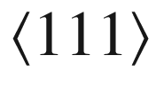

direction is shown. In Fig. [3.18](#u116076_4_En_3_Chapter-Fig18)b the arrangement of atoms along



is depicted. The symmetry along this line is at least

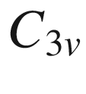

. At the atoms sites it is

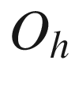

. The bond center (BC) and the hexagonal (H) position are a center of inversion and have

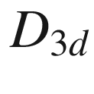

symmetry. The unoccupied ‘T’ positions have

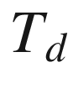

symmetry. High-pressure phases of silicon are already found in indentation experiments [206].

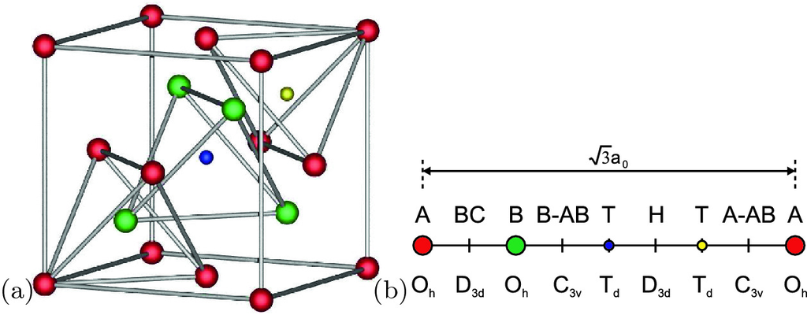

Fig. 3.18

**a** Unit cell of the zincblende structure with the indication of tetragonal symmetries. The position of the small *yellow* (*blue*) *sphere* is the tetrahedrally configured unoccupied positions of the A (B) sublattice, denoted with ‘T’ in part (**b**). **b** Line along [111] in the zincblende structure. The positions of the A and B atoms are denoted by *red* and *green circles* as labeled. Other positions are called the bond center (‘BC’), antibonding (‘AB’) relative to A and B atoms (‘A–AB’, ‘B–AB’), hexagonal (‘H’) and tetrahedral position (‘T’, *blue* and *yellow circles*)

We note that

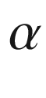

-Sn has little current importance. The diamond structure



–Sn phase is stable below 13.2

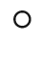

C. The addition of Ge inhibits the retransformation to metallic tin up to higher temperatures (e.g. 60

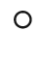

C for 0.75 weight percent Ge). The properties of gray tin are reviewed in [207].

#### 3.4.4 Zincblende Structure

The zincblende (sphalerite,[5](#u116076_4_En_3_Chapter-Fn5) ZnS, space group 216, F

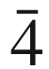

3m) structure (Fig. [3.16](#u116076_4_En_3_Chapter-Fig16)b) has a fcc lattice with a diatomic base. The metal (A) atom is at (0, 0, 0) and the nonmetal (B) atom is at (1/4, 1/4, 1/4)*a*. Thus the cation and anion sublattices  are shifted with respect to each other by a quarter of the body diagonal of the fcc lattice. The atoms are tetrahedrally coordinated, a Zn atom is bonded to four S atoms and vice versa. However, no inversion center is present any longer (point group

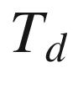

). In the zincblende structure the stacking order of diatomic planes along the body diagonal is aAbBcCaAbBcC

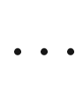

Many important compound semiconductors, such as GaAs, InAs, AlAs, InP, GaP and their alloys (cf. Sect. [3.7](#u116076_4_En_3_Chapter-Sec31)), but also the II–VI compounds ZnS, ZnSe, ZnTe, HgTe and CdTe and halides, including AgI, CuF, CuCl, CuBr, and CuI, crystallize in the zincblende structure.

Four-fold coordinated materials (zincblende and wurtzite) typically undergo a phase transition into 6-fold coordinated structures upon hydrostatic pressure [208]. For GaAs under pressure see [209].

#### 3.4.5 Wurtzite Structure

The wurtzite structure (ZnS, space group 186, P6

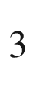

mc) is also called the hexagonal ZnS structure (because ZnS has both modifications). It consists of a hexagonal lattice with a unit cell of four atoms (Fig. [3.19](#u116076_4_En_3_Chapter-Fig19)). Typically, it is thought of as a hcp structure with a diatomic base. The *c*/*a* ratio typically deviates from the ideal value

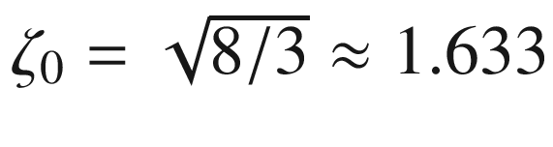

([3.4](The_Physics_of_Semiconductors00001.docx#u116076_4_En_3_Chapter-Equ4)) as listed in Table [3.3](#u116076_4_En_3_Chapter-Tab3). The *c*-axis is a

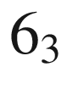

screw axis.

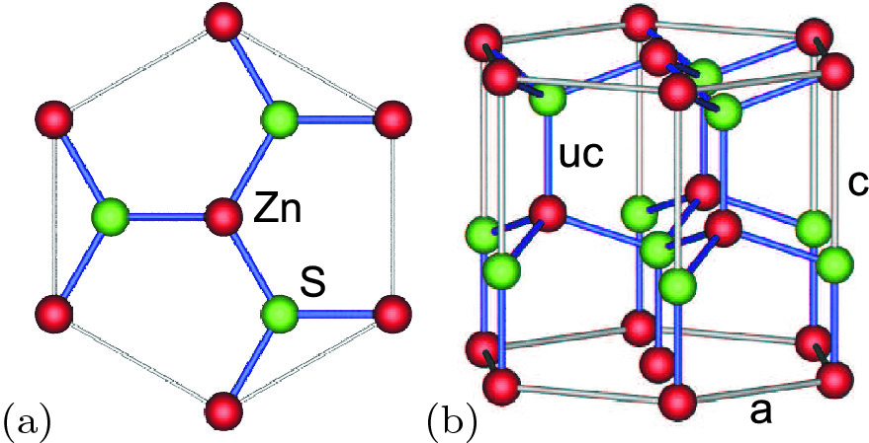

Fig. 3.19

**a** Top view (along the *c*-axis) and **b** side view of the wurtzite structure with the tetragonal bonds indicated. The top (bottom) surface of the depicted structure is termed the Zn-face, (00.1) (O-face, (00.

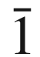

))

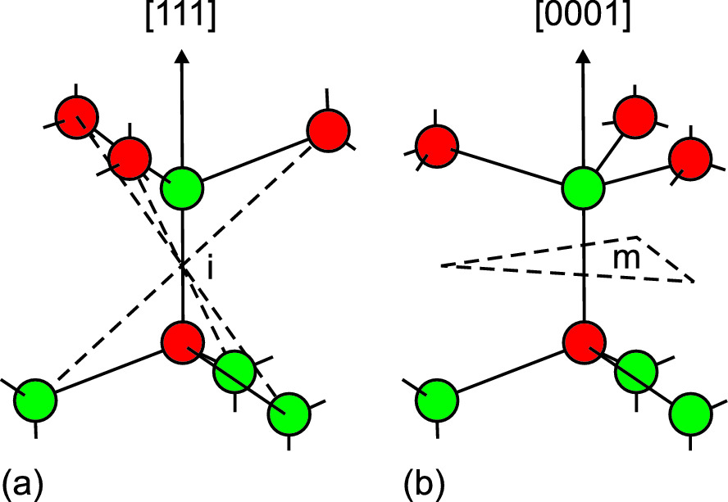

Fig. 3.20

Comparison of the tetragonal bonds in the **a** zincblende and **b** wurtzite structure (*i*: inversion center, *m*: symmetry plane)

The Zn atom is located at (0, 0, 0), the S atom at

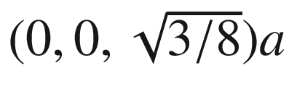

. This corresponds to a shift of

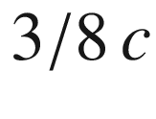

along the *c*-axis. This factor is called the cell-internal parameter *u*. For real wurtzite crystals *u* deviates from its ideal value

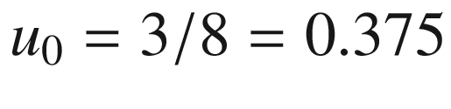

, e.g. for group-III nitrides

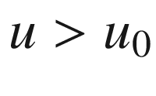

. The diatomic planes have a stacking order of aAbBaAbB

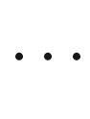

along the [00.1]-direction as visualized in Fig. [3.17](#u116076_4_En_3_Chapter-Fig17)b.Table 3.3

*c*/*a* ratio of various wurtzite semiconductors. Listed is

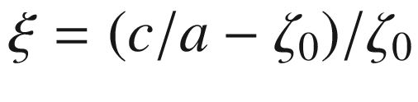

. Data based on [210]

| Material | $$\xi $$  (%) | Material | $$\xi (\%)$$ | Material | $$\xi $$  (%) | Material | $$\xi $$  (%) |
| --- | --- | --- | --- | --- | --- | --- | --- |
| AlN | −2.02 | CdS | −0.61 | CuBr | 0.43 | BeO | −0.61 |
| GaN | −0.49 | CdSe | −0.18 | CuCl | 0.55 | ZnO | −1.9 |
| InN | −1.35 | CdTe | 0.25 | CuI | 0.74 | 6H-SiC | 0.49 |
| ZnS | 0.25 | MgS | −0.80 | AgI | 0.12 | BN | 0.74 |
| ZnSe | 0.06 | MgSe | −0.67 | ZnTe | 0.74 | MgTe | −0.67 |

In Fig. [3.20](#u116076_4_En_3_Chapter-Fig20) the different local structural environment of the atoms in the zincblende and wurtzite structure is shown.

Many important semiconductors with large band gap crystallize in the wurtzite structure, such as GaN, AlN, InN, [211] ZnO, [212] SiC, [213], CdS und CdSe.

#### 3.4.6 Chalcopyrite Structure

The chalcopyrite [214] (ABC

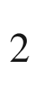

, named after ‘fool’s gold’ CuFeS



, space group 122, I



2d) structure is relevant for I–III–VI



(with chalcogenide anions) and II–IV–V



(with pnictide anions) semiconductors such as, e.g., (Cu,Ag)(Al,Ga,In)(S,Se,Te)

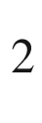

and (Mg,Zn,Cd)(Si,Ge,Sn)(As,P,Sb)



.

In Fig. [3.21](#u116076_4_En_3_Chapter-Fig21), the derivation of zincblende and chalcopyrite compounds is shown schematically, including the kesterite materials of type I



-II-IV-VI

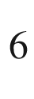

.

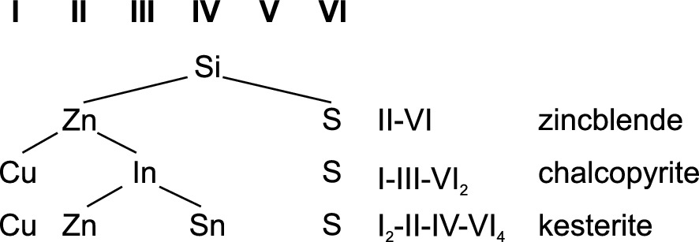

Fig. 3.21

Scheme of II–VI zincblende and related chalcopyrite and kesterite compounds

In the chalcopyrite structure, a nonmetallic anion atom (‘C’) is tetrahedrally bonded to two different types of cation atoms (‘A’ and ‘B’) as shown in Fig. [3.22](#u116076_4_En_3_Chapter-Fig22). The local surrounding of each anion is identical, two of both the A and B atoms. The structure is tetragonal. The aspect ratio

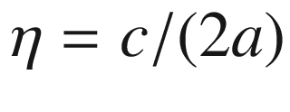

deviates from its ideal value 1; typically

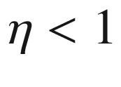

 [215, 216].

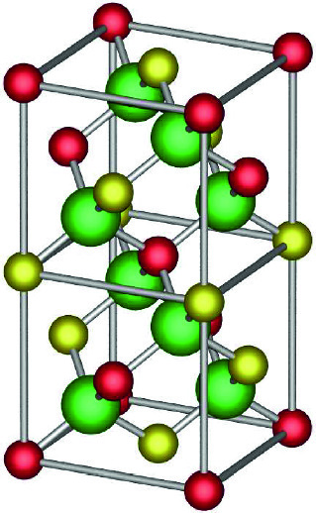

Fig. 3.22

Chalcopyrite structure, *red* and *yellow spheres* denote the metal species. The bigger *green spheres* represent the nonmetal anion

If the C atom is in the tetrahedral center of the two A and two B atoms, the bond lengths

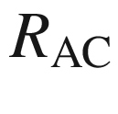

and

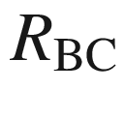

of the A–C and B–C bonds, respectively, are equal. Since the ideal A–C and B–C bond lengths

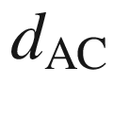

and

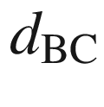

are typically unequal, this structure is strained. The common atom C is therefore displaced along [100] and [010] such that it is closer (if

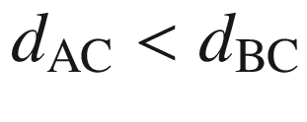

) to the pair of A atoms and further away from the B atoms. The displacement parameter is

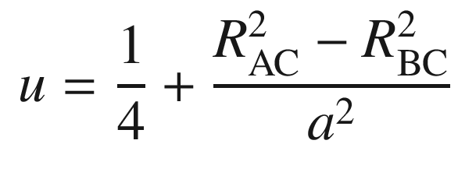

(3.8)

and it deviates from the ideal value

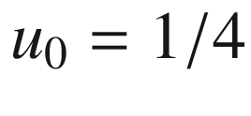

for the zincblende structure as listed in Table [3.4](#u116076_4_En_3_Chapter-Tab4) for a number of chalcopyrite compounds. In the chalcopyrite structure

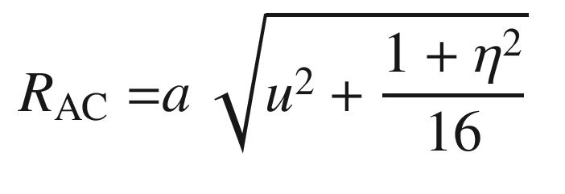

(3.9a)

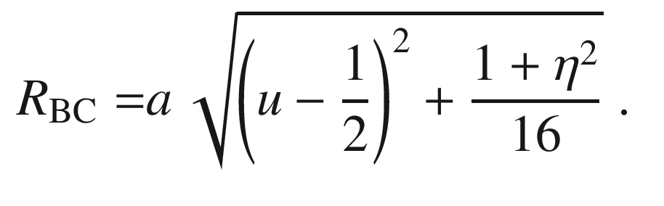

(3.9b)

The minimization of the microscopic strain yields (in first order) [217]

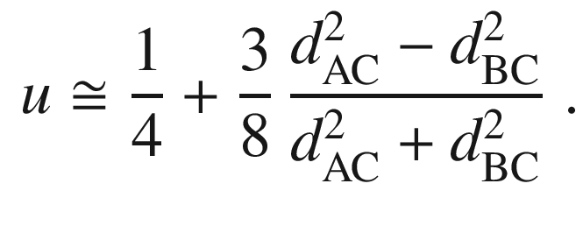

(3.10)

Compounds with

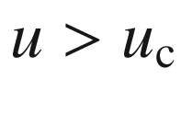

,

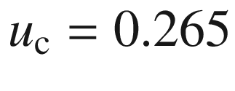

being a critical displacement parameter, (or

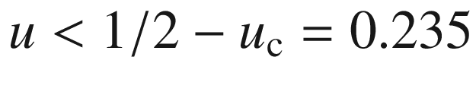

) are stable with regard to cation disorder [216]. In Fig. [3.23](#u116076_4_En_3_Chapter-Fig23) the correlation of the calculated value for *u* according to ([3.10](#u116076_4_En_3_Chapter-Equ11)) and the experimental values is shown.Table 3.4

Lattice nonideality parameters

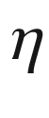

and *u* (from ([3.10](#u116076_4_En_3_Chapter-Equ11))) of various chalcopyrite compounds and their experimentally observed disorder stability (

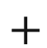

/− indicates compound with/without order–disorder (D–O) transition, respectively). Data from [216]

|  | $$\eta $$ | *u* | D–O |  | $$\eta $$ | *u* | D–O |
| --- | --- | --- | --- | --- | --- | --- | --- |
| CuGaSe  $$_2$$ | 0.983 | 0.264 | $$+$$ | ZnSiAs  $$_2$$ | 0.97 | 0.271 | − |
| CuInSe  $$_2$$ | 1.004 | 0.237 | $$+$$ | ZnGeAs  $$_2$$ | 0.983 | 0.264 | $$+$$ |
| AgGaSe  $$_2$$ | 0.897 | 0.287 | − | CdSiAs  $$_2$$ | 0.92 | 0.294 | − |
| AgInSe  $$_2$$ | 0.96 | 0.261 | $$+$$ | CdGeAs  $$_2$$ | 0.943 | 0.287 |  |
| CuGaS  $$_2$$ | 0.98 | 0.264 |  | ZnSiP  $$_2$$ | 0.967 | 0.272 | − |
| CuInS  $$_2$$ | 1.008 | 0.236 | $$+$$ | ZnGeP  $$_2$$ | 0.98 | 0.264 | $$+$$ |
| AgGaS  $$_2$$ | 0.895 | 0.288 | − | CdSiP  $$_2$$ | 0.92 | 0.296 | − |
| AgInS  $$_2$$ | 0.955 | 0.262 |  | CdGeP  $$_2$$ | 0.939 | 0.288 | − |

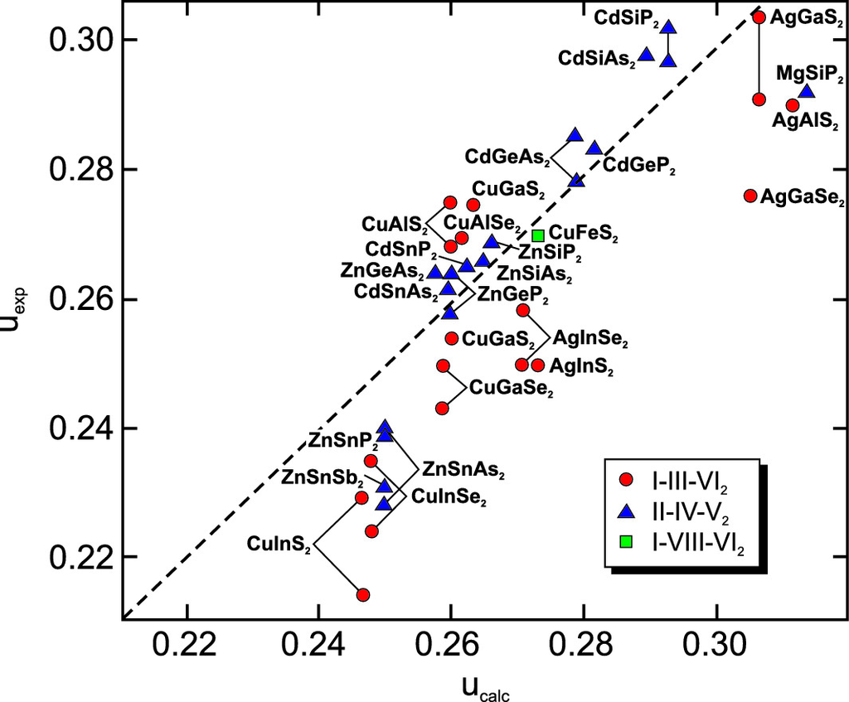

Fig. 3.23

Experimental values

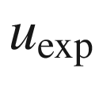

of the displacement parameter for various chalcopyrites vs. the calculated value

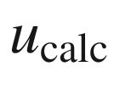

according to ([3.10](#u116076_4_En_3_Chapter-Equ11)). The *dashed line* indicates

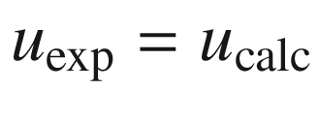

. Adapted from [217]

#### 3.4.7 Spinel Structure

A large variety of ternary compounds of type A

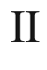

B

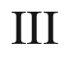



C

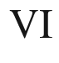

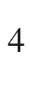

crystallize inb the cubic spinel structure (spinel, MgAl



O

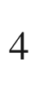

, space group 227, Fd3m). Typical elements are A: Mg, Cr, Mn, Fe, Co, Ni, Cu, Zn, Cd, Sn, B: Al, Ga, In, Ti, V, Cr, Mn, Fe, Co, Rh, Ni, and C: O, S, Se, Te.

As an example ZnGa



O

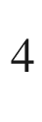

(zinc gallate) has received attention as interfacial layer in ZnO/GaAs epitaxy [218], luminescent material [219], and as ferromagnetic semiconductor [220]. Also the (unwanted) appearance of zinc gallate inclusions is in competition with the formation of highly doped wurtzite ZnO:Ga; in the (normal) spinel cubic structure of ZnGa



O

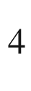

the Zn

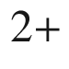

ions still occupy tetrahedral sites, but the Ga

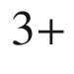

ions occupy octahedral sites instead of tetrahedral sites in doped wurtzite ZnO:Ga. (Sc,Al)MgO



(SCAM) is available as substrate material. Also A

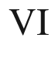

B

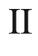

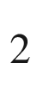

C

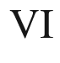



compounds exist, e.g. GeB



O



(with B=Mg, Fe, Co, Ni).

The anion atoms (C

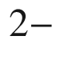

) sit on a fcc lattice. The A atoms fill 1/8 of all tetraeder spaces and the B atoms fill half of all octaeder places (Fig. [3.24](#u116076_4_En_3_Chapter-Fig24)). Often the cations are charged A

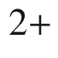

and B

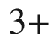

, e.g. in ZnAl

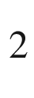

O

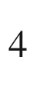

, MgCr



O

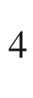

or ZnCo



O



. Also A

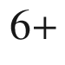

and B

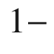

exists, e.g. in WNa



O



.

The cubic lattice constant is denoted as *a*. In real spinels, the anions deviate from the ideal fcc array which is accounted for by the parameter *u*, measuring the displacement of anions along the [111]-direction [221]; if the A-site cation is at (0,0,0), an anion is at (*u*, *u*, *u*). The cation-anion distances are given by [222]

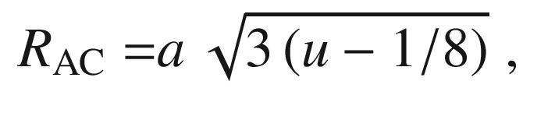

(3.11a)

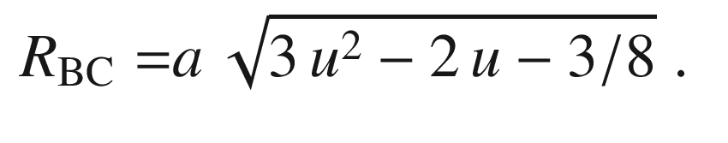

(3.11b)

The ideal value is

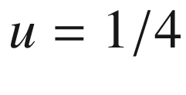

; examples are

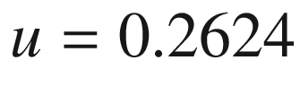

for MgAl



O



,

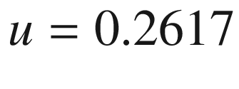

for ZnGa



O



and

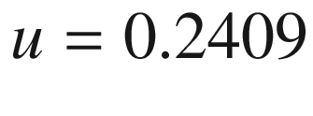

for SiFe



O

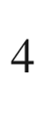

 [222].

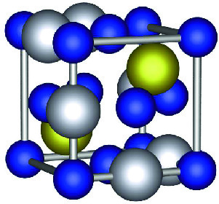

Fig. 3.24

Spinel AB



C

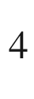

crystal structure, the cations are depicted as *yellow* (A atoms) and *silver* (B atoms) *spheres*, the anions (C atoms) as *blue spheres*

In the inverted spinel structure, for A

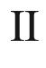

B

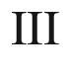



C

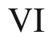



compounds, the cations are distributed like B(AB)C



, i.e. the B cations occupy tetraeder and octaeder places, e.g. in Mg

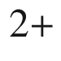

(Mg

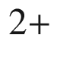

Ti

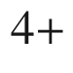

)O

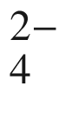

or Fe



(Ni



Fe

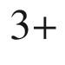

)O

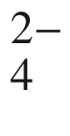

. Examples are magnetite (Fe

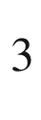

O



), a material with high spin polarization, or MgFe



O



. Also A

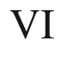

B

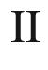

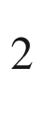

C





compounds exist in this structure, e.g. SnB



O



(with B = Mg, Mn, Co, Zn), TiB



O



(with B = Mg, Mn, Fe, Co, Zn), and VB



O

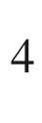

(with B = Mg, Co, Zn).

#### 3.4.8 Fluorite Structure

Named after the minerale fluorite (CaF



, space group 225, Fm3m), this structure for binary ionic compounds occurs when the cation valence is twice the anion valence, e.g. for (cubic) ZrO



(zirconia) or HfO



. The lattice is fcc with a triatomic base. At (0,0,0) is the cation (e.g. Zr

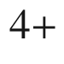

), the anions (e.g. O



) are at

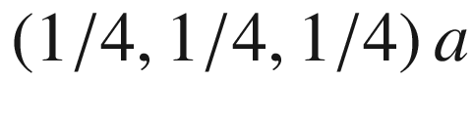

(as in the zincblende structure) and

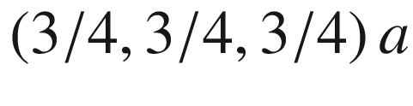

(Fig. [3.25](#u116076_4_En_3_Chapter-Fig25)). The anion atom positions are on a simple cubic lattice with lattice constant *a*/2. Zirconia can crystallize in various phases [223], the most prominent being the monoclinic, tetragonal and cubic phases. The cubic phase can be extrinsically stabilized using yttrium [224, 225] (YSZ, yttria-stabilized zirconia). Hafnium oxide has the remarkable property that the HfO



/Si interface is stable and allows the fabrication of transistor gate oxides with high dielectric constant (see Sect. [24.​5.​5](The_Physics_of_Semiconductors00009.docx#u116076_4_En_24_Chapter)).

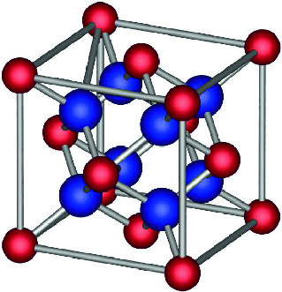

Fig. 3.25

Fluorite crystal structure, the cations are depicted as *red spheres*, the anions as *blue spheres*

#### 3.4.9 Delafossite Structure

The I–III–O



materials crystallize in the trigonal delafossite (CuFeO



, space group 166, R

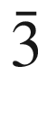

m) structure (Fig. [3.26](#u116076_4_En_3_Chapter-Fig26)). This structure is also called caswellsilverite (NaCrS



). In Table [3.5](#u116076_4_En_3_Chapter-Tab5) the lattice parameters of some delafossite compounds are given. The (Cu,Ag) (Al,Ga,In)O



materials are transparent conductive oxides (TCO). We note that Pt and Pd as group-I component create metal-like compounds because of the d

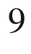

configuration as opposed to the d

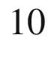

configuration of Cu and Ag.

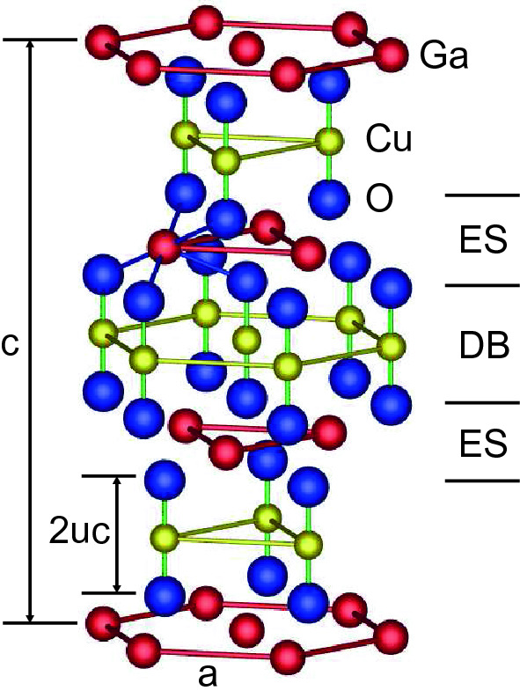

Fig. 3.26

Hexagonal unit cell of delafossite CuGaO



. Oxygen atoms are bonded to the Cu in a dumbbell (‘DB’) configuration. In the edge-sharing (‘ES’) layer the Ga atoms are octahedrally configured as GaO

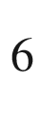

Table 3.5

Lattice parameters *a*, *c*, and *u* of some delafossite compounds. Theoretical values are shown with asterisk. Data from [226]

|  | *a* (nm) | *c* (nm) | *u* (nm) |
| --- | --- | --- | --- |
| CuAlO  $$_2$$ | 0.2858 | 1.6958 | 0.1099 |
| CuGaO  $$_2$$ | 0.2980 | 1.7100 | 0.1073  $$^*$$ |
| CuInO  $$_2$$ | 0.3292 | 1.7388 | 0.1056  $$^*$$ |

#### 3.4.10 Perovskite Structure

The perovskite structure for ABO

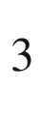

materials (calcium titanate, CaTiO



, space group 62, Pnma) (Fig. [3.27](#u116076_4_En_3_Chapter-Fig27)) is relevant for ferroelectric semiconductors (cf. Sect. [16.​3](The_Physics_of_Semiconductors00006.docx#u116076_4_En_16_Chapter)). It is cubic with the Ca (or Ba, Sr) ions (charge state

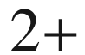

) on the corners of the cube, the O ions (

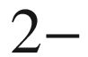

) on the face centers and the Ti (

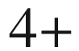

) in the body center. The lattice is simple cubic, the base is Ca at (0,0,0), O at (1/2,1/2,0), (1/2,0,1/2) and (0,1/2,1/2) and Ti at (1/2,1/2,1/2). The ferroelectric polarization is typically evoked by a shift of the negatively and positively charged ions relative to each other. LaAlO

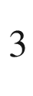

(lanthanium aluminate) is available as substrate material (space group 226, Fm

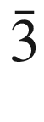

c [227]). Perovskites are also important for materials for high temperature superconductivity.

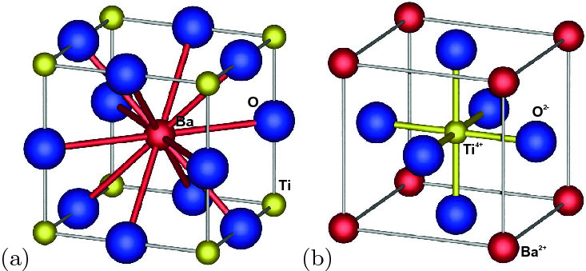

Fig. 3.27

Perovskite structure (BaTiO

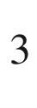

), **a** A cell with 12-fold (cuboctahedrally) configured Ba, **b** B cell with octahedrally configured Ti

Another group of ABX



perovskites is formed by halogen atoms (Cl, Br, I) instead of oxygen on the X-site (in

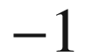

charge state). The B-site (former Ti-position) is taken up by lead (Pb) or other elements of same

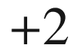

valence. The A-site (former Ba-position) is populated with an organic molecule (

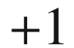

) such as CH



NH



(methylammonium, or MA) [228] or HC(NH



)



(formamidinium, or FA). In a purely inorganic version of such halogen perovskite, the A-site site is populated with Cs [229]. In order to avoid Pb, CsSnX

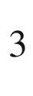

has been investigated. Various phases are observed next to the cubic phase (

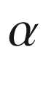

-CsPbI



) such as orthorhombic (

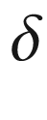

-CsPbBr



) or tetragonal [230]. Also, angular distortions of the PbX

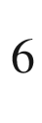

octahedrons are common and depend on material composition (Fig. [3.28](#u116076_4_En_3_Chapter-Fig28)).

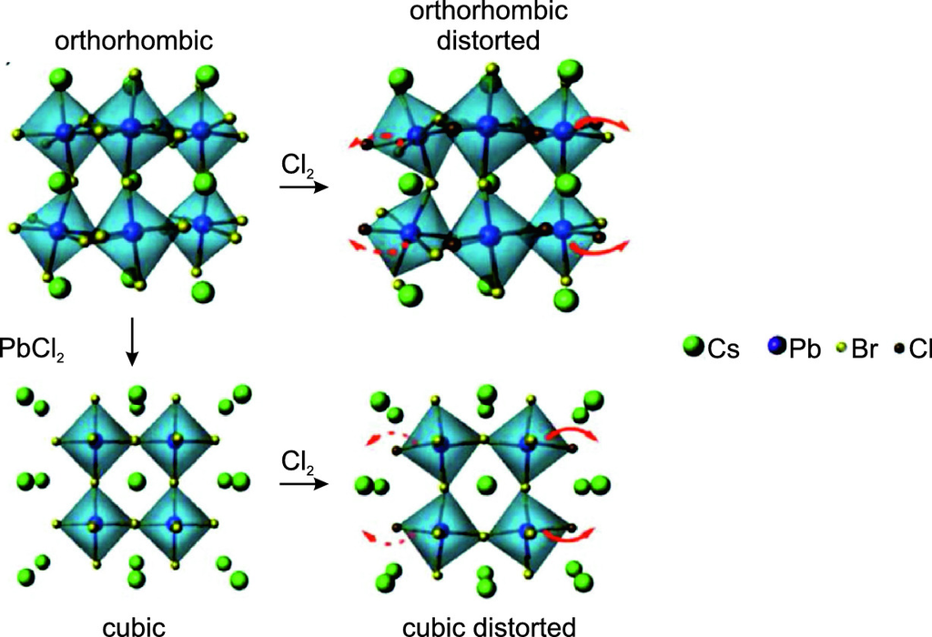

Fig. 3.28

Schematic molecular models of orthorhombic- and cubic-phase CsPbBr



perovskites with and without PbCl



and Cl



doping. Adapted from [232]

The phase stability depends on the octahedral factor

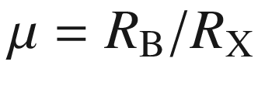

and the tolerance factor *t*,

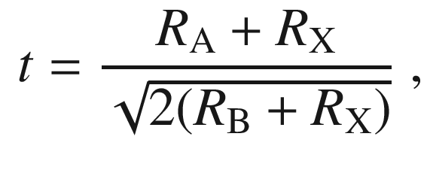

(3.12)

with

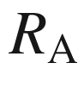

,

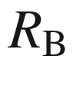

and

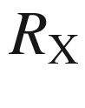

denoting the radius of the A-site and B-site cation, and X-site anion, respectively. The stability of 138 different halide perovskites has been calculated in terms of

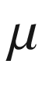

and *t* [231] (Fig. [3.29](#u116076_4_En_3_Chapter-Fig29)) and stability criteria have been given. A stable cubic phase requires

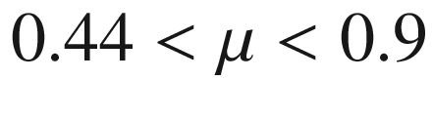

and

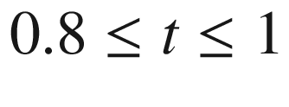

 [232].

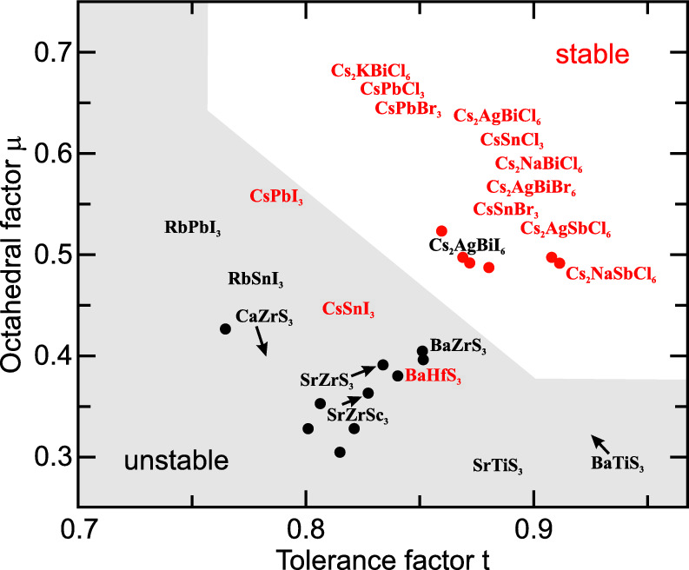

Fig. 3.29

Stability of ABX

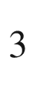

halide perovskites in terms of octahedral factor

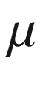

and tolerance factor *t*. *Red* (*black*) dots indicate stable (unstable) compounds. The region of unstable materials is shown in *grey*. Adapted from [231]

#### 3.4.11 NiAs Structure

The NiAs structure (space group 194, P6



/mmc) (Fig. [3.30](#u116076_4_En_3_Chapter-Fig30)) is relevant for magnetic semiconductors, such as MnAs, and also occurs in the formation of Ni/GaAs Schottky contacts [233]. The structure is hexagonal. The arsenic atoms form a hcp structure and are trigonal prismatically configured with six nearest metal atoms. The metal atoms form hcp planes and fill all octahedral holes of the As lattice. For a cubic close packed, i.e. fcc, structure this would correspond to the rocksalt crystal. The stacking is ABACABAC... (A: Ni, B,C: As).

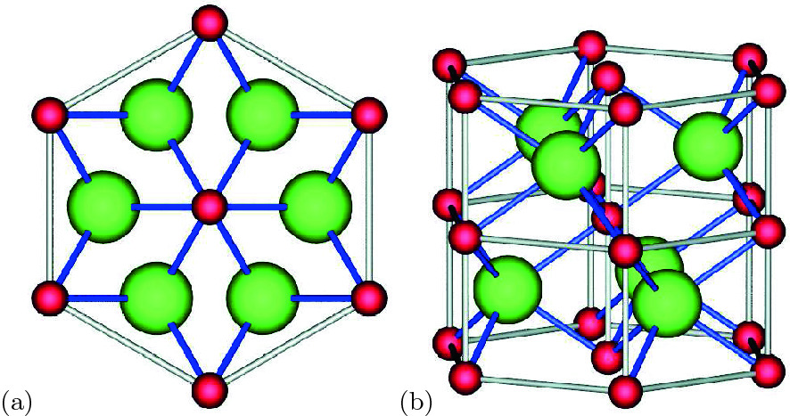

Fig. 3.30

NiAs structure, metal atoms: *dark grey*, chalcogenide atoms: *light grey*

#### 3.4.12 Further Structures

There are many other crystal structures that have relevance for semiconductor materials. Among them are the

corundum structure (Al



O



, space group 167, R



c) occurring, e.g., for sapphire substrates used in epitaxy or for gallium oxide

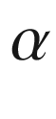

-Ga



O



(Ga



O



is a multiphase material [234, 235])

bixbyite structure (In



O



,

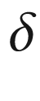

-Ga



O

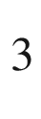

, space group 206, Ia

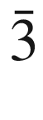

) (see Fig. [20.​3](The_Physics_of_Semiconductors00007.docx#u116076_4_En_20_Chapter-Fig3))

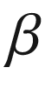

-Ga



O



monoclinic structure (space group 12, C2/m) [235]

quartz (SiO



) structures,

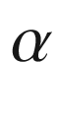

-quartz (space group 154, P3



21) and

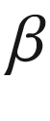

-quartz (space group 180, P6



22)

Space does not permit to discuss these and other structures in more detail here. The reader should refer to textbooks on crystallography, e.g. [236–238], and space groups [195, 239]. A good source for information and images of crystal structures on the web is [240].

### 3.5 Polytypism and Polymorphism

In polytype materials, several stacking orders are possible. One of them represents the thermodynamic ground state but others have very similar energy. An example is GaN which has been extensively investigated in its (equilibrium) wurtzite and also in its (zincblende) cubic form. But not only hcp or fcc but many different sequences, such as, e.g., ACBCABAC as the smallest unit cell along the stacking direction, are possible. A typical example is SiC, for which besides hcp and fcc many other (>40) stacking sequences are known. The largest primitive unit cell of SiC [213] contains 594 layers. Some of the smaller polytypes are sketched in Fig. [3.31](#u116076_4_En_3_Chapter-Fig31). In Fig. [3.32](#u116076_4_En_3_Chapter-Fig32) cubic diamond crystallites and metastable hexagonal and orthorhombic phases (in silicon) are shown.

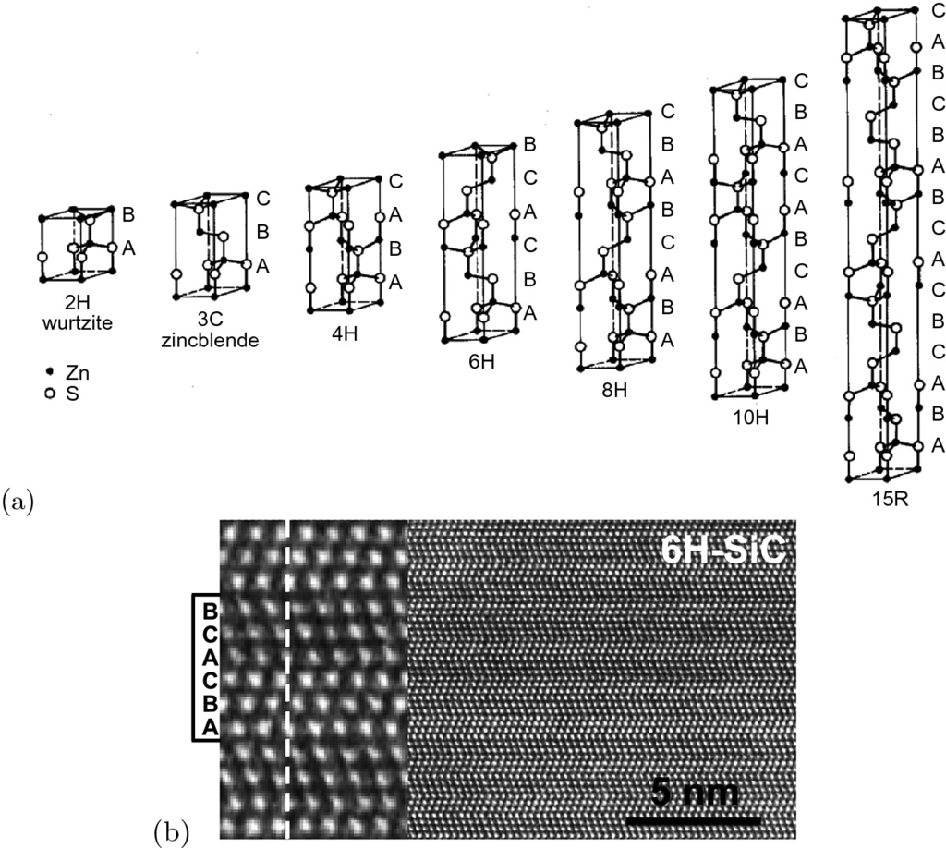

Fig. 3.31

**a** Polytypes of the zincblende and wurtzite lattice (found in SiC), the letters A, B and C denote the three possible positions of the diatomic layers (see Fig. [3.7](The_Physics_of_Semiconductors00001.docx#u116076_4_En_3_Chapter-Fig7)). **b** High resolution TEM image of 6H-SiC. For the enlarged view on the left, the unit cell and the stacking sequence are indicated. Adapted from [241]

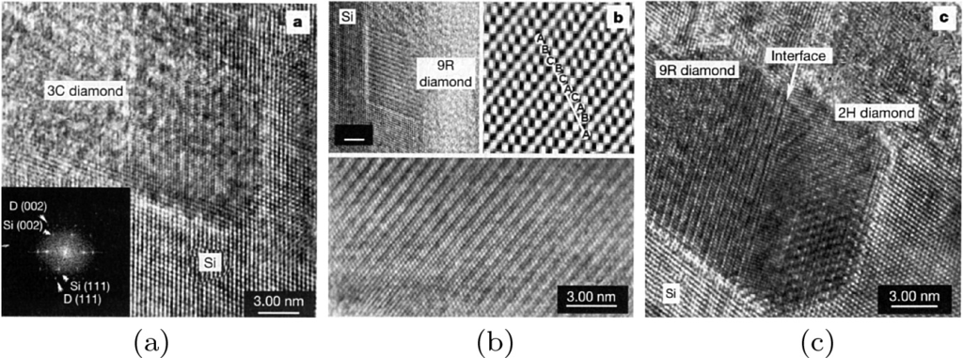

Fig. 3.32

Polytypes of diamond found in crystallites (metastable phases in silicon). **a** cubic type (3C) with stacking ABC, *inset* shows a diffractogram and the alignment of the C and Si lattice, **b** rhombohedral 9R crystallite with ABCBCACABA stacking, **c** 9R phase with interface to a hexagonal 2H (AB stacking) phase. Reprinted from [242] with permission, ©2001, Springer Nature

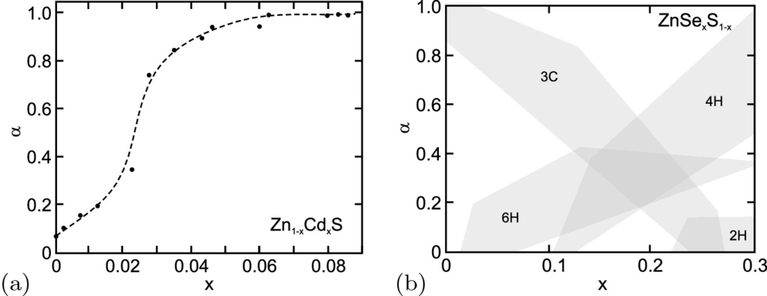

Fig. 3.33

**a** Hexagonality index



([3.13](#u116076_4_En_3_Chapter-Equ15)) of Zn

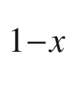

Cd



S for various ternary compositions. *Dashed line* is a guide to the eye. **b** Regions of different polytypes in ZnSe



S

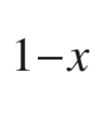

. Adapted from [243]

For the ternary alloy (cf. Sect. [3.7](#u116076_4_En_3_Chapter-Sec31)) Zn

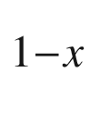

Cd



S the numbers

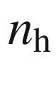

of diatomic layers with hexagonal stacking (AB) and

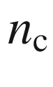

of layers with cubic stacking (ABC) have been investigated. CdS has wurtzite structure and ZnS mostly zincblende structure. The hexagonality index



as defined in ([3.13](#u116076_4_En_3_Chapter-Equ15)) is shown in Fig. [3.33](#u116076_4_En_3_Chapter-Fig33) for Zn

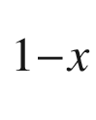

Cd



S

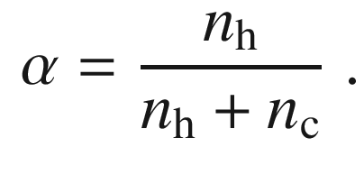

(3.13)

Some semiconductor materials possess several crystal phases (polymorphs) that can be readily prepared under various (non-equilibrium) conditions. Due to their different physical properties, eventually they can be employed for different device applications. GaN with its hexagonal and cubic phases can be counted as such material. A prominent example of a multi-phase semiconductor is Ga



O

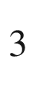

that exhibits, next to its monoclinic equilibrium structure, various other phases such as a rhombohedral (corundum,

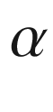

-Ga



O



) and an orthorhombic (

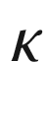

-Ga



O



) phase [244].

### 3.6 Reciprocal Lattice

The reciprocal lattice is of utmost importance for the description and investigation of periodic structures, in particular for X-ray diffraction [245], surface electron diffraction, phonon dispersion or scattering and the electronic band structure. It is the quasi-Fourier transformation of the crystal lattice. The crystal lattice is also called the *direct* lattice, in order to distinguish it from the *reciprocal* lattice.

#### 3.6.1 Reciprocal Lattice Vectors

When

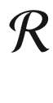

denotes the set of vectors of the direct lattice, the set

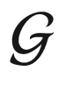

of the reciprocal lattice vectors is given by the condition[6](#u116076_4_En_3_Chapter-Fn6)

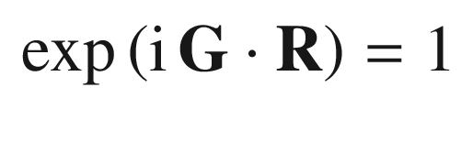

(3.14)

for all

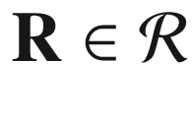

and

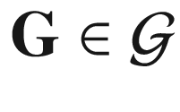

. Therefore, for all vectors

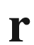

and a reciprocal lattice vector

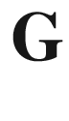

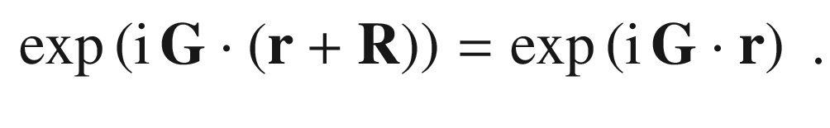

(3.15)

Each Bravais lattice has a certain reciprocal lattice. The reciprocal lattice is also a Bravais lattice, since when

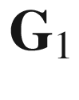

and

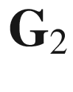

are two reciprocal lattice vectors, then this is obviously true also for

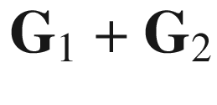

. For the primitive translation vectors



,

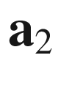

and

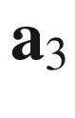

of the direct lattice, the vectors

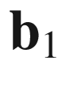

,

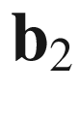

and

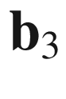

that span the reciprocal lattice are given directly for any lattice as

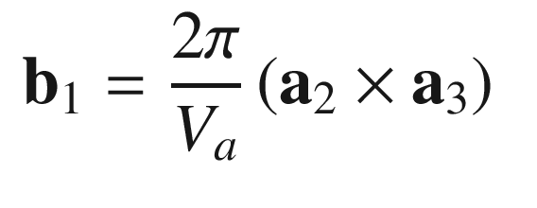

(3.16a)

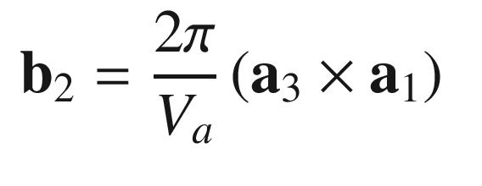

(3.16b)

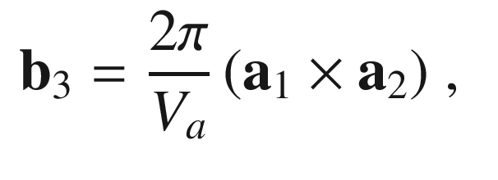

(3.16c)

where

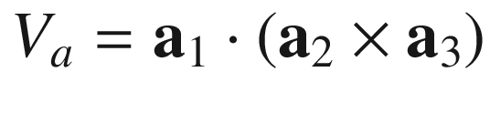

is the volume of the unit cell spanned by the vectors

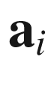

. The volume of the unit cell in reciprocal space is

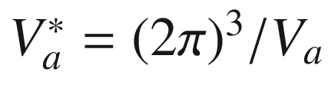

.

The vectors

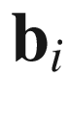

fulfill the conditions

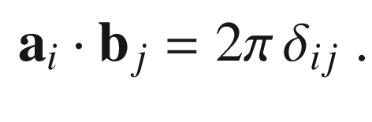

(3.17)

Thus, it is clear that ([3.14](#u116076_4_En_3_Chapter-Equ16)) is fulfilled. For an arbitrary reciprocal lattice vector

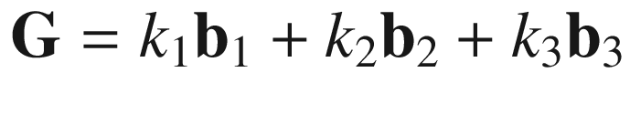

and a vector

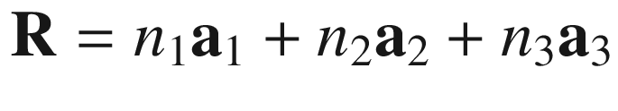

in direct space we find

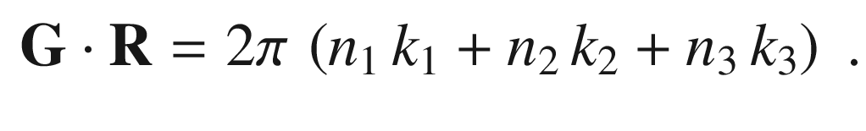

(3.18)

The number in brackets is an integer. Additionally, we note that the reciprocal lattice of the reciprocal lattice is again the direct lattice. The reciprocal lattice of the fcc is bcc and vice versa. The reciprocal lattice of hcp is hcp (rotated by 30



with respect to the direct lattice).

For later, we note two important theorems. A (sufficiently well behaved) function

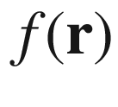

that is periodic with the lattice, i.e.

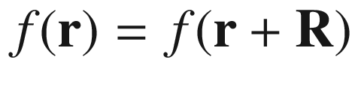

can be expanded into a Fourier series with the reciprocal lattice vectors according to

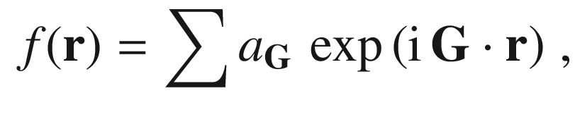

(3.19)

where

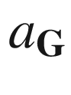

denotes the Fourier component of the reciprocal lattice vector

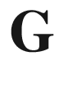

,

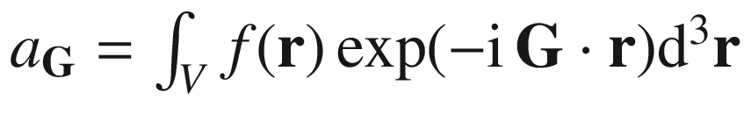

. If

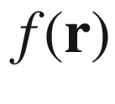

is lattice periodic, the integral given in ([3.20](#u116076_4_En_3_Chapter-Equ24)) is zero unless

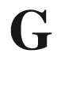

is a reciprocal lattice vector.

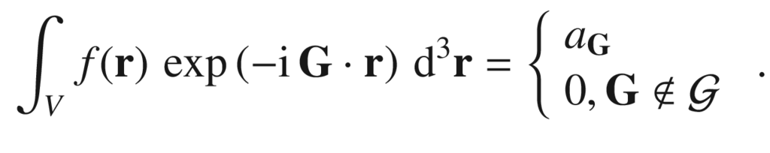

(3.20)

#### 3.6.2 Miller Indices

The Miller indices [246] form a triplet of integer numbers to denote directions and lattice planes in the crystal. A vector



in direct space is denoted with its components *h*, *k*, and *l* relative to the lattice vectors

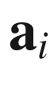

, i.e.

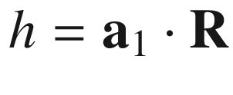

and so forth. In order to arrive at the set of smallest possible integer numbers, the values possibly must be divided by a suitable fraction. Directions are denoted in square brackets [*hkl*], and go into the direction of

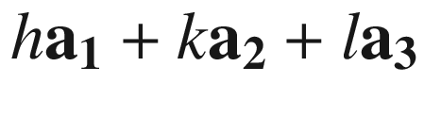

. A set of crystallographically equivalent directions is denoted with

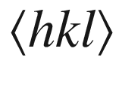

. For negative indices,

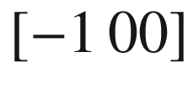

can also be written with a bar,

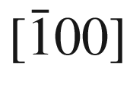

.

A lattice plane is the set of all lattice points in a plane spanned by two independent lattice vectors

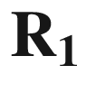

and

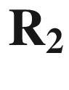

. Lattice planes are denoted as (*hkl*) with parentheses; a set of equivalent planes is denoted with curly brackets as

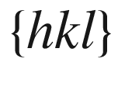

. The lattice points on that plane form a two-dimensional Bravais lattice. The entire lattice can be generated by shifting the lattice plane along its normal

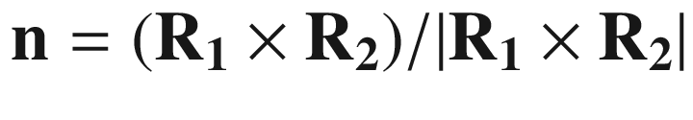

. The plane belongs to the reciprocal lattice vector

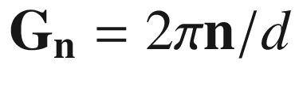

, *d* being the distance between planes.

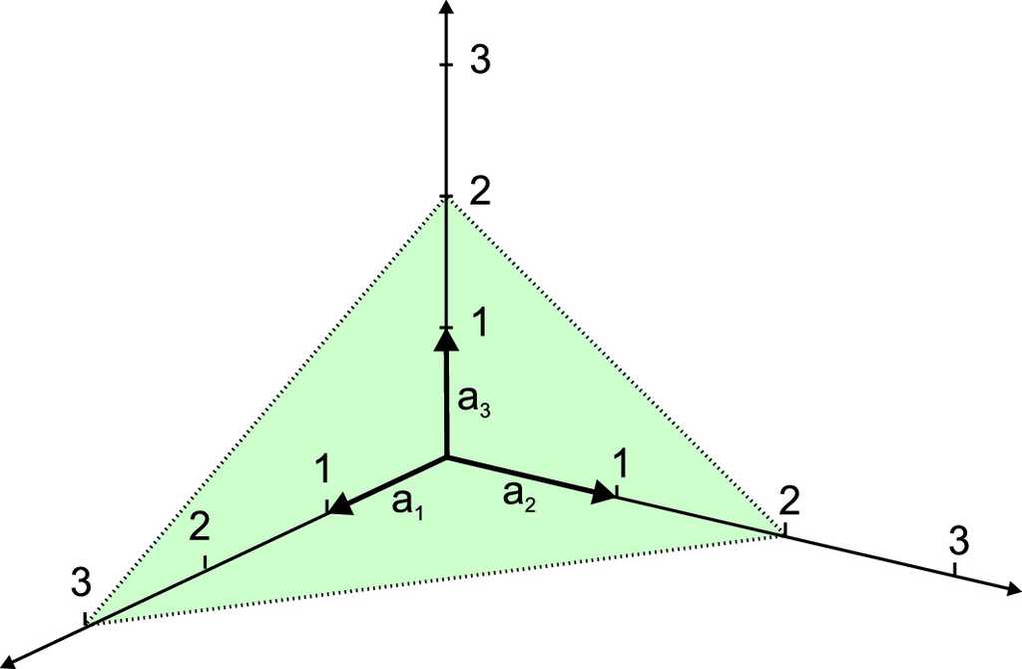

Fig. 3.34

The plane intersects the axes at 3, 2, and 2. The inverse of these numbers is 1/3, 1/2, and 1/2. The smallest integer numbers of this ratio form the Miller indices (233)

This correspondence between reciprocal lattice vectors and sets of planes allows the orientation of planes to be described in a simple manner. The shortest reciprocal lattice vector perpendicular to the plane is used. The coordinates with respect to the primitive translation vectors of the reciprocal space

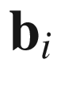

form a triplet of integer numbers and are called Miller indices of the plane, i.e.

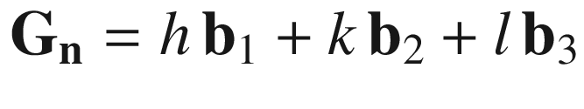

.

The plane described by

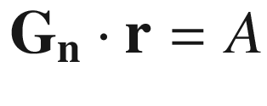

fulfills the condition for a suitable value of A. The plane intersects the axes



at the points

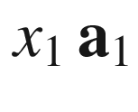

,

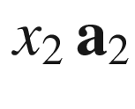

and

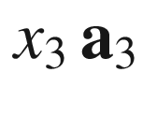

. Thus we find

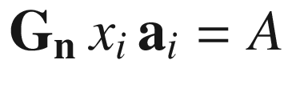

for all *i*. From ([3.18](#u116076_4_En_3_Chapter-Equ22)) follows

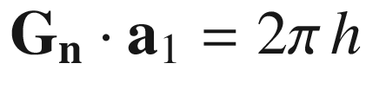

,

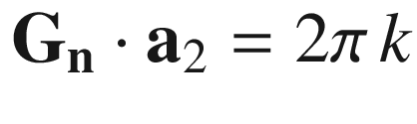

and

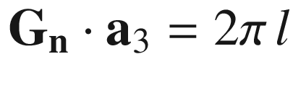

, where *h*, *k* and *l* are integers. The Miller indices (*hkl*) are thus proportional to the reciprocal values

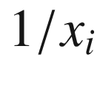

of the axis intersections of the plane with the lattice vectors of the direct lattice. An example is shown in Fig. [3.34](#u116076_4_En_3_Chapter-Fig34).

In a cubic lattice, the faces of the cubic unit cell are

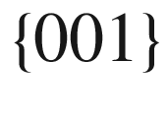

and the planes perpendicular to the area (body) diagonals are



(

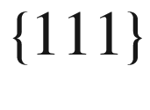

) (Fig. [3.35](#u116076_4_En_3_Chapter-Fig35)a). For example, in the simple cubic lattice (100), (010), (001), (

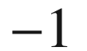

00), (0

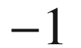

0) are (00

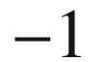

) equivalent and are denoted by

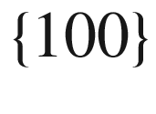

.

In the zincblende lattice, the

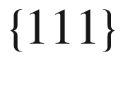

planes consist of diatomic planes with Zn and S atoms. It depends on the direction whether the metal or the nonmetal is on top. These two cases are denoted by A and B. We follow the convention that the (111) plane is (111)A and the metal is on top (as in Fig. [3.16](#u116076_4_En_3_Chapter-Fig16)b). For each change of sign the type changes from A to B and vice versa, e.g. (111)A, (1

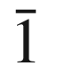

1)B and (

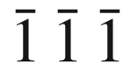

)B. In Fig. [3.35](#u116076_4_En_3_Chapter-Fig35)b the in-plane directions for the (001), (110) and (111) planes are visualized.

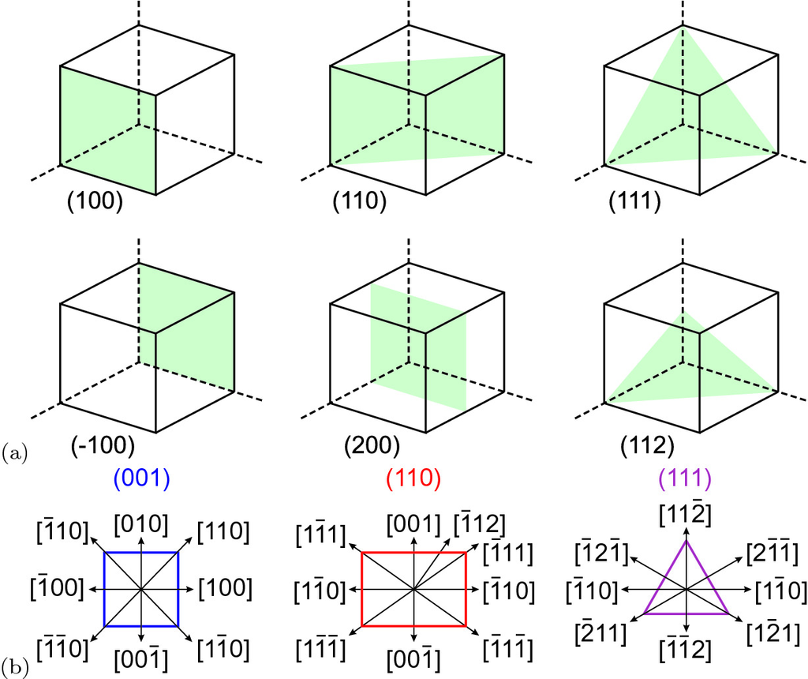

Fig. 3.35

**a** Miller indices of important planes for the simple cubic (and fcc, bcc) lattice. (**b**) Directions within three low index planes of cubic crystals

We note that for orthogonal lattices, the (outward) normal direction of a plane (*hkl*) is the same direction as [*hkl*]. Caveat: in non-rectangular lattices this is not the case! This can be easily seen for a monoclinic lattice, depicted as example in Fig. [3.36](#u116076_4_En_3_Chapter-Fig36).

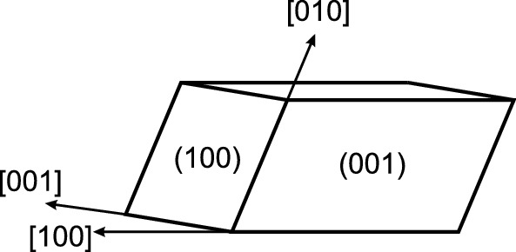

Fig. 3.36

Sketch of lattice directions and planes in a monoclinic lattice. The [100] direction and the normal of the (100) plane are not parallel

In the wurtzite lattice, the Miller indices are denoted as [*hklm*] (Fig. [3.37](#u116076_4_En_3_Chapter-Fig37)). Within the (0001) plane three indices *hkl* are used that are related to the three vectors

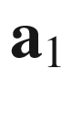

,

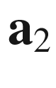

and

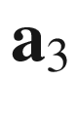

(see Fig. [3.37](#u116076_4_En_3_Chapter-Fig37)a) rotated with respect to each other by 120

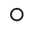

. Of course, the four indices are not independent and

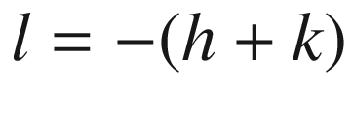

. The third (redundant) index can be denoted as a dot. The *c*-axis [0001] is then denoted as [00.1]. Wurtzite (and trigonal, e.g. sapphire) substrates are available typically with (polished) a (11.0), m (01.0) and r (01.2), c (00.1) surfaces (Fig. [3.37](#u116076_4_En_3_Chapter-Fig37)b).

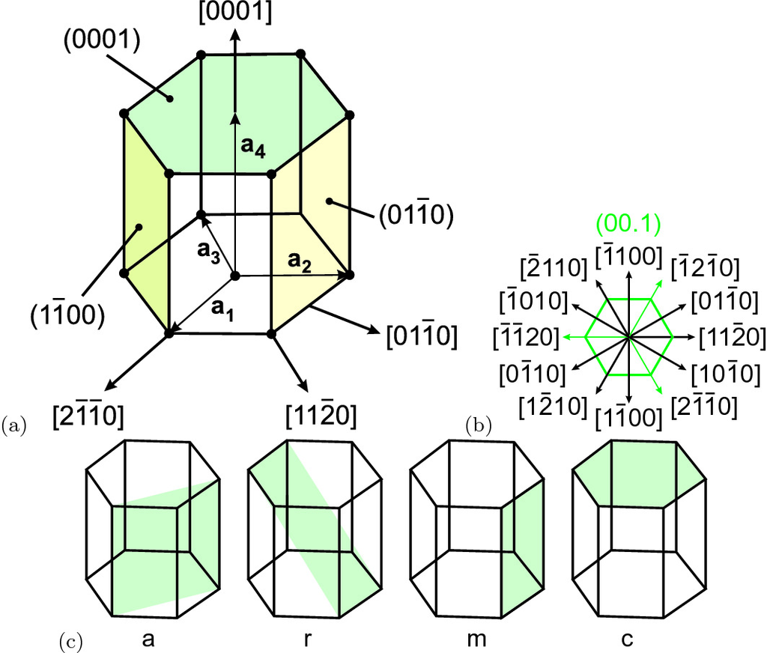

Fig. 3.37

(**a**, **b**) Miller indices for the wurtzite (or hcp) structure. (**c**) Orientation of the a-, r-, m-, and c-plane in the wurtzite structure

The distance of lattice planes

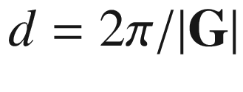

can be expressed via the Miller indices for cubic ([3.21a](#u116076_4_En_3_Chapter-Equ25)), tetragonal ([3.21b](#u116076_4_En_3_Chapter-Equ26)) and hexagonal ([3.21c](#u116076_4_En_3_Chapter-Equ27)) crystals as

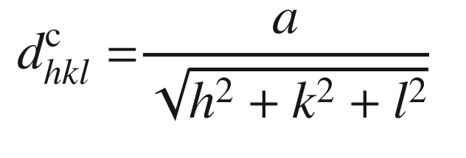

(3.21a)

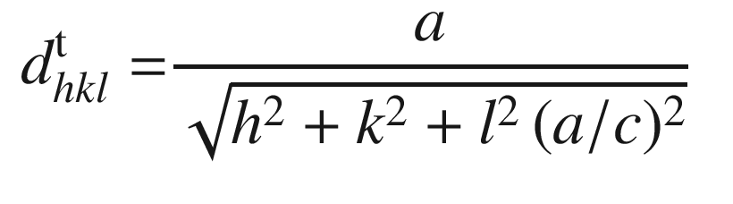

(3.21b)

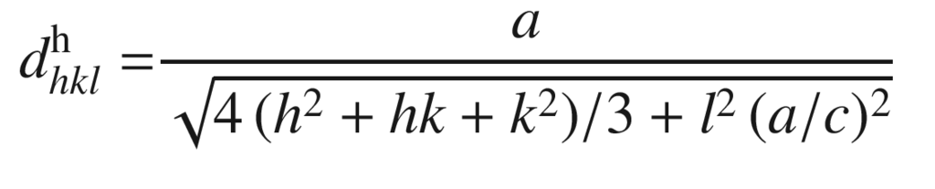

(3.21c)

Useful formulas for the angle

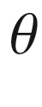

between a [*hk*.*l*]-plane and the [00.1]-direction in the cubic, tetragonal and wurtzite structures are:

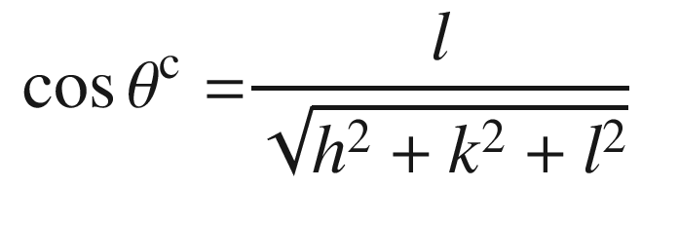

(3.22a)

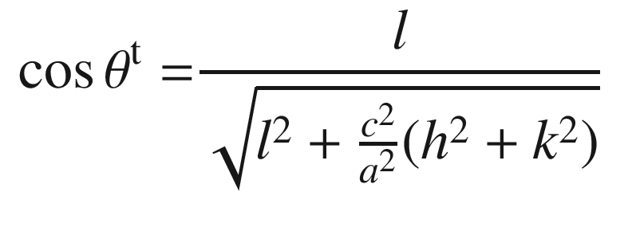

(3.22b)

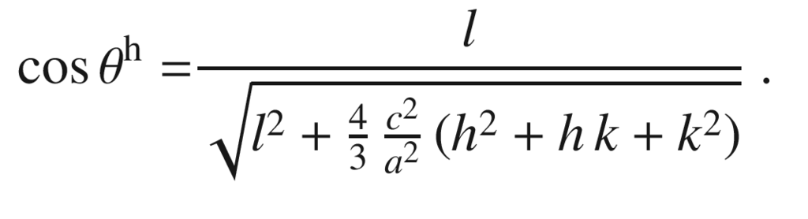

(3.22c)

#### 3.6.3 Brillouin Zone

The Wigner–Seitz cell in reciprocal space is called the (first) Brillouin zone. In Fig. [3.38](#u116076_4_En_3_Chapter-Fig38), the Brillouin zones for the most important lattices are shown. High symmetry points in the Brillouin zone are labeled with dedicated letters. The

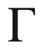

point  always denotes

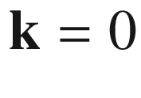

(zone center). High symmetry paths in the Brillouin zone are labeled with dedicated Greek symbols.

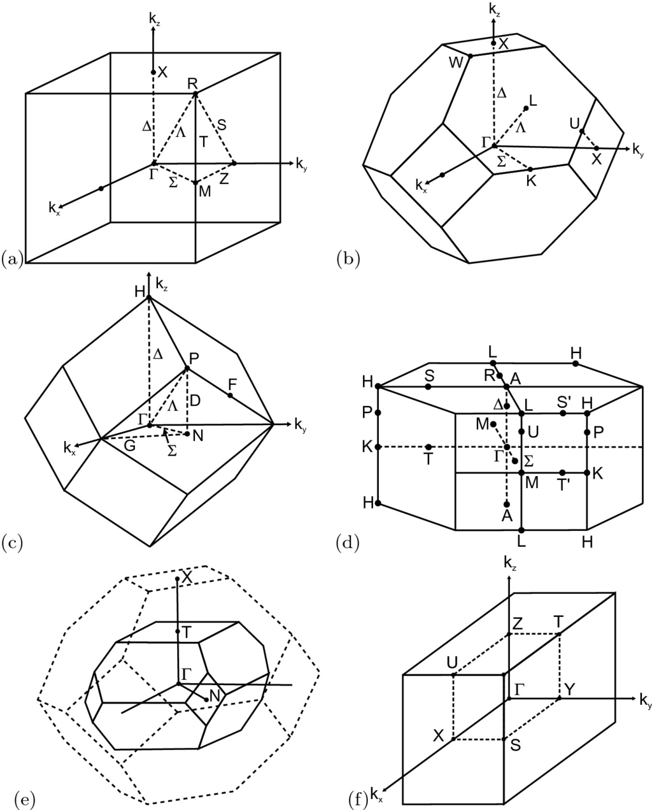

Fig. 3.38

Brillouin zones and special



points for the **a** primitive cubic (pc), (**b**) fcc, **c** bcc, and **d** hcp lattice. **e** Brillouin zone for chalcopyrite structure with fcc Brillouin zone shown as *dashed outline* **f** Brillouin zone for orthorhombic lattice with one quadrant shown with *dashed lines*

In the Brillouin zone of the fcc lattice (Si, Ge, GaAs, ...) the X point denotes the point at the zone boundary in

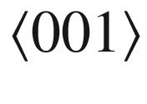

-directions (at distance

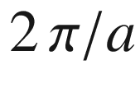

from

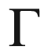

), K for

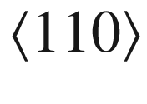

-directions (at distance

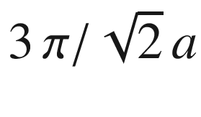

from



) and L for the

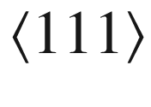

-directions (at distance

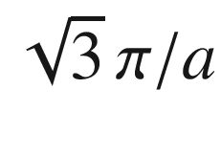

from

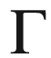

) (see Table [3.6](#u116076_4_En_3_Chapter-Tab6)) . The straight paths from



to X, K, and L are denoted as

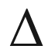

,

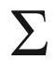

, and

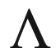

, respectively. High symmetry points and directions of the Brillouin zone of the hcp lattice are given in Table [3.7](#u116076_4_En_3_Chapter-Tab7).Table 3.6

High symmetry points and directions from

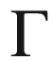

-point in the Brillouin zone of the fcc lattice

| Point | $$\mathbf{k}$$  (  $$\frac{2 \, \pi }{a}$$  ) | Direction | Multiplicity |
| --- | --- | --- | --- |
| $$\Gamma $$ | (0, 0, 0) |  | 1 |
| X | (0, 1, 0) | $$\Delta $$ | 6 |
| K | $$3/4 \, (1, 1, 0) $$ | $$\Sigma $$ | 12 |
| L | $$1/2 \, (1, 1, 1) $$ | $$\Lambda $$ | 8 |
| W | (1, 1/2, 0) |  | 24 |
| U | (1, 1/4, 1/4) |  | 24 |

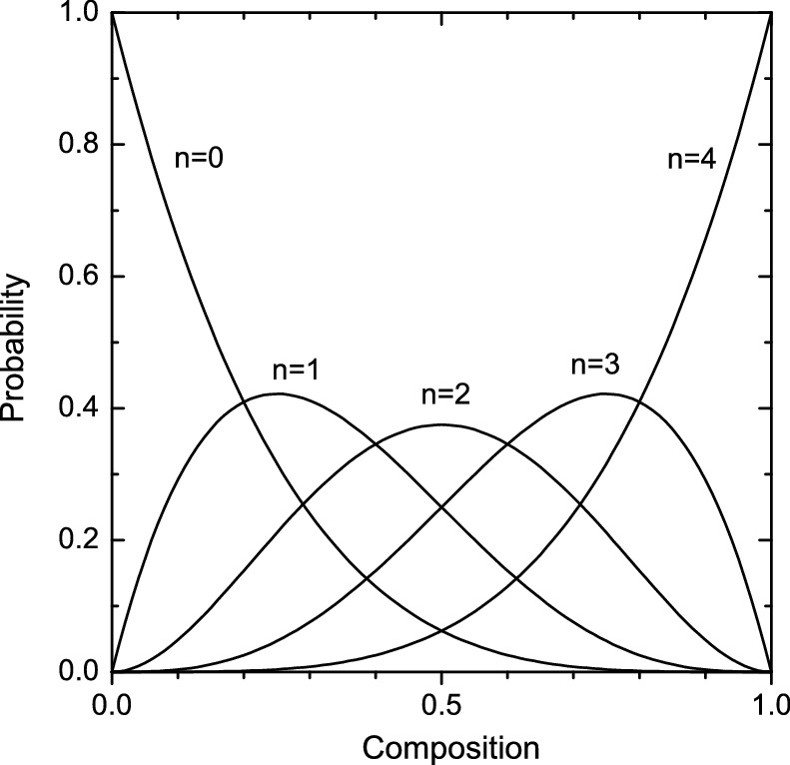

Fig. 3.39

Probability that a Si atom has *n* next-neighbor Ge atoms in a random Ge



Si



alloy

Table 3.7

High symmetry points and directions from

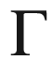

-point in the Brillouin zone of the hcp lattice

| Point | $$\mathbf{k}$$  (  $$2 \, \pi $$  ) | Direction | Multiplicity |
| --- | --- | --- | --- |
| $$\Gamma $$ | (0, 0, 0) |  | 1 |
| A | $$(0, 0, \frac{1}{2 \, c}) $$ | $$\Delta $$ | 2 |
| L | $$(0, \frac{1}{\sqrt{3} \, a}, \frac{1}{2 \, c}) $$ |  | 12 |
| M | $$(0, \frac{1}{\sqrt{3} \, a}, 0) $$ | $$\Sigma $$ | 6 |
| H | $$(-\frac{1}{3 \, a}, \frac{1}{\sqrt{3} \, a}, \frac{1}{2 \, c}) $$ |  | 12 |
| K | $$(-\frac{1}{3 \, a}, \frac{1}{\sqrt{3} \, a}, 0) $$ | T | 6 |

### 3.7 Alloys

When different semiconductors are mixed various cases can occur:

The semiconductors are not miscible and have a so-called miscibility gap. They will tend to form clusters that build up the crystal. The formation of defects is probable.

They form an ordered (periodic) structure that is called a superlattice.

They form a random alloy.

#### 3.7.1 Random Alloys

Alloys for which the probability to find an atom at a given lattice site is given by the fraction of these atoms (i.e. the stoichiometry), independent of the surrounding, are called *random* alloys. Deviations from the random population of sites is termed *clustering*.

For a Ge



Si

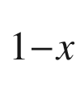

alloy this means that any given atom site has the probability *x* to have a Ge atom and

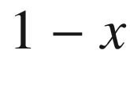

to have a Si atom. The probability

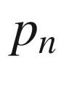

that a Si atom has *n* next-neighbor Ge atoms is

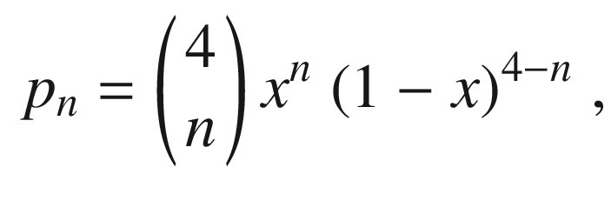

(3.23)

and is depicted in Fig. [3.39](#u116076_4_En_3_Chapter-Fig39) as a function of the alloy composition. The symmetry of the Si atom is listed in Table [3.8](#u116076_4_En_3_Chapter-Tab8). If it is surrounded by four of the same atoms (either Ge or Si), the symmetry is



. If one atom is different from the other three next neighbors, the symmetry is reduced to

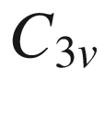

since one bond is singled out. For two atoms each the symmetry is lowest (

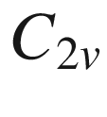

).

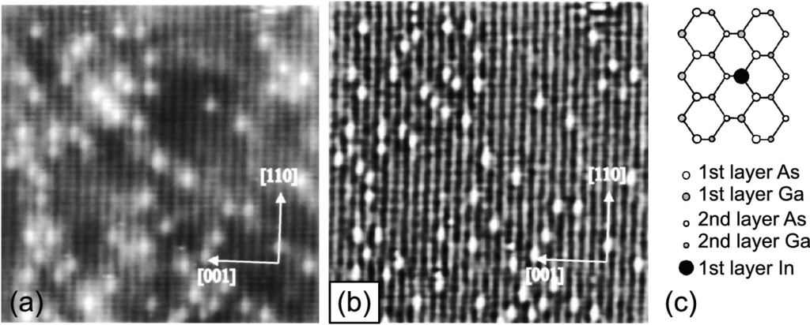

Fig. 3.40

**a** STM empty-state image (

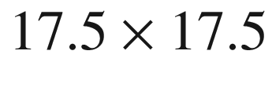

 nm

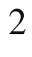

) of the (

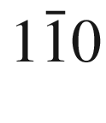

) surface of an MBE-grown In

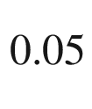

Ga

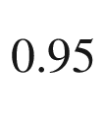

As alloy on GaAs, **b** curvature-enhanced image. **c** Schematic atomic arrangement of the first and second atomic layer. Adapted from [248]

Table 3.8

Probability

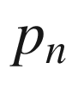

([3.23](#u116076_4_En_3_Chapter-Equ31)) and symmetry of an A atom being surrounded by *n* B atoms in a tetrahedrally configured B



A

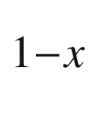

random alloy

| *n* | $$p_n$$ | Symmetry |
| --- | --- | --- |
| 0 | $$x^4$$ | $$T_d$$ |
| 1 | $$4 \, x^3 \, (1-x)$$ | $$C_{3v}$$ |
| 2 | $$6 \, x^2 \, (1-x)^2$$ | $$C_{2v}$$ |
| 3 | $$4 \, x \, (1-x)^3$$ | $$C_{3v}$$ |
| 4 | $$(1-x)^4$$ | $$T_d$$ |

In an alloy from binary compound semiconductors such as Al



Ga

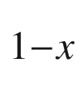

As the mixing of the Al and Ga metal atoms occurs only on the metal (fcc) sublattice. Each As atom is bonded to four metal atoms. The probability that it is surrounded by *n* Al atoms is given by ([3.23](#u116076_4_En_3_Chapter-Equ31)). The local symmetry of the As atom is also given by Table [3.8](#u116076_4_En_3_Chapter-Tab8). For AlAs



P



the mixing occurs on the nonmetal (anion) sublattice. If the alloy contains three atom species it is called a *ternary* alloy. In Fig. [3.40](#u116076_4_En_3_Chapter-Fig40) the (

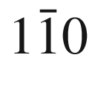

) surface (UHV cleave) of an In

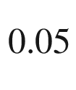

Ga

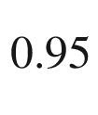

As alloy is shown. Indium atoms in the first layer show up as brighter round dots [247]. Along the [001]-direction the positions are uncorrelated, along [110] an anti-correlation is found, corresponding to an effective repulsive pair interaction energy of 0.1 eV for the nearest neighbor In–In pairs along the [110]-direction due to strain effects [248].

If the binary end components have different crystal structure, the alloy shows a transition (or compositional transition range) from one structure to the other at a particular concentration. An example is the alloy between wurtzite ZnO and rocksalt MgO. Mg



Zn



O alloy thin films exhibits wurtzite structure up to about

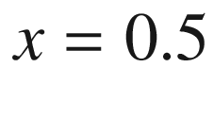

and rocksalt structure for

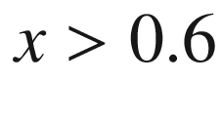

[249] (cmp. Fig. [3.43](#u116076_4_En_3_Chapter-Fig43)).

If the alloy contains four atom species it is called *quaternary*. A quaternary zincblende alloy can have the mixing of three atom species on one sublattice, such as Al



Ga



In

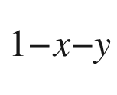

As or GaAs



P



Sb

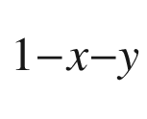

or the mixing of two atom species on both of the two sublattices, such as In



Ga

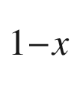

As



N

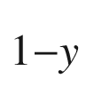

.

The random placement of different atoms on the (sub)lattice in an alloy represents a perturbation of the ideal lattice and causes additional scattering (alloy scattering). In the context of cluster formation, the probability of an atom having a direct neighbor of the same kind on its sublattice is important. Given a A



B



C alloy, the probability

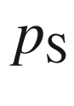

to find a single A atom surrounded by B atoms is given by ([3.24a](#u116076_4_En_3_Chapter-Equ32)). The probability

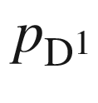

to find a cluster of two neighbored A atoms surrounded by B atoms is given by ([3.24b](#u116076_4_En_3_Chapter-Equ33)).

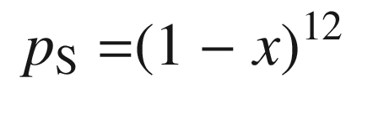

(3.24a)

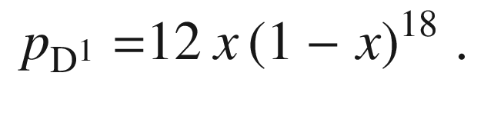

(3.24b)

These formulas are valid for fcc and hcp lattices. For larger clusters [250, 251], probabilities in fcc and hcp structures differ.

#### 3.7.2 Phase Diagram

The mixture A



B



with average composition *x* between two materials A and B can result in a single phase (alloy), a two-phase system (phase separation) or a metastable system. The molar free enthalpy

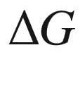

of the mixed system is approximated by



(3.25)

The first term on the right-hand side of ([3.25](#u116076_4_En_3_Chapter-Equ34)) is the (regular solution) enthalpy of mixing with the interaction parameter

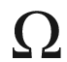

, which can depend on *x*. The second term is the ideal configurational entropy based on a random distribution of the atoms. The function is shown for various ratios of

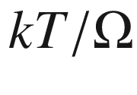

in Fig. [3.41](#u116076_4_En_3_Chapter-Fig41)a. In an equilibrium phase diagram (see Fig. [3.41](#u116076_4_En_3_Chapter-Fig41)b) the system is above the binodal curve in one phase (miscible). On the binodal line

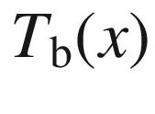

in the (*x*, *T*) diagram the A- and B-rich disordered phases have equal chemical potentials, i.e.

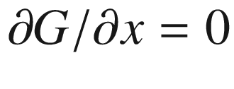

. For

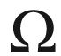

independent of *x* the temperature

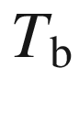

is given by ([3.26a](#u116076_4_En_3_Chapter-Equ35)). A critical point is at the maximum temperature

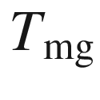

and concentration

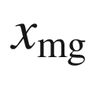

of the miscibility gap. For

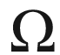

independent of *x* it is given by

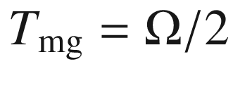

and

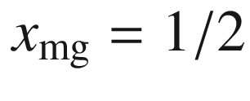

. In the region below the spinodal boundary, the system is immiscible and phases immediately segregate (by spinodal decomposition). On the spinodal line

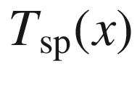

the condition

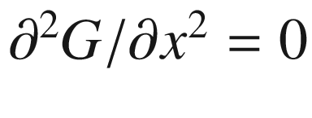

is fulfilled. For

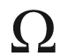

independent of *x* the temperature

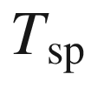

is given by ([3.26b](#u116076_4_En_3_Chapter-Equ36)). The region between the binodal and spinodal curves is the metastable region, i.e. the system is stable to small fluctuations of concentration or temperature but not for larger ones.

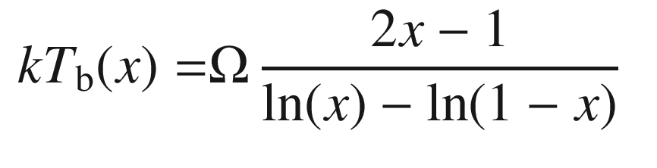

(3.26a)

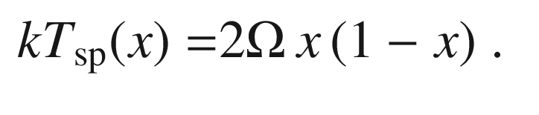

(3.26b)

In Fig. [3.42](#u116076_4_En_3_Chapter-Fig42) calculated diagrams for GaAs-AlAs and GaAs-GaP [252] are shown. The arrows denote the critical point. These parameters and the interaction parameters for a number of ternary alloys are given in Table [3.9](#u116076_4_En_3_Chapter-Tab9). For example, for Al



Ga



As complete miscibility is possible for typical growth temperatures (

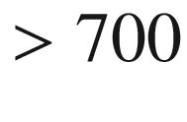

 K), but for In



Ga



N the In solubility at a typical growth temperature of 1100 K is only 6% [253].

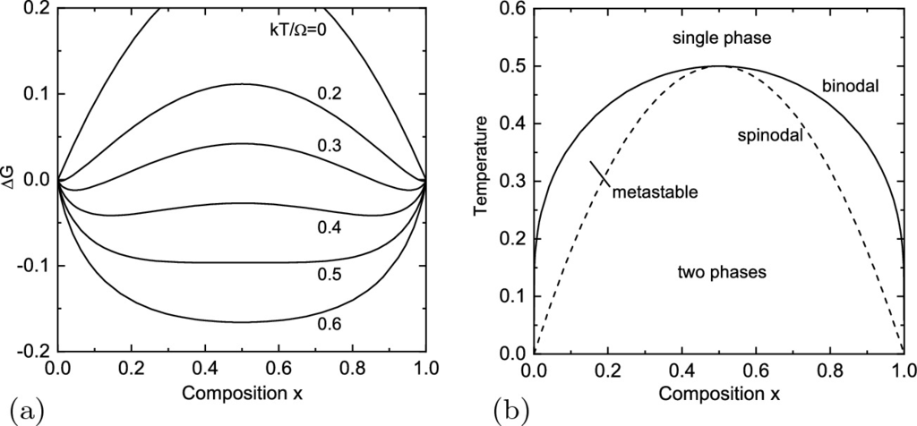

Fig. 3.41

**a** Free enthalpy



of mixed binary system ([3.25](#u116076_4_En_3_Chapter-Equ34)) in units of



for

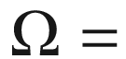

const. and various values of

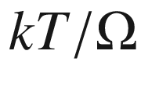

as labeled. **b** Schematic phase diagram for binary mixture. The temperature is given in units of

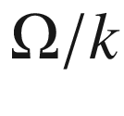

. The *solid* (*dashed*) line denotes the binodal (spinodal) line

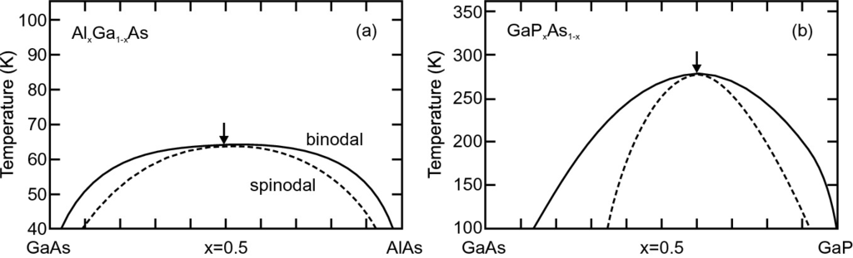

Fig. 3.42

Calculated phase diagrams for **a** Al



Ga



As and **b** GaP



As



. The binodal (spinodal) curve is shown as *solid* (*dashed*) line. Adapted from [252]

Table 3.9

Calculated interaction parameter

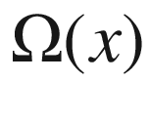

(at

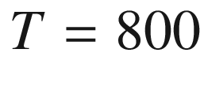

 K, 1 kcal/mol= 43.39 meV), miscibility-gap temperature

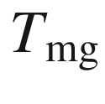

and concentration

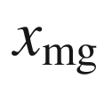

for various ternary alloys. Data for (In,Ga)N from [253], other data from [252]

| Alloy | $$T_{\mathrm {mg}}$$ | $$x_{\mathrm {mg}}$$ | $$\Omega (0)$$ | $$\Omega (0.5)$$ | $$\Omega (1)$$ |
| --- | --- | --- | --- | --- | --- |
|  | (K) |  | (kcal/mol) | (kcal/mol) | (kcal/mol) |
| Al  $$_x$$  Ga  $$_{1-x}$$  As | 64 | 0.51 | 0.30 | 0.30 | 0.30 |
| GaP  $$_x$$  As  $$_{1-x}$$ | 277 | 0.603 | 0.53 | 0.86 | 1.07 |
| Ga  $$_x$$  In  $$_{1-x}$$  P | 961 | 0.676 | 2.92 | 3.07 | 4.60 |
| GaSb  $$_x$$  As  $$_{1-x}$$ | 1080 | 0.405 | 4.51 | 3.96 | 3.78 |
| Hg  $$_x$$  Cd  $$_{1-x}$$  Te | 84 | 0.40 | 0.45 | 0.80 | 0.31 |
| Zn  $$_x$$  Hg  $$_{1-x}$$  Te | 455 | 0.56 | 2.13 | 1.88 | 2.15 |
| Zn  $$_x$$  Cd  $$_{1-x}$$  As | 605 | 0.623 | 2.24 | 2.29 | 2.87 |
| In  $$_x$$  Ga  $$_{1-x}$$  N | 1505 | 0.50 | 6.32 | 5.98 | 5.63 |

The alloy system (Al,Ga,In)(As,P,Sb) always crystallizes in the zincblende structure and (Al,Ga,In)N always in the wurtzite structure. If the binary end components of a ternary alloy have a *different* crystal structure things become more complicated and the crystal phase has to be determined experimentally (and modelled) for each composition. As an example the energy of the wurtzite, hexagonal and rocksalt structure of Mg



Zn



O has been calculated [254] as depicted in Fig. [3.43](#u116076_4_En_3_Chapter-Fig43) (cmp. Fig. [2.​4](The_Physics_of_Semiconductors00001.docx#u116076_4_En_2_Chapter-Fig4) for silicon). The transition between wurtzite and rocksalt structure is predicted for

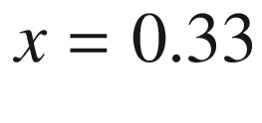

.

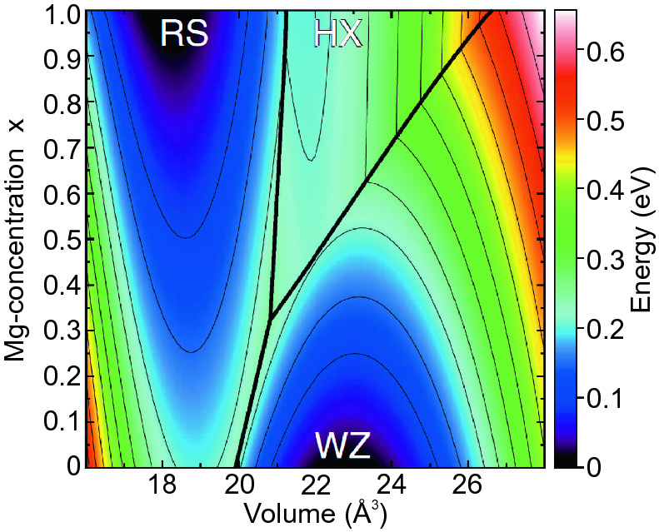

Fig. 3.43

Calculated energy vs. volume of the formula unit for Mg



Zn



O in the wurtzite (WZ), hexagonal (HX) and rocksalt phase (RS). The separations between the three phase are denoted by *straight bold lines*. Adapted from [254]

#### 3.7.3 Virtual Crystal Approximation

In the *virtual crystal approximation* (VCA) the disordered alloy AB



C



is replaced by an ordered binary compound AD with D being a ‘pseudoatom’ with properties that are configuration averaged over the properties of the B and C atoms, e.g. their masses or charges. Such an average is weighted with the ternary composition, e.g. the mass is

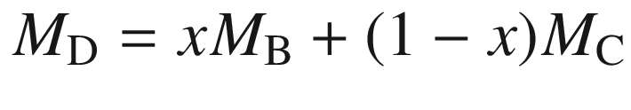

. For example, the A–D force constant would be taken as the weighted average over the A–B and A–C force constants.

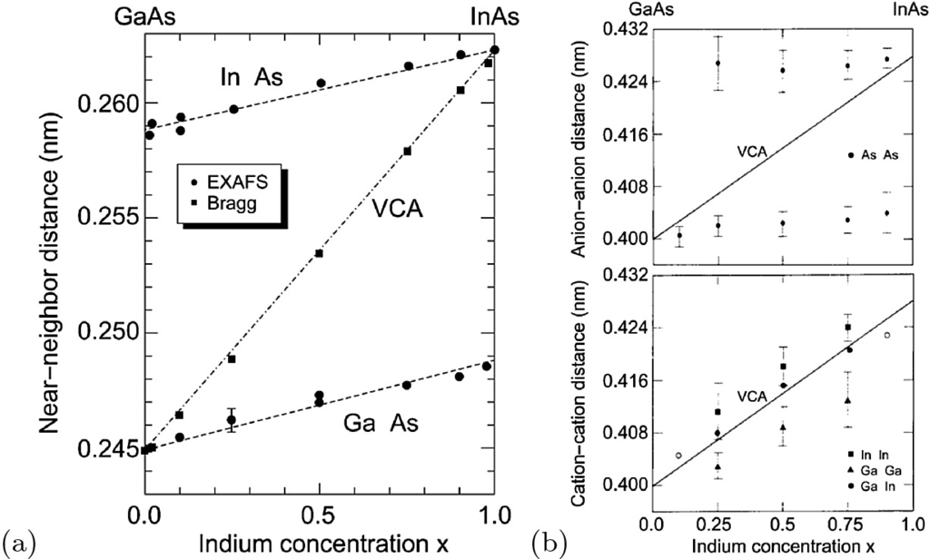

Fig. 3.44

**a** Near-neighbor distance (

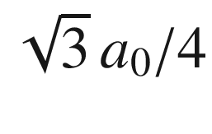

) of In



Ga



As as measured by standard X-ray diffraction (Bragg reflection, *solid squares*) and VCA approximation (*dash-dotted line*). Near-neighbor Ga–As and In–As distances as determined by EXAFS (extended X-ray absorption fine structure, *solid squares*). *Dashed lines* are guides to the eye. Data from [255]. **b** Second-neighbor distances for In



Ga

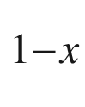

As as determined from EXAFS, *top*: anion–anion distance (for As–As), *bottom*: cation–cation distance (for In–In, Ga–Ga, and Ga–In). *Solid lines* in both plots are the VCA (

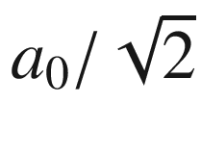

). Data from [256]

#### 3.7.4 Lattice Parameter

In the VCA for an alloy a new sort of effective atom is assumed that has an averaged bond length that depends linearly on the composition. Typically, Vegard’s law ([3.27](#u116076_4_En_3_Chapter-Equ37)), which predicts that the lattice constant of a ternary alloy A



B



C depends linearly on the lattice constants of the binary alloys AC and BC, is indeed fulfilled

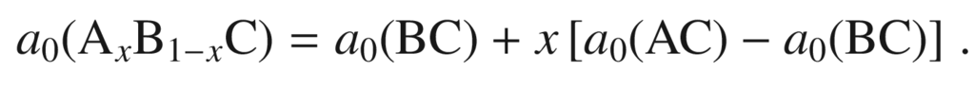

(3.27)

In reality, the bond length of the AC and BC bonds changes rather little (Fig. [3.44](#u116076_4_En_3_Chapter-Fig44)a) such that the atoms in the alloy suffer a displacement from their average position and the lattice is deformed on the nanoscopic scale. In a lattice of the type In



Ga



As the anions suffer the largest displacement since their position adjusts to the local cation environment. For In



Ga



As a bimodal distribution, according to the As–Ga–As and As–In–As configurations, is observed (Fig. [3.44](#u116076_4_En_3_Chapter-Fig44)b). The cation–cation second-neighbor distances are fairly close to the VCA.

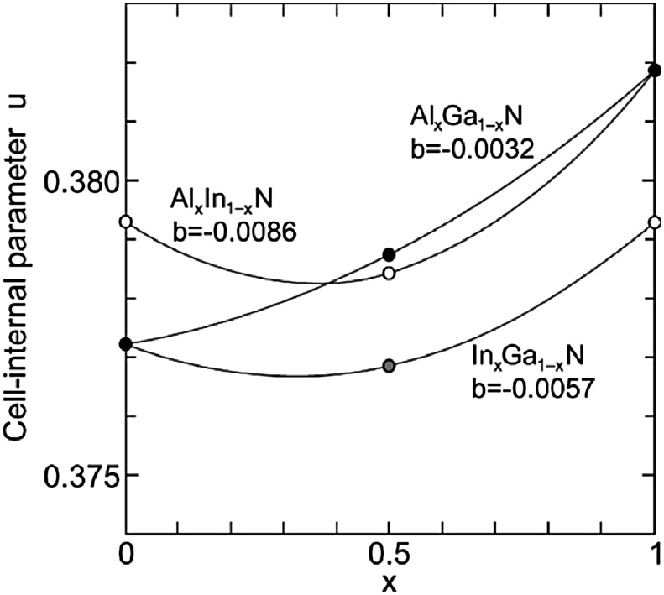

Fig. 3.45

Theoretical values (

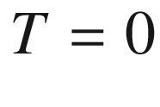

 K) for the cell-internal parameter *u* as a function of the composition for group-III nitride alloys. The *solid lines* are quadratic curves (bowing parameter *b* is shown) through the points for

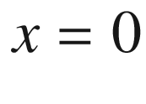

, 0.5, and 1.0. Data from [257]

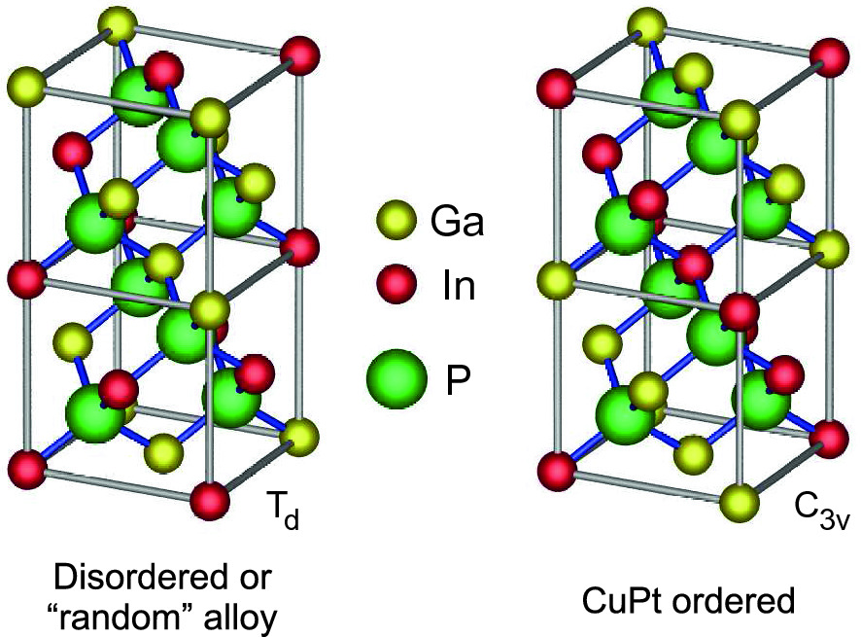

Fig. 3.46

CuPt-ordered ternary alloy In

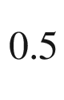

Ga

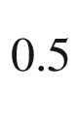

P; the lattice symmetry is reduced from

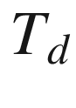

to

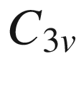

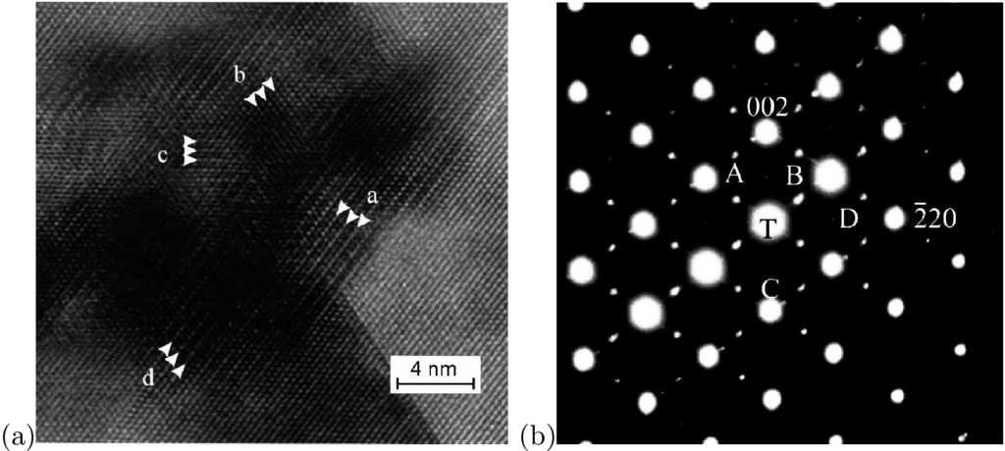

Fig. 3.47

(**a**) Cross-sectional transmission electron microscope image along the [110] zone axis of a Cd

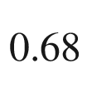

Zn

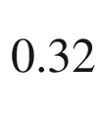

Te epilayer on GaAs showing ordered domains having a doublet periodicity on the

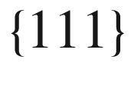

and

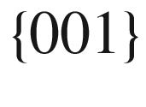

lattice planes. Two different

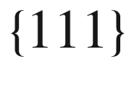

variants are labeled ‘a’ and ‘b’. The doublet periodicity in the [001] is seen in the ‘c’ region. (**b**) Selected-area diffraction pattern along the [110] zone. Strong peaks are fundamental peaks of the zincblende crystal, weak peaks are due to CuPt ordering, labeled A and B, and CuAu-I ordering, labeled C and D. The latter are the weakest due to a small volume fraction of CuAu-ordered domains. Adapted from [259]

While the average lattice parameter in alloys changes linearly with composition, the cell-internal parameter *u* (for wurtzite structures, see Sect. [3.4.5](#u116076_4_En_3_Chapter-Sec18)) exhibits a nonlinear behavior as shown in Fig. [3.45](#u116076_4_En_3_Chapter-Fig45). Therefore physical properties connected to *u*, such as the spontaneous polarization, will exhibit a bowing.

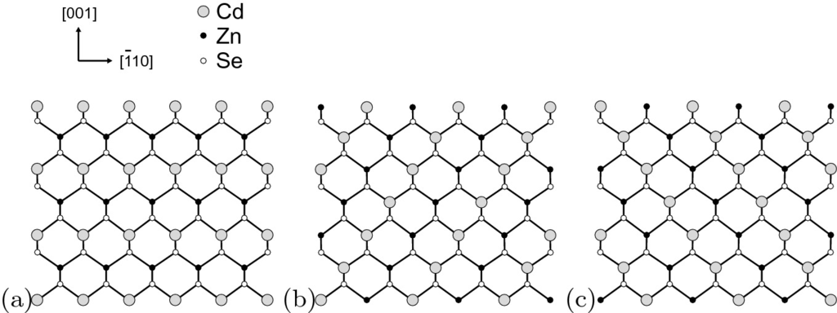

Fig. 3.48

Schematic diagrams of zincblende Cd



Zn



Te along [110] with (**a**) CuAu-I type ordering and (**b**, **c**) two types of the CuPt

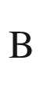

type ordering. Doublet periodicity is along (**a**) [001] and

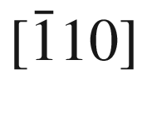

, (**b**)

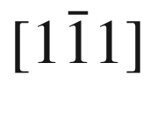

and (**c**)

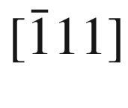

. Adapted from [259]

#### 3.7.5 Ordering

Some alloys have the tendency for the formation of a superstructure [258]. Growth kinetics at the surface can lead to specific adatom incorporation leading to ordering. For example, in In

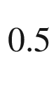

Ga

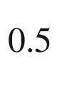

P the In and Ga atoms can be ordered in subsequent (111) planes (CuPt structure) instead of being randomly mixed (Fig. [3.46](#u116076_4_En_3_Chapter-Fig46)). This impacts fundamental properties such as the phonon spectrum or the band gap. CuPt ordering on (111) and

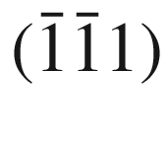

planes is called CuPt

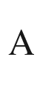

, on

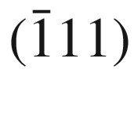

and

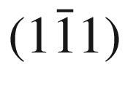

planes CuPt

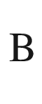

ordering. In Fig. [3.47](#u116076_4_En_3_Chapter-Fig47), a TEM image of a Cd

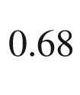

Zn

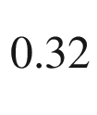

Te epilayer is shown with simultaneous ordering in the CuPt structure (doublet periodicity along

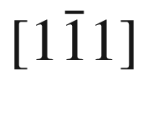

and

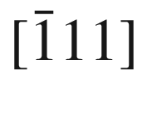

) and in the CuAu-I structure[7](#u116076_4_En_3_Chapter-Fn7) (doublet periodicity along [001] and

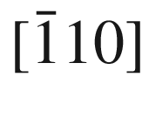

).

Footnotes

[1](The_Physics_of_Semiconductors00001.docx#u116076_4_En_3_Chapter-Fn1_source)

The hcp structure is not a Bravais lattice since the individual lattice sites are not completely equivalent.

[2](#u116076_4_En_3_Chapter-Fn2_source)

5-fold periodic symmetry is geometrically impossible. However, *quasicrystals* with aperiodic five-fold symmetry exist [191, 192], some of them possibly being semiconducting [193, 194].

[3](#u116076_4_En_3_Chapter-Fn3_source)

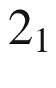

,

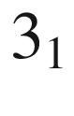

,

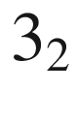

,

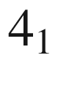

,



,

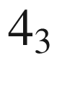

,

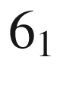

,

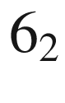

,

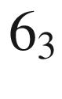

,

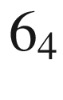

,

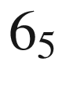

.

[4](#u116076_4_En_3_Chapter-Fn4_source)

One should in particular consider the pitfalls pointed out in Appendix 10 of this reference.

[5](#u116076_4_En_3_Chapter-Fn5_source)

Zincblende technically means the material ZnS which occurs in sphalerite (cubic) and wurtzite (hexagonal) phase. However, in the literature the term ‘zincblende’ for the sphalerite structure is common and used throughout this book.

[6](#u116076_4_En_3_Chapter-Fn6_source)

The dot product

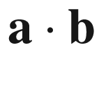

of two vectors shall also be denoted as

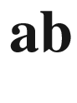

.

[7](#u116076_4_En_3_Chapter-Fn7_source)

The CuAu-I structure has tetragonal symmetry. There exists also the CuAu-II structure that is orthorhombic.

© Springer Nature Switzerland AG 2021

M. Grundmann

The Physics of Semiconductors

Graduate Texts in Physics

<https://doi.org/10.1007/978-3-030-51569-0_4>

## 4. Structural Defects

Marius Grundmann[1](#u116076_4_En_4_Chapter-Aff11)

(1)

Felix Bloch Institute for Solid State Physics, Universität Leipzig, Leipzig, Germany

Marius Grundmann

Email:

[grundmann@physik.uni-leipzig.de](mailto:grundmann@physik.uni-leipzig.de)

*Crystals are like people: it is the defects in them which tend to make them interesting!*

*C.J. Humphreys, 1979* [260]

## Abstract

No crystal is perfect. Various point defects and their thermodynamics, diffusion and distribution of defects are discussed. Also dislocations and extended defects such as cracks, stacking faults, grain boundaries and antiphase domains are covered.

### 4.1 Introduction

In an ideal lattice each atom is at its designated position. Deviations from the ideal structure are called defects. In the following, we will briefly discuss the most common defects. The electrical activity of defects will be discussed in Sects. [7.​5](The_Physics_of_Semiconductors00003.docx#u116076_4_En_7_Chapter) and [7.​7](The_Physics_of_Semiconductors00003.docx#u116076_4_En_7_Chapter). For the creation (formation) of a defect a certain free enthalpy

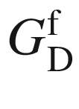

is necessary. At thermodynamical equilibrium a (point) defect density

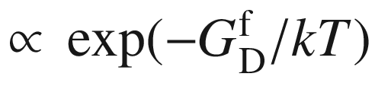

will always be present (cf. Sect. [4.​2.​2](#u116076_4_En_4_Chapter)).

Point defects (Sect. [4.​2](#u116076_4_En_4_Chapter)) are deviations from the ideal structure involving essentially only one lattice point. The formation energy for line defects (Sect. [4.​3](#u116076_4_En_4_Chapter)) or area defects (Sect. [4.​4](#u116076_4_En_4_Chapter))  scales with

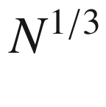

and

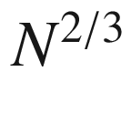

, respectively, *N* being the number of atoms in the crystal. Therefore, these defects are not expected in thermodynamic equilibrium. However, the path into thermodynamical equilibrium might be so slow that these defects are metastable and must be considered quasi-frozen. There may also exist metastable point defects. By annealing the crystal, the thermodynamic equilibrium concentration might be re-established. The unavoidable two-dimensional defect of the bulk structure is the surface, discussed in Chap. [11](The_Physics_of_Semiconductors00005.docx#u116076_4_En_11_Chapter).

### 4.2 Point Defects

#### 4.2.1 Point Defect Types

The simplest point defect is a vacancy V, a missing atom at a given atomic position. If an atom is at a position that does not belong to the crystal structure an interstitial I (or Frenkel defect)  is formed. Depending on the position of the interstitial different types are distinguished. An interstitial atom that has the same chemical species as the crystal is called ‘self-interstitial’.

If an atom site is populated with an atom of different order number *Z*, an impurity is present. An impurity can also sit on interstitial position. If the number of valence electrons is the same as for the original (or correct) atom, then it is an isovalent impurity and quasi fits into the bonding scheme. If the valence is different, the impurity adds extra (negative or positive) charge to the crystal bonds, which is compensated by the extra, locally fixed charge in the nucleus. This mechanism will be discussed in detail in the context of doping (Chap. [7](The_Physics_of_Semiconductors00003.docx#u116076_4_En_7_Chapter)). If in an *AB* compound an *A* atom sits on the *B* site, the defect is called an antisite defect

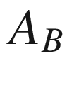

.

A Ga vacancy, a silicon impurity atom on Ga- and As-site and a Si

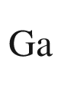

-vacancy complex at the (110) surface of Si doped GaAs are shown in Fig. [4.​1](#u116076_4_En_4_Chapter-Fig1) as observed with STM [261, 262]. Also antisite defects in GaAs can be observed with STM [263, 264].

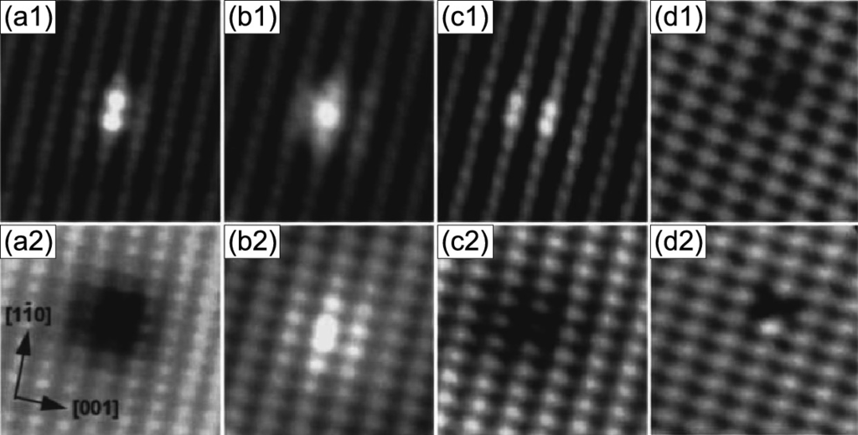

Fig. 4.1

Images of occupied (*upper frames*) and empty (*lower frames*) density of states of typical defects on Si-doped GaAs (110) surfaces. (**a1**, **a2**) show a Ga vacancy, (**b1**, **b2**) a Si

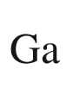

donor, (**c1**, **c2**) a Si

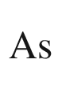

acceptor and (**d1**, **d2**) a Si

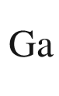

–V

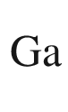

complex.

Adapted from [261]

A point defect is typically accompanied by a relaxation of the surrounding host atoms. As an example, we discuss the vacancy in Si (Fig. [4.​2](#u116076_4_En_4_Chapter-Fig2)a). The missing atom leads to a lattice relaxation with the next neighbors moving some way into the void (Fig. [4.​2](#u116076_4_En_4_Chapter-Fig2)b). The bond lengths of the next and second-next neighbor Si atoms around the neutral vacancy are shown in Fig. [4.​2](#u116076_4_En_4_Chapter-Fig2)c. The lattice relaxation depends on the charge state of the point defect (Jahn–Teller effect) which is discussed in more detail in Sect. [7.​7](The_Physics_of_Semiconductors00003.docx#u116076_4_En_7_Chapter). In Fig. [4.​2](#u116076_4_En_4_Chapter-Fig2)d the situation for the positively charged vacancy with one electron missing is shown. One of the two bonds is weakened since it lacks an electron. The distortion is therefore different from that for

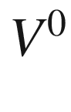

. Also the (self-)interstitial is accompanied with a lattice relaxation as shown in Fig. [4.​3](#u116076_4_En_4_Chapter-Fig3) for a silicon interstitial at tetrahedral place. Self-interstitials in silicon and germanium are reviewed and compared in [265] for their various charge states.

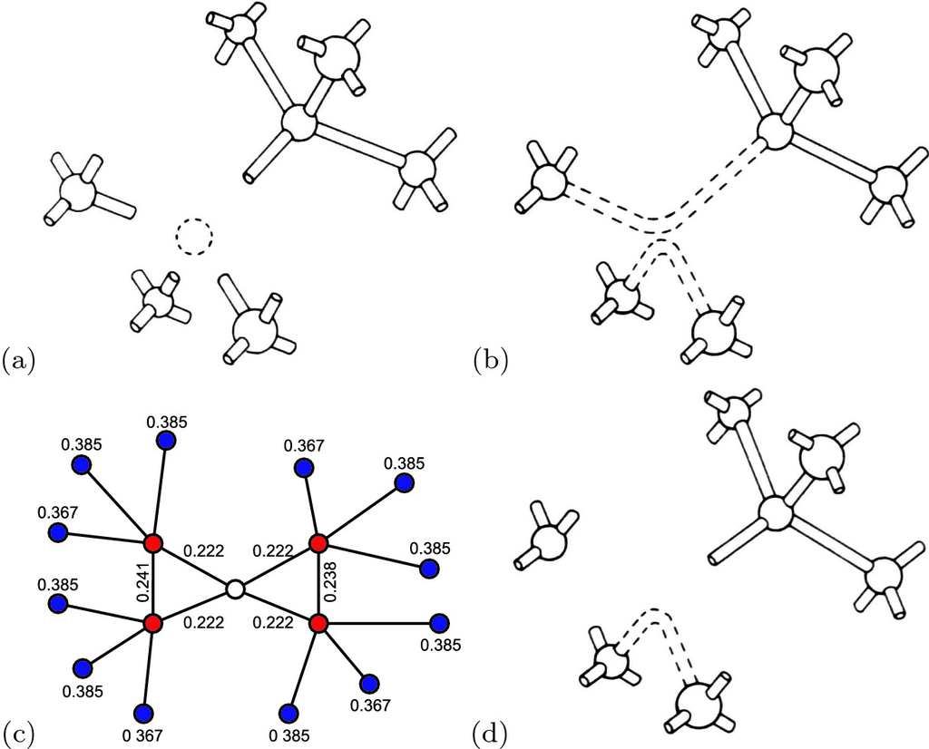

Fig. 4.2

(**a**) Schematic diamond lattice with vacancy, i.e. a missing Si atom without relaxation. (**b**) Si with neutral vacancy (

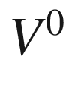

), lattice relaxation and formation of two new bonds. (**c**) Schematic diagram showing the (inward) relaxation of the neighbors around the neutral Si vacancy defect site (*empty circle*) calculated by an ab initio method. The distances of the outer shell of atoms (*red circles*) from the vacant site is labeled (in nm). The bond lengths of the two new bonds and the second-neighbor (*blue circles*) distance are also indicated. The bond length in bulk Si is 0.2352 nm, the second-neighbor distance 0.3840 nm. Adapted from [266]. (**d**) Si unit cell with positively charged vacancy (

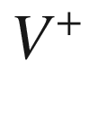

).

Parts (**a**, **b**, **d**) reprinted with permission from [267]

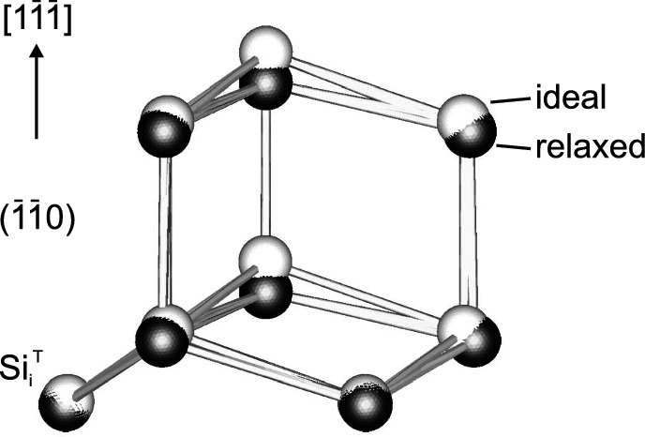

Fig. 4.3

Silicon tetrahedral interstitial Si

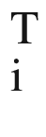

and its next atoms in ideal (*white spheres*) and relaxed (*black spheres*) position.

Adapted from [175]

#### 4.2.2 Thermodynamics

For a given temperature, the free enthalpy *G* of a crystal (a closed system with regard to particle exchange)

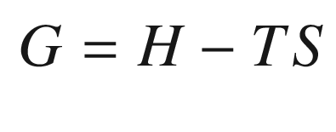

(4.1)

is minimum. *H* is the enthalpy and *S* the entropy. The enthalpy

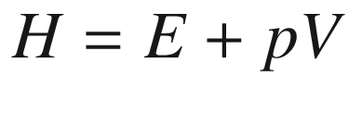

is the thermodynamic potential for a system whose only external parameter is the volume *V*. It is used when the independent variables of the system are the entropy *S* and pressure *p*. The free enthalpy is used when the independent parameters are *T* and *p*.

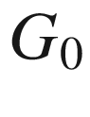

(

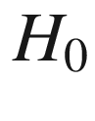

) is the free energy (enthalpy) of the perfect crystal.

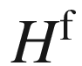

is the formation enthalpy of an isolated defect. This could be, e.g., the enthalpy of a vacancy, created by bringing an atom from the (later) vacancy site to the surface, or an interstitial, created by bringing an atom from the surface to the interstitial site. In the limit that the *n* defects do not interact with each other, i.e. their concentration is sufficiently small, they can be considered independent and the enthalpy is given by

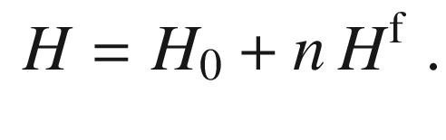

(4.2)

The increase of entropy due to increased disorder is split into the configurational disorder over the possible sites, denoted as

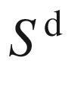

, and the formation entropy

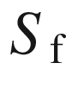

 due to localized vibrational modes. The total change

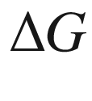

of the free energy is

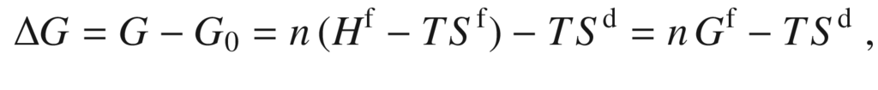

(4.3)

where

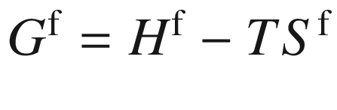

denotes the free enthalpy of formation of a single isolated defect. In Table [4.​1](#u116076_4_En_4_Chapter-Tab1) experimental values for the formation entropy and enthalpy are given for several defects. Surprisingly, despite their fundamental importance in semiconductor defect physics, these numbers are not very well known and disputed in the literature.

The defect concentration is obtained by minimizing

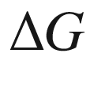

, i.e.

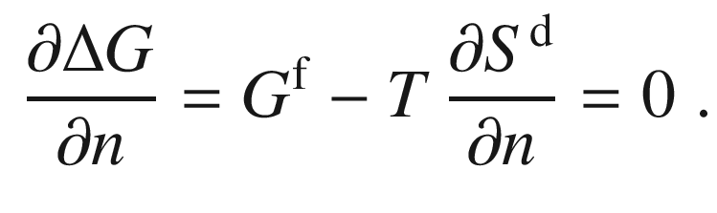

(4.4)

Table 4.1

Formation enthalpy



and entropy

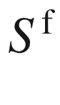

of the interstitial (*I*) and vacancy (*V*) in Si and the Ga vacancy in GaAs. Data for Si from [268, 269], for GaAs from [270]

| Material | Defect | $$H^{\mathrm {f}}$$   (eV) | $$S^{\mathrm {f}}$$   (  $$k_{\mathrm {B}}$$  ) |
| --- | --- | --- | --- |
| Si | *I* | 3.2 | 4.1 |
| Si | *V* | 2.8 | $$\sim 1$$ |
| GaAs | $$V_{\mathrm {Ga}}$$ | 3.2 | 9.6 |

The entropy

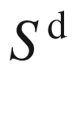

due to disorder is given as

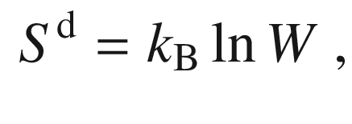

(4.5)

where *W* is the complexion number, usually the number of distinguishable ways to distribute *n* defects on *N* lattice sites

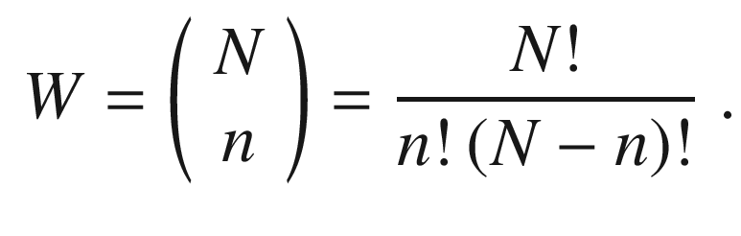

(4.6)

With Stirling’s formula

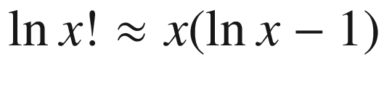

 for large *x* we obtain

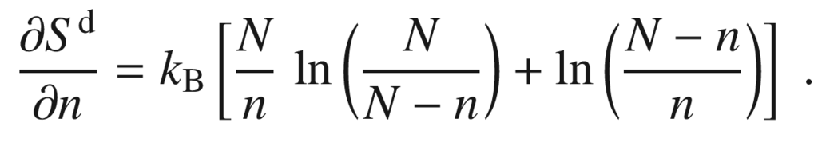

(4.7)

If

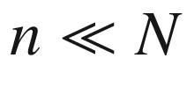

,

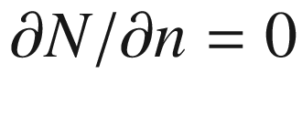

and the right side of ([4.​7](#u116076_4_En_4_Chapter)) reduces to

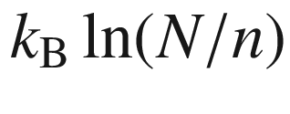

. The condition ([4.​4](#u116076_4_En_4_Chapter)) reads

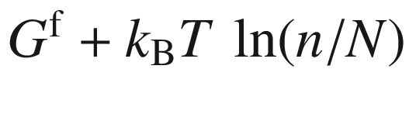

, or

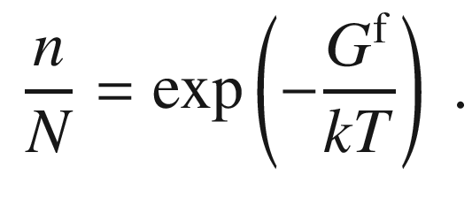

(4.8)

In the case of several different defects *i* with a degeneracy

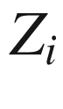

, e.g. a spin degree of freedom or several equivalent configurations, ([4.​8](#u116076_4_En_4_Chapter)) can be generalized to

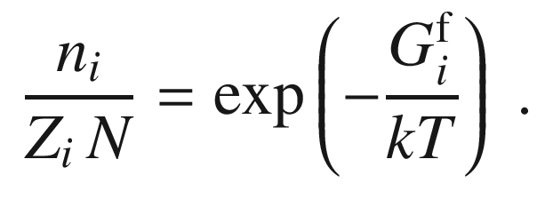

(4.9)

In [271] the equilibrium concentration of interstitials

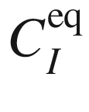

in silicon has been given as

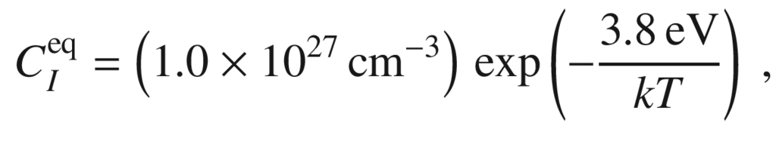

(4.10)

about

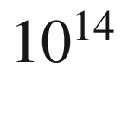

 cm

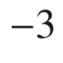

at 1200

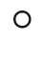

C. The vacancy concentration has been investigated in [272]. Around a temperature of 1200

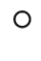

C it is in the

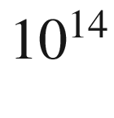

–

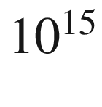

 cm

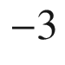

range. Due to the reaction

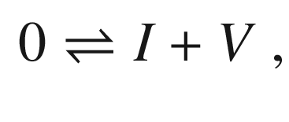

(4.11)

a mass action law holds for the concentrations of interstitials and vacancies

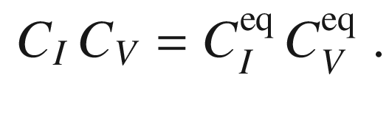

(4.12)

#### 4.2.3 Diffusion

The diffusion of point defects is technologically very important, in particular for silicon as host material. Typically a dopant profile should be stable under following technological processing steps and also during device performance. Also defect annihilation is crucial after implantation processes. Diffusion of an interstitial *I* and a vacancy *V* to the same site is prerequisite for recombination of defects (so called *bulk process*) according to the scheme

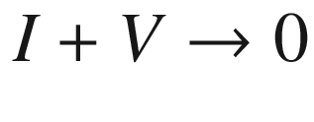

. We note that the process

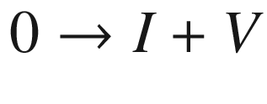

is called *Frenkel pair process*.[1](#u116076_4_En_4_Chapter-Fn1) Also the self-diffusion of silicon has been studied, e.g. using radioactively marked isotopes [271]. The diffusion of point defects including dopants in silicon has been reviewed in [273, 274]. Usually Fick’s law is applied, stating how the flux *J* depends on the concentration gradient, for an interstitial it reads:

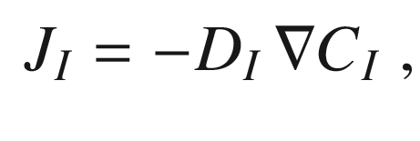

(4.13)

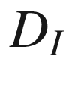

being the interstitial diffusion coefficient. For interstitials in Si it was found [271] that

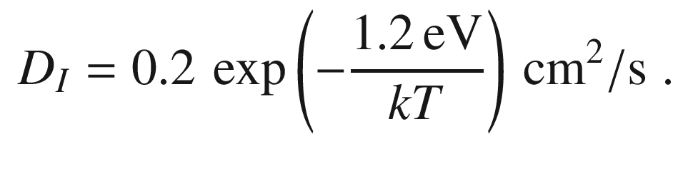

(4.14)

The diffusion of neutral vacancies occurs with [275]

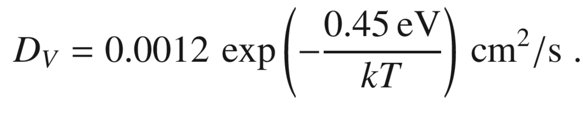

(4.15)

The temperature dependent diffusion coefficients of point defects and dopants in silicon are shown in Fig. [4.​4](#u116076_4_En_4_Chapter-Fig4).

The self-diffusion coefficient of silicon has been determined from the annealing of isotope superlattices (Sect. [12.​5](The_Physics_of_Semiconductors00005.docx#u116076_4_En_12_Chapter)) of sequence

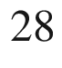

Si



/

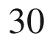

Si



,

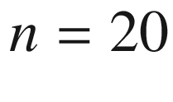

to be [276]

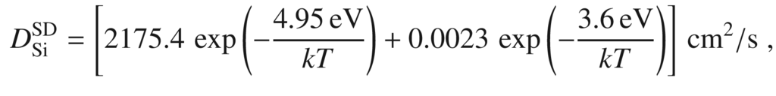

(4.16)

the first (second) term being due to interstitial (vacancy) mechanism, dominant for temperatures larger (smaller) than 900

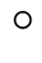

C. The enthalpy in the exponent, e.g.

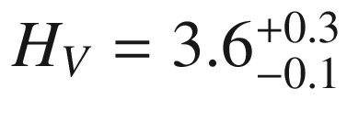

 eV [276], consists of the formation and migration enthalpies,

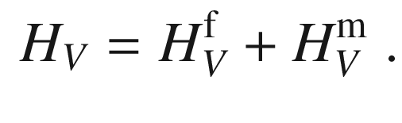

(4.17)

Using the experimental value

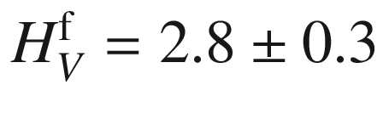

 eV [269] from Table [4.​1](#u116076_4_En_4_Chapter-Tab1), for the migration enthalpy a value around

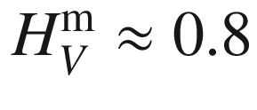

 eV is obtained.

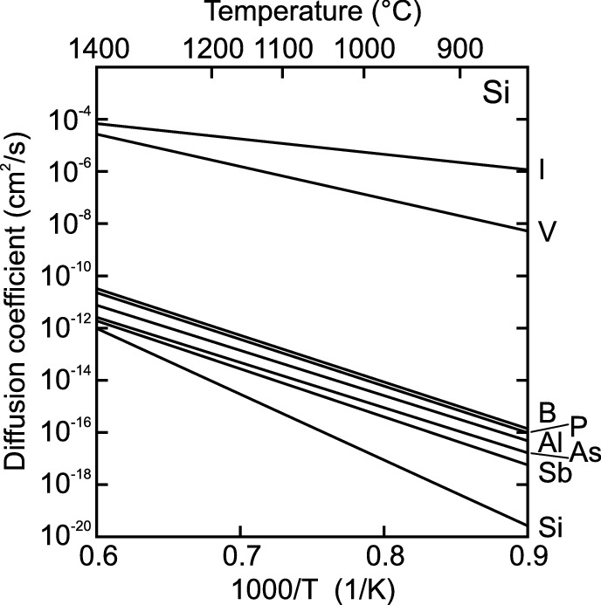

Fig. 4.4

The temperature dependent diffusion coefficient of Si interstitials *I*, vacancies *V* and various impurities in silicon. Also the self-diffusion coefficient, labeled with ‘Si’ is shown.

Based on data from [273]

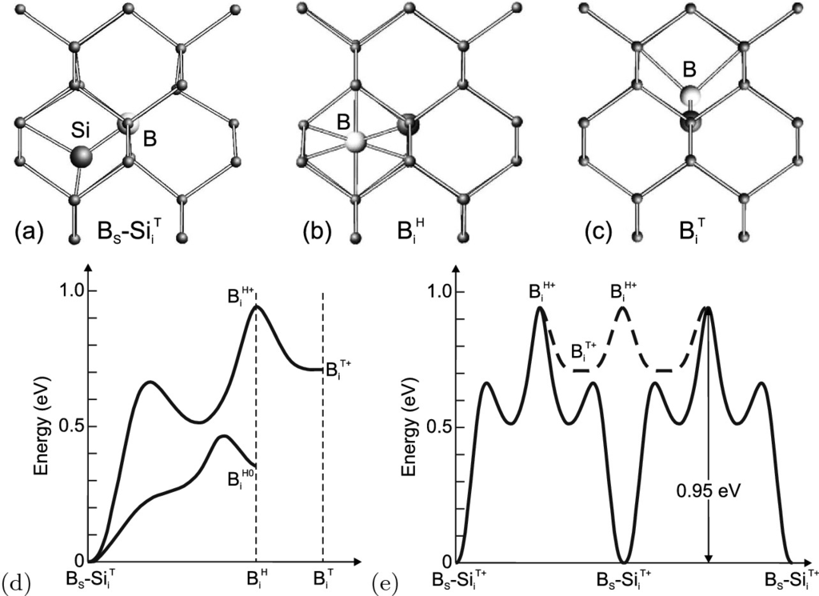

Fig. 4.5

Configurations of boron in Si: (**a**) Substitutional boron and Si self-interstitial at ‘T’ site (B

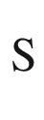

–Si

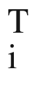

). Interstitial boron at (**b**) ‘H’ (B

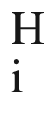

) and (**c**) ‘T’ site (B

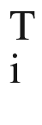

), each with the Si atoms on the Si lattice sites. The *large bright ball* represents the boron atom, *large* and *small dark balls* represent Si atoms. (**d**) Lowest energy barrier diffusion paths for positively charged and neutral B–Si states, total energy vs. configuration. (**e**) Two diffusion pathways for positively charged B–Si, kick-out (*dashed line*) and pair diffusion (*solid line*); the activation energy is labeled.

Adapted from [279]

As an example for a dopant diffusion process that has been understood microscopically, we discuss here boron in silicon. In Fig. [4.​5](#u116076_4_En_4_Chapter-Fig5)a the lowest-energy configuration of a boron-related defect in silicon is depicted, B



–Si

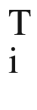

, i.e. boron on a substitutional site and a self-interstitial Si on the ‘T’ place with highest symmetry[2](#u116076_4_En_4_Chapter-Fn2) (see Fig. [3.​18](#u116076_4_En_3_Chapter-Fig18)). Due to its importance as an acceptor in Si, the configuration and diffusion of B in Si has found great interest [277–279]. The diffusion depends on the charge state of boron. The diffusion of positively charged boron has been suggested [279] to occur via the following route: The boron leaves its substitutional site and goes to the hexagonal site (‘H’) (Fig. [4.​5](#u116076_4_En_4_Chapter-Fig5)b) with an activation energy of about 1 eV (Fig. [4.​5](#u116076_4_En_4_Chapter-Fig5)d). It can then relax (

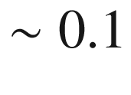

 eV) without barrier to the tetrahedral ‘T’ position (Fig. [4.​5](#u116076_4_En_4_Chapter-Fig5)c). The direct migration B



–Si

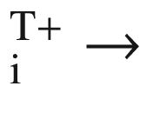

B

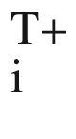

has a higher activation energy of 1.12 eV and is thus unlikely. The boron atom can then diffuse through the crystal by going from ‘H’ to ‘T’ to ‘H’ and so on (Fig. [4.​5](#u116076_4_En_4_Chapter-Fig5)e). However, long-range diffusion seems to be not possible in this way because the kick-in mechanism will bring back the boron to its stable configuration. The pair diffusion mechanism  for neutral boron B



–Si

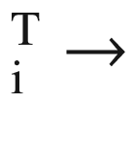

B

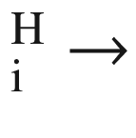

B



–Si



via the hexagonal site has an activation energy of about 0.5 eV (Fig. [4.​5](#u116076_4_En_4_Chapter-Fig5)d) while the path via B



has a larger 0.9 eV barrier. The concentration dependence of the diffusion mechanism has been discussed in [280].

Similarly, indium diffusion in silicon has been investigated suggesting a minimum energy In



–Si

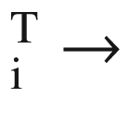

In



In



–Si



diffusion pathway via the tetrahedral site with 0.8 eV activation energy [281]. Microscopic modeling has been reported also for diffusion of phosphorus [282].

#### 4.2.4 Dopant Distribution

The introduction of impurities into a semiconductor (or other materials such as glasses) is termed *doping*. The unavoidable incorporation of impurities in the nominally pure (nominally undoped) material is called *unintentional* doping and leads to a residual or background impurity concentration. Several methods are used for doping and the creation of particular doping profiles (in depth or lateral). All doping profiles underly subsequent diffusion of dopants (Sect. [4.​2.​3](#u116076_4_En_4_Chapter)).

Various methods of doping are used. A straightforward method of doping is the incorporation during crystal growth or epitaxy. For semiconductor wafers a homogeneous doping concentration is targeted, both laterally and along the rod from which the wafer is cut (Sect. [12.​2.​2](The_Physics_of_Semiconductors00005.docx#u116076_4_En_12_Chapter)). When a crystal is grown from melt, containing a concentration

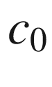

of the impurity, the concentration in the solid is given by (‘normal freezing’ case [283–285])[3](#u116076_4_En_4_Chapter-Fn3)

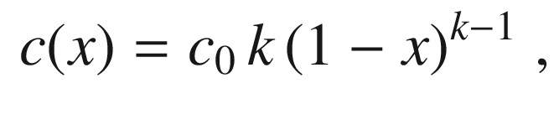

(4.18)

where *c*(*x*) is the impurity concentration in the crystal at the freezing interface, *x* is the frozen melt fraction (ratio of solid mass to total mass,

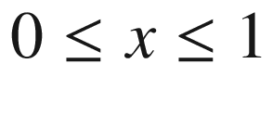

). *k* is the *distribution coefficient* (or segregation coefficient)  which is the fraction of impurities that is built into the crystal at the liquid–solid interface. Since the melt volume reduces during the solidification, the impurity concentration rises over time. For small distribution coefficients ([4.​18](#u116076_4_En_4_Chapter)) can be approximated to

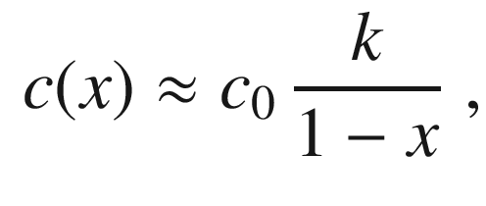

(4.19)

An experimental example for Ge:In is shown in Fig. [4.​6](#u116076_4_En_4_Chapter-Fig6)a.

In Table [4.​2](#u116076_4_En_4_Chapter-Tab2) the distribution coefficients for various impurities in Si, Ge and GaAs is given. The modification of distribution coefficients in SiGe alloys is discussed in [286]. Equilibrium values (

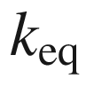

) are obtained for ‘slow’ crystal growth. For finite growth rates, *k* becomes a function of the growth rate and is then called the *effective* distribution coefficient. For

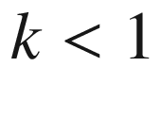

,

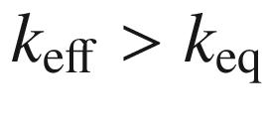

.

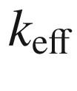

approaches 1 for high growth rates, i.e. all impurities at the rapidly moving interface are incorporated.

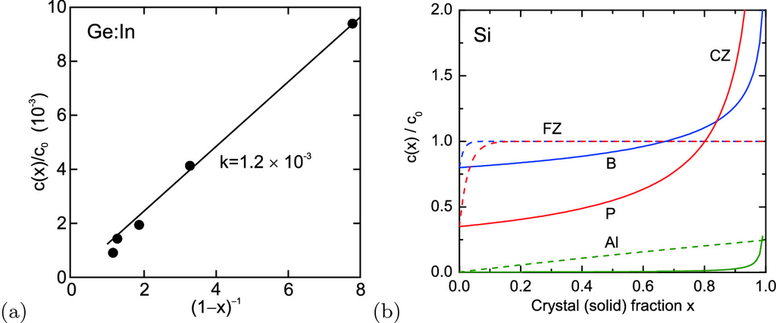

Fig. 4.6

(**a**) Relative concentration of indium along a CZ-grown germanium crystal. Absolute concentration is in the

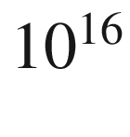

 cm



range. *Solid line* follows ([4.​19](#u116076_4_En_4_Chapter)) with

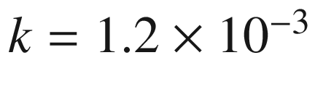

. *Symbols* are experimental data from [288]. (**b**) Impurity distribution (relative concentration

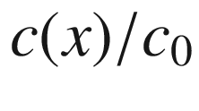

) for CZ ([4.​18](#u116076_4_En_4_Chapter)) (*solid lines*) and FZ ([4.​20](#u116076_4_En_4_Chapter)) (*dashed lines*,

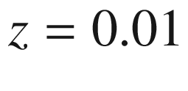

) silicon crystals for B (*blue*), P (*red*), and Al (*green*). Distribution coefficients have been taken from Table [4.​2](#u116076_4_En_4_Chapter-Tab2). Note crossing of B and P lines and possibly associated change from p-type to n-type (cmp. Fig. [1.​7](The_Physics_of_Semiconductors00001.docx#u116076_4_En_1_Chapter-Fig7))

Table 4.2

Equilibrium distribution coefficients (at melting point) of various impurities in silicon, germanium and GaAs. Data for Si from [285, 287], for Ge from [164, 288–290] and for GaAs from [164]

| Impurity | Si | Ge | GaAs |
| --- | --- | --- | --- |
| C | 0.07 | $$&gt;1.85$$ | 0.8 |
| Si |  | 5.5 | 0.1 |
| Ge | 0.33 |  | 0.03 |
| N | $$7 \times 10^{-4}$$ |  |  |
| O | $$\approx 1$$ |  | 0.3 |
| B | 0.8 | 12.2 |  |
| Al | $$2.8 \times 10^{-3}$$ | 0.1 | 3 |
| Ga | $$8 \times 10^{-3}$$ | 0.087 |  |
| In | $$4 \times 10^{-4}$$ | $$1.2 \times 10^{-3}$$ | 0.1 |
| P | 0.35 | 0.12 | 2 |
| As | 0.3 | 0.04 |  |
| Sb | 0.023 | $$3.3 \times 10^{-3}$$ | $$&lt;0.02$$ |
| S | $$10^{-5}$$ | $$&gt; 5 \times 10^{-5}$$ | 0.3 |
| Fe | $$6.4 \times 10^{-6}$$ | $$3 \times 10^{-5}$$ | $$2 \times 10^{-3}$$ |
| Ni | $$\approx 3 \times 10^{-5}$$ | $$2.3 \times 10^{-6}$$ | $$6 \times 10^{-4}$$ |
| Cu | $$8 \times 10^{-4}$$ | $$1.3 \times 10^{-5}$$ | $$2 \times 10^{-3}$$ |
| Ag | $$\approx 1 \times 10^{-6}$$ | $$10^{-4}$$ | 0.1 |
| Au | $$2.5 \times 10^{-5}$$ | $$1.5 \times 10^{-5}$$ |  |
| Zn | $$2.5 \times 10^{-5}$$ | $$6 \times 10^{-4}$$ | 0.1 |

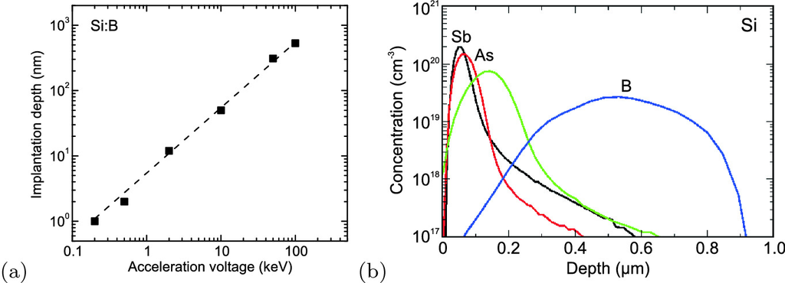

Fig. 4.7

(**a**) Depth of peak concentration of boron implanted in silicon for various acceleration voltages *U*. Data from various sources, for

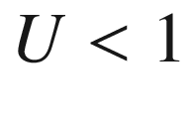

 keV from [299]. *Dashed line* is linear dependence. (**b**) Simulated depth profiles of impurity concentration for B, P, As, and Sb implanted into crystalline silicon with

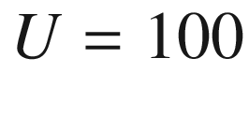

 keV and a dose of



 cm

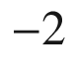

.

Adapted from [300]

Equation ([4.​18](#u116076_4_En_4_Chapter)) applies to Czrochalski growth where the crystal is pulled out of the melt [291]. In float-zone (FZ) growth [291] a polycrystalline rod is transformed into a crystalline one while a RF-heated and liquid ‘float’ zone is moved through the crystal. In this case the impurity distribution is given by[4](#u116076_4_En_4_Chapter-Fn4)

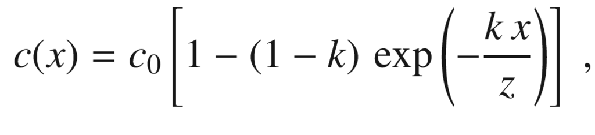

(4.20)

where *x* is the ratio of the crystal mass to the total mass, i.e. crystal, liquid and feed rod. *z* is the relative mass of the (liquid) float zone, i.e. the ratio of liquid mass to the total mass. The impurity distribution for CZ and FZ crystals is compared in Fig. [4.​6](#u116076_4_En_4_Chapter-Fig6)b. Obviously the FZ process can create much more homogeneous profiles.[5](#u116076_4_En_4_Chapter-Fn5)

Using epitaxy arbitrary doping profiles along the growth directions can be created by varying the impurity supply during growth. Impurities can be introduced through the surface of the material by diffusion from a solid or gas phase. In ion implantation [292] the impurity atoms are accelerated towards the semiconductor and deposited with a certain depth profile due to multiple scattering and energy loss events, depending on the acceleration voltage (increasing deposition depth with increasing voltage, Fig. [4.​7](#u116076_4_En_4_Chapter-Fig7)a) and ion mass (decreasing deposition depth with increasing mass, Fig. [4.​7](#u116076_4_En_4_Chapter-Fig7)b). The depth profile is often investigated using secondary ion mass spectrometry (SIMS) [293, 294]. The profile also depends on the matrix material whose stopping power depends on its density and atomic mass. While an implantation depth of about 50 nm is reached for boron in silicon (

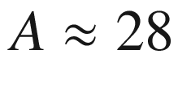

) for 10 keV, 20 keV are necessary in germanium (

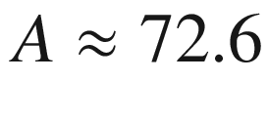

) [295]. The mean path length[6](#u116076_4_En_4_Chapter-Fn6)

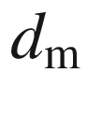

depends also on the crystallographic direction (channeling effects, Fig. [4.​8](#u116076_4_En_4_Chapter-Fig8)) [296]. A simulation of the interaction of ions and solids can be performed using the SRIM software [297, 298].

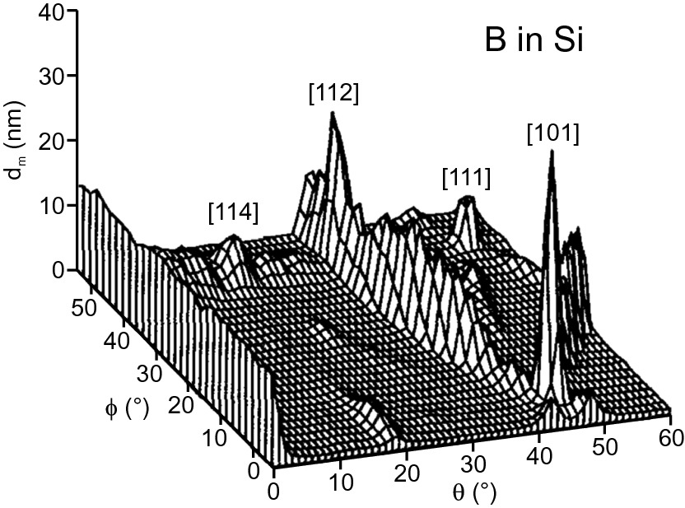

Fig. 4.8

Simulated mean path length as a function of implantation direction (azimuthal angle

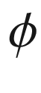

and polar angle

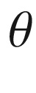

) near [001] for 5 keV boron in silicon. The [001] channeling peak appears as a ridge at the left side of the plot (

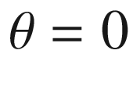

, any value of

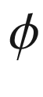

).

Adapted from [296]

#### 4.2.5 Large Concentration Effects

##### 4.2.5.1 Lattice Constant

At high doping concentration, a noticeable effect on the lattice constant

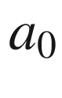

is found. For silicon the atom density[7](#u116076_4_En_4_Chapter-Fn7) is

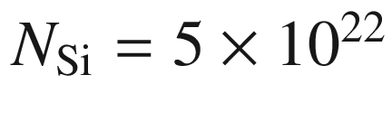

 cm



. A doping level of

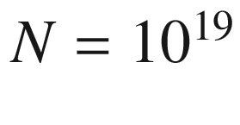

 cm

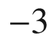

corresponds thus to a dopant fraction of 0.02%. Such crystal could also be considered a very dilute alloy. About each

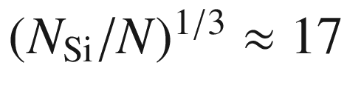

-th atom in a given direction is a dopant.

The effect of high doping on the lattice constant is due to different ionic radius of the dopant and the hydrostatic deformation potential of the band edge occupied by the free carriers [301]. In a linear approach, the effect is summarized in the coefficient

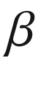

via

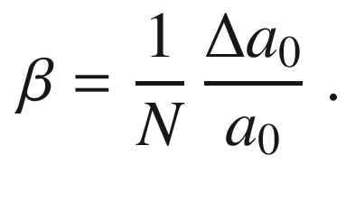

(4.21)

The effect due to charge carriers on

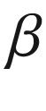

is negative (positive) for p-doping (n-doping). Experimental data for Si, Ge, GaAs and GaP are compiled in [302, 303] and theoretically discussed. The effect is in the order of

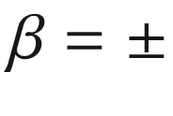

(1–10)

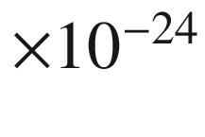

 cm

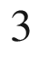

. For example, in the case of Si:B, the shrinkage of the lattice constant is mostly due to the charge carrier effect, for Si:P both effects almost cancel. In [304] it is shown that boron incorporation in silicon changes the lattice constant in various directions quite differently, e.g.

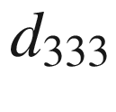

is shrunk by 0.4% for a doping level of

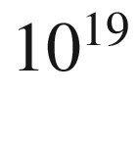

 cm



while the {620} lattice constant remains constant.

##### 4.2.5.2 Clustering

Point defects can cluster, i.e. several point defects aggregate at neighboring sites. An example the configuration of five nearby vacancies in silicon, the so-called V

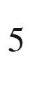

cluster is shown in Fig. [4.​9](#u116076_4_En_4_Chapter-Fig9)a. In [305] the ring-like hexavacancy in silicon is predicted a very stable defect. A large number of clustered vacancies is equivalent to a void. An example is depicted in Fig. [4.​9](#u116076_4_En_4_Chapter-Fig9)b for an In

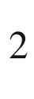

O

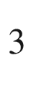

crystal which has locally ’decomposed’ into an indium particle and a void as revealed by TEM [306]. Also impurities can exhibit clustering.

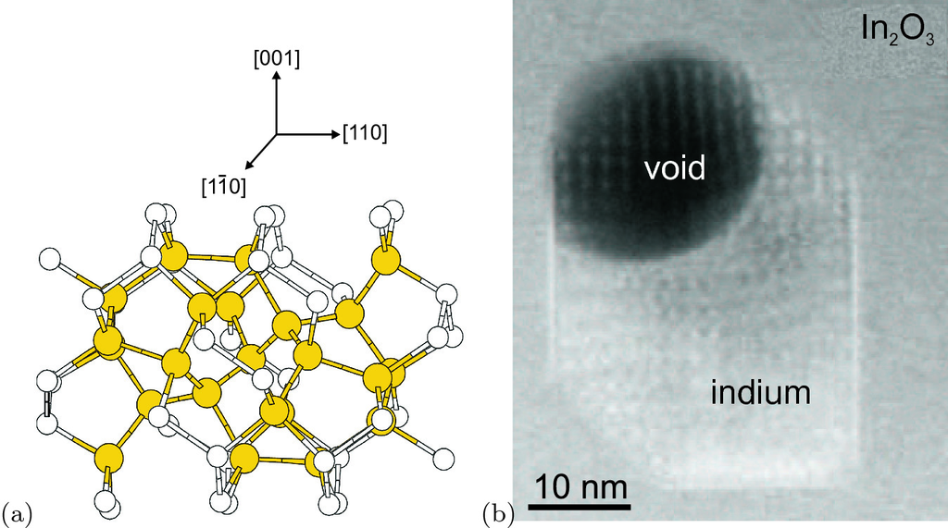

Fig. 4.9

(**a**) Predicted configuration of the V

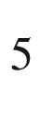

-cluster (five vacancies) in silicon. *Yellow spheres* indicate more distorted atoms than the rest of the lattice atoms (*white spheres*). Adapted from [307]. (**b**) Indium particle with adjacent void embedded in In

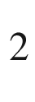

O

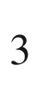

(STEM image revealing *Z*-contrast in [001]).

Adapted from [306]

Typically a random distribution of dopants in the host is assumed (cmp. Sect. [3.​7.​1](The_Physics_of_Semiconductors00001.docx#u116076_4_En_3_Chapter) on random alloys). The introduction of several impurities can lead to pairing effects, e.g. described for Se and B, Ga, Al or In in silicon [308]. A high concentration of a single impurity makes the existence of clusters, i.e. two or more neighboring dopant atoms, more probable. This effect has been extensively studied for B in Si [309], showing that several boron atoms with interstitials I form thermodynamically stable clusters, e.g. B



I

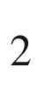

. This cluster forms from B



I and BI with only 0.2 eV activation barrier [310] as shown in Fig. [4.​10](#u116076_4_En_4_Chapter-Fig10). The formation is limited by diffusion of the smaller clusters to the same site. The number of free carriers (here holes) released from such cluster is smaller than the number of boron atoms since it forms a deep acceptor [309]. This autocompensation mechanism is thus limiting the maximum achievable free carrier concentration due to doping and is technologically unfavorable. Reactions between boron atoms and silicon self-interstitials often lead to boron clustering in the peak region of an implantation profile and require detailed optimization of the annealing process [311].

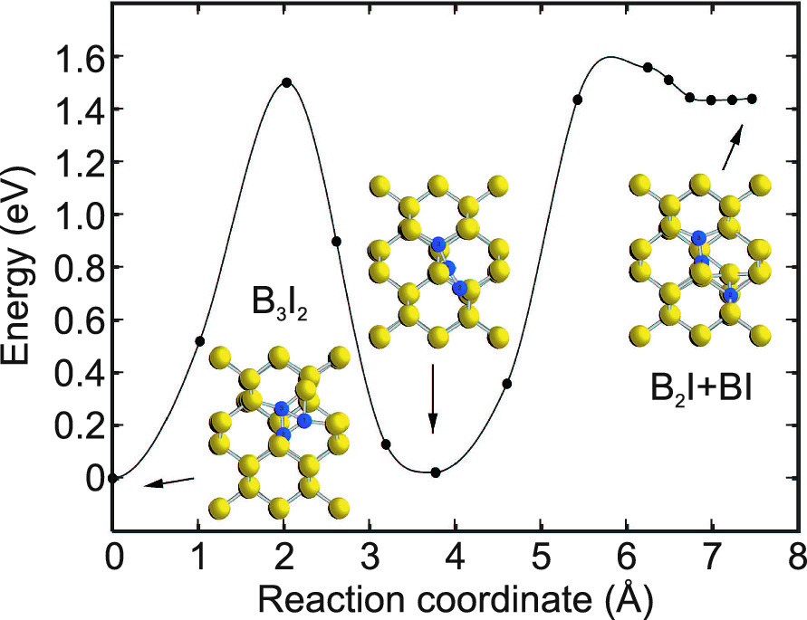

Fig. 4.10

Minimum energy path for the breakup of a B



I



cluster into B



I and BI. Silicon (boron) atoms are shown as *yellow* (*blue*) *spheres*.

Adapted from [310]

##### 4.2.5.3 Solubility Limit

The steady-state impurity solubility can be defined as the maximum concentration of impurity atoms in a crystal allowing thermodynamic balance between the crystal and another phase, e.g. a liquid phase, an extended defect or a precipitate. Precipitates are small inclusions of a second phase in a crystal, exhibiting a high concentration of ‘gathered’ impurities that cannot be solved in the crystal. Solubility limits for impurities in silicon have been first determined in [312] with a bulk of subsequent research [313] due to its practical relevance in device fabrication. The solubility limits for a few impurities in silicon are listed in Table [4.​3](#u116076_4_En_4_Chapter-Tab3). It is related to the ionization energy of the defect (cmp. Sect. [7.​4](The_Physics_of_Semiconductors00003.docx#u116076_4_En_7_Chapter)) as shown in Fig. [4.​11](#u116076_4_En_4_Chapter-Fig11).

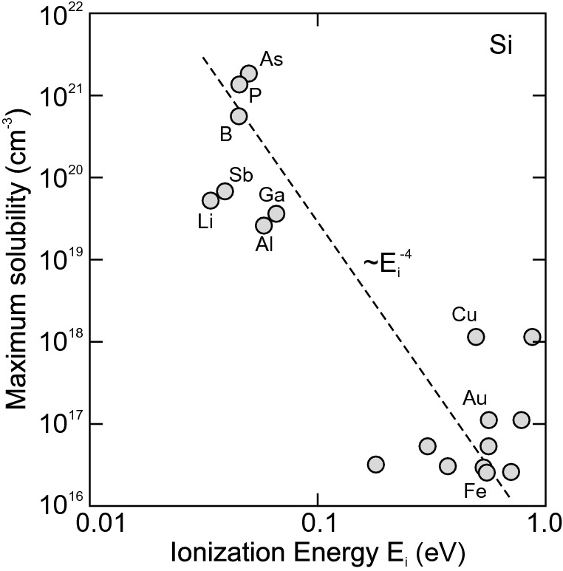

Fig. 4.11

Solubility limit for various impurities in silicon vs. their ionization energy.

Adapted from [314]

The temperature dependence of the solubility for a few dopants is depicted in Fig. [4.​12](#u116076_4_En_4_Chapter-Fig12)a. The solubility depends also on the present strain [315]. The simple empirical relation

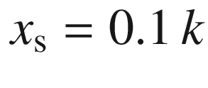

(Fig. [4.​12](#u116076_4_En_4_Chapter-Fig12)b) between the maximum molar solubility

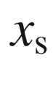

and the distribution coefficient *k* in silicon and germanium has been pointed out in [316].

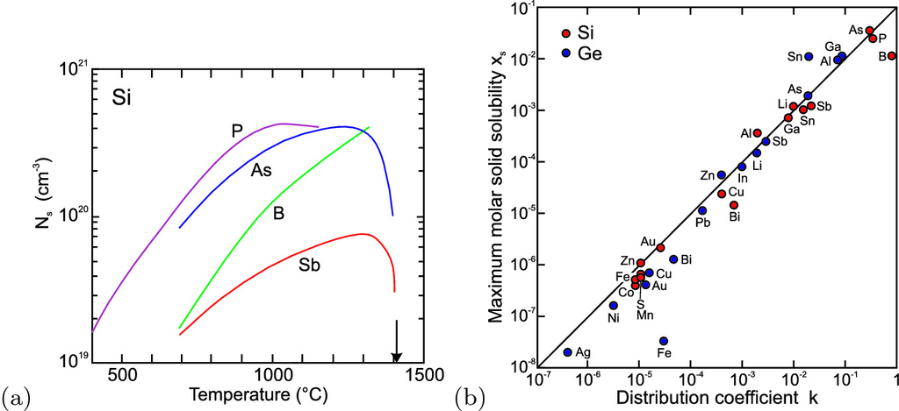

Fig. 4.12

**a** Steady-state solubility of impurities (P, As, B and Sb as labeled) in silicon. *Solid lines* are theoretical model matching various experimental data. *Arrow* denotes the melting point of silicon (1410



). Adapted from [313]. **b** Maximum molar solid solubility

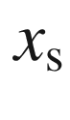

vs. the distribution coefficient for various impurities in crystalline silicon and germanium. *Solid line* follows

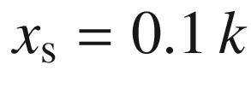

.

Adapted from [316]

Table 4.3

Maximum solubility

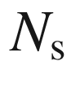

of some impurities in silicon. Data for B, P, As, Sb from [313], other data from [316]

| Impurity | $$N_{\mathrm {s}}$$  (  $$10^{20}$$   cm  $$^{-3}$$  ) |
| --- | --- |
| B | 4 |
| P | 5 |
| As | 4 |
| Sb | 0.7 |
| Al | 0.13 |
| Cu | $$1.4 \times 10^{-2}$$ |
| Au | $$1.2 \times 10^{-3}$$ |
| Fe | $$3 \times 10^{-4}$$ |

A typical example for the formation of precipitates is Fe in InP, used for compensation of shallow donors in order to produce semi-insulating material (Sect. [7.​7.​8](The_Physics_of_Semiconductors00003.docx#u116076_4_En_7_Chapter)). The solubility of Fe in InP is fairly low, about

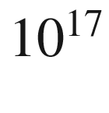

 cm



at growth temperature [317]. In Fig. [4.​13](#u116076_4_En_4_Chapter-Fig13) a high-resolution TEM image of a precipitate in InP doped with

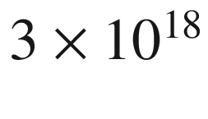

 cm



Fe is shown. The precipitate exhibits a lattice constant of

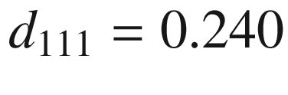

 nm in [111]-direction, much different from that of InP (

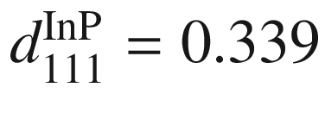

 nm). The angle between the [101] and [111] direction is 50

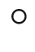

instead of 35



for InP. This is consistent with orthorhombic FeP [318]. Typically FeP and FeP



precipitates are found in highly Fe-doped InP [319].

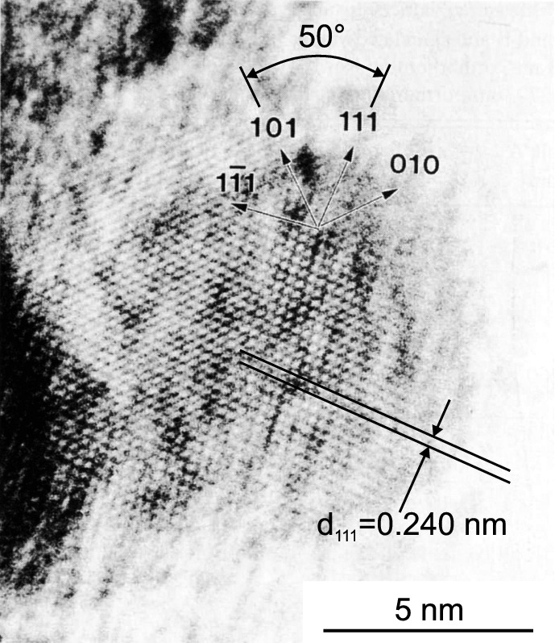

Fig. 4.13

High resolution TEM image of a FeP precipitate in iron-doped InP.

Adapted from [318]

### 4.3 Dislocations

Dislocations are line defects along which the crystal lattice is shifted by a certain amount. The vector along the dislocation line is called line vector



. A closed path around the dislocation core differs from that in an ideal crystal. The difference vector is called the Burger’s vector

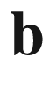

. Dislocations for which the Burger’s vector is a vector of the lattice are called *full* dislocations. In contrast, dislocations with Burger’s vectors that are not translation vectors of the lattice are called *partial* dislocations. The history of dislocation theory is described in [320].

Since the energy of a dislocation is proportional to

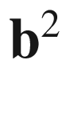

, only dislocations with the shortest Burger’s vector are stable. The plane spanned by



and

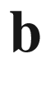

is called the *glide* plane. In Fig. [4.​14](#u116076_4_En_4_Chapter-Fig14) a high-resolution image of the atoms around a dislocation and the phase and amplitude of the (111) reflection are shown. The phase corresponds to the atomic columns, the amplitude to the displacement of the atoms at the dislocation core (see also Fig. [4.​14](#u116076_4_En_4_Chapter-Fig14)).

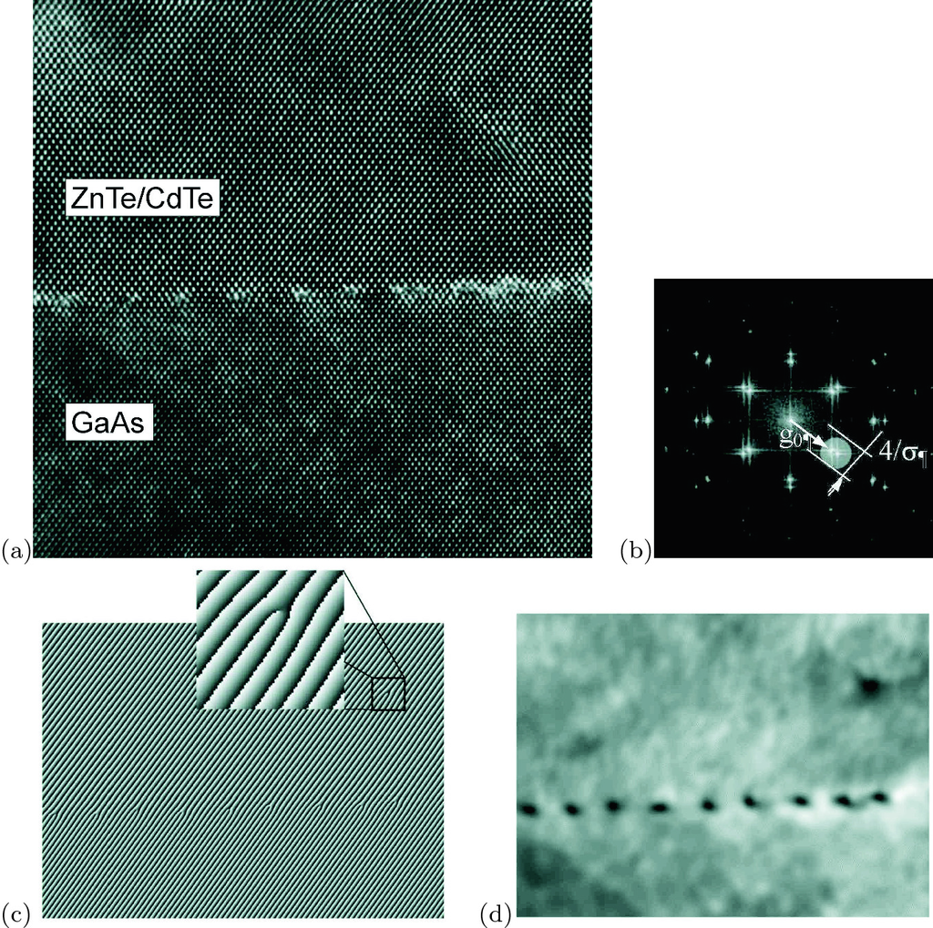

Fig. 4.14

**a** High-resolution transmission electron microscopy image (HRTEM) in the

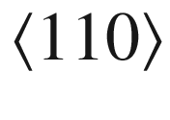

projection of a network of misfit dislocations at a GaAs/CdTe/ZnTe interface. Substrate: GaAs (001), 2

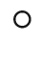

off

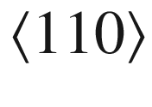

, ZnTe buffer layer is 2 monolayers thick. **b** Fourier transform with round mask around the (111) Bragg reflection. (**c**) Phase and **d** amplitude images for the mask from (**b**).

From [321]

#### 4.3.1 Dislocation Types

##### 4.3.1.1 Edge Dislocations

For an *edge* dislocation (Fig. [4.​15](#u116076_4_En_4_Chapter-Fig15)a)



and



are perpendicular to each other. An extra half-plane spanned by



and

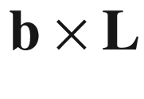

is inserted.

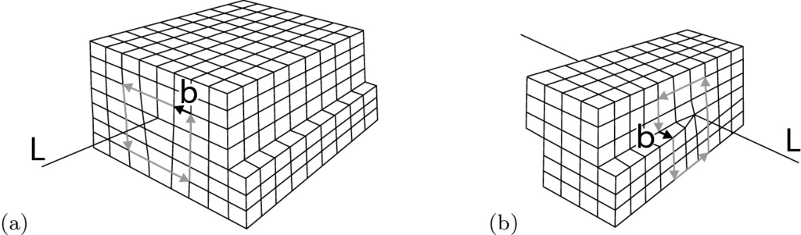

Fig. 4.15

Model of **a** an edge and **b** a screw dislocation. The line vector



and the Burger’s vector



are indicated

##### 4.3.1.2 Screw Dislocations

For a *screw* dislocation (Fig. [4.​15](#u116076_4_En_4_Chapter-Fig15)b)

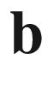

and



are collinear. The solid has been cut along a half-plane up to the dislocation line, shifted along



by the amount

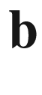

and reattached.

Around the intersection of a screw dislocation with a surface, the epitaxial growth occurs, typically in the form of a growth spiral that images the lattice planes around the defect.

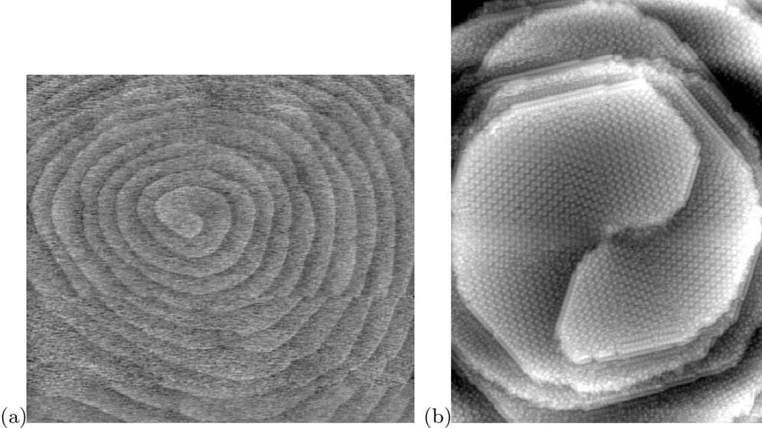

Fig. 4.16

**a** Atomic force microscopy image of growth spiral around a screw dislocation on a silicon surface; image width: 4

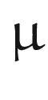

m. (textbfb STM image (width: 75 nm) of a screw-type dislocation with a Burgers vector of [000-1] on the N-face of GaN. The reconstruction is c(6

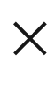

12). The c(6

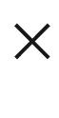

12) row directions correspond to

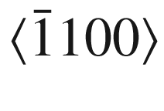

.

Reprinted with permission from [322], ©1998 AVS



##### 4.3.1.3 60 Dislocations

The most important dislocations in the zincblende lattice (Fig. [4.​17](#u116076_4_En_4_Chapter-Fig17)) have the line vector along



. With the Burger’s vector

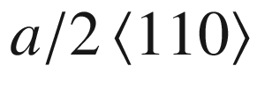

three different types of dislocations can be formed: edge, screw and 60



dislocations. The vicinity of the core of the latter is shown in more detail in Fig. [4.​17](#u116076_4_En_4_Chapter-Fig17)d. We note that the atomistic structure of 60



dislocations is different for



along [110] and

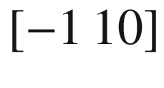

; depending on whether the cations or anions are in the core, they are labeled

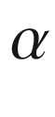

or

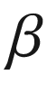

dislocations .

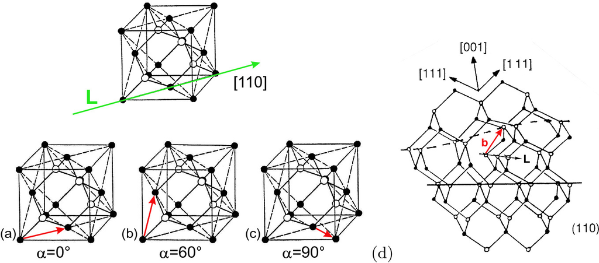

Fig. 4.17

Dislocations in the zincblende structure. The line vector is along [100]. The Burger’s vector

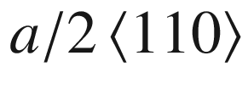

can create an **a** edge dislocation, a **b** screw dislocation, and **c** a 60



dislocation. **d** Atomistic structure of a 60

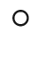

dislocation

##### 4.3.1.4 Misfit Dislocations

When materials with different lattice constants are grown on top of each other, the strain can plastically relax via the formation of misfit dislocations. A typical network of such dislocations is shown in Fig. [4.​18](#u116076_4_En_4_Chapter-Fig18)a for (In,Ga)As on InP (001). Another example is given in Fig. [4.​18](#u116076_4_En_4_Chapter-Fig18)b for the (Al,Ga)N/GaN system on a semipolar

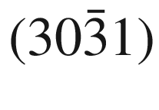

lattice plane tilted to the *c*-axis. This leads to non-rectangular dislocation directions which are universal for dislocations from glide on *a*- and *m*-planes in heterostructures of trigonal and hexagonal materials [325] (Fig. [4.​19](#u116076_4_En_4_Chapter-Fig19)).

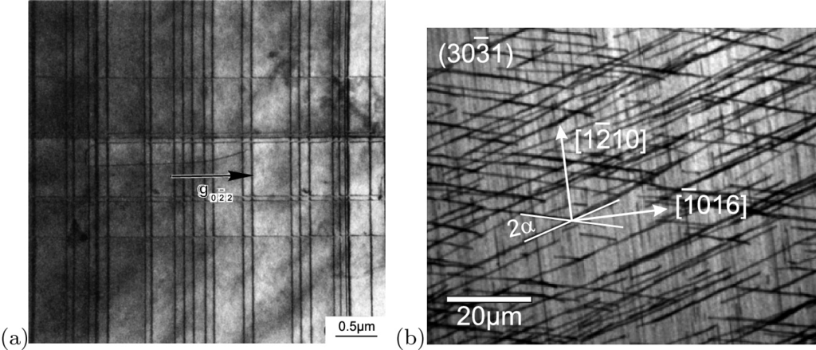

Fig. 4.18

**a** Plan-view transmission electron microscopy image of a network of



dislocation lines in (In,Ga)As on InP (001) with a lattice mismatch of about 0.1%. The TEM diffraction vector is

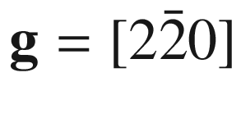

. Adapted from [323]. **b** Panchromatic cathodoluminescence image of partially relaxed Al

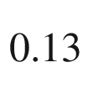

Ga

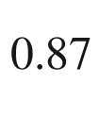

N on

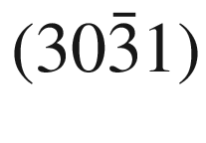

GaN heterostructure with in-plane directions indicated.

Adapted from [324], reprinted under a Creative Commons Attribution (CC BY 3.0) unported licence

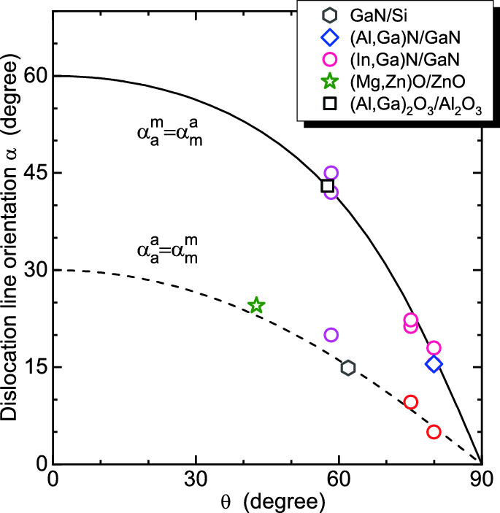

Fig. 4.19

Dislocation line orientation angle

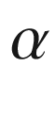

(versus the projected *c*-axis direction) for the *a*-plane prismatic slip system for *m*-azimuth and vice versa (*solid line*) and the *m*-plane prismatic slip system for *m*-azimuth (and *a*/*a*) (*dashed line*) as a function of interface inclination angle

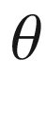

. Experimental data from epitaxy on semipolar planes are shown for (Al,Ga)



O



/Al



O

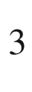

(square), (Al,Ga)N/GaN (diamond, cmp. Fig. [4.​18](#u116076_4_En_4_Chapter-Fig18)b), (In,Ga)N/GaN (circles), GaN/Si (hexagon) and (Mg,Zn)O/ZnO (star).

Adapted from [325, 326]

##### 4.3.1.5 Partial Dislocations

Partial dislocations, i.e. the Burger’s vector is not a lattice vector, must necessarily border a two-dimensional defect, usually a stacking fault (Sect. [4.​4.​2](#u116076_4_En_4_Chapter)). A typical partial dislocation in diamond or zincblende material is the Shockley partial dislocation (or just Shockley partial) with Burger’s vector

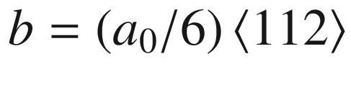

. Another important partial is the Frank partial with

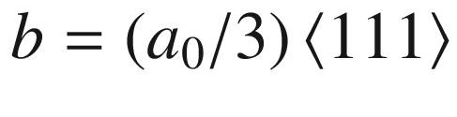

. A perfect dislocation can be dissociated into two partials. This is energetically favorable. As an example we consider the reaction (Fig. [4.​20](#u116076_4_En_4_Chapter-Fig20)a)

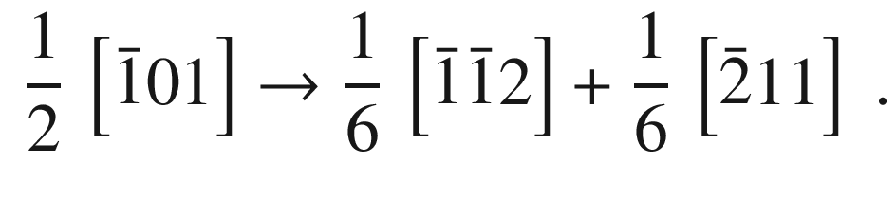

(4.22)

The length of the full dislocation is

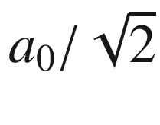

. The length of the Shockley partial is

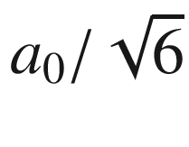

. Thus the energy

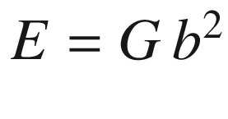

of the full dislocation is

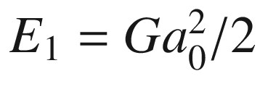

and the sum of the energies of the partials is smaller,

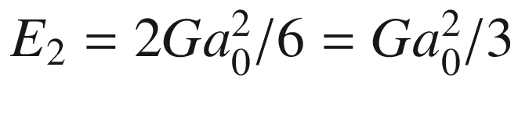

. In Fig. [4.​20](#u116076_4_En_4_Chapter-Fig20)b a TEM image of a Ge/Si interface with a Shockley partial is shown.

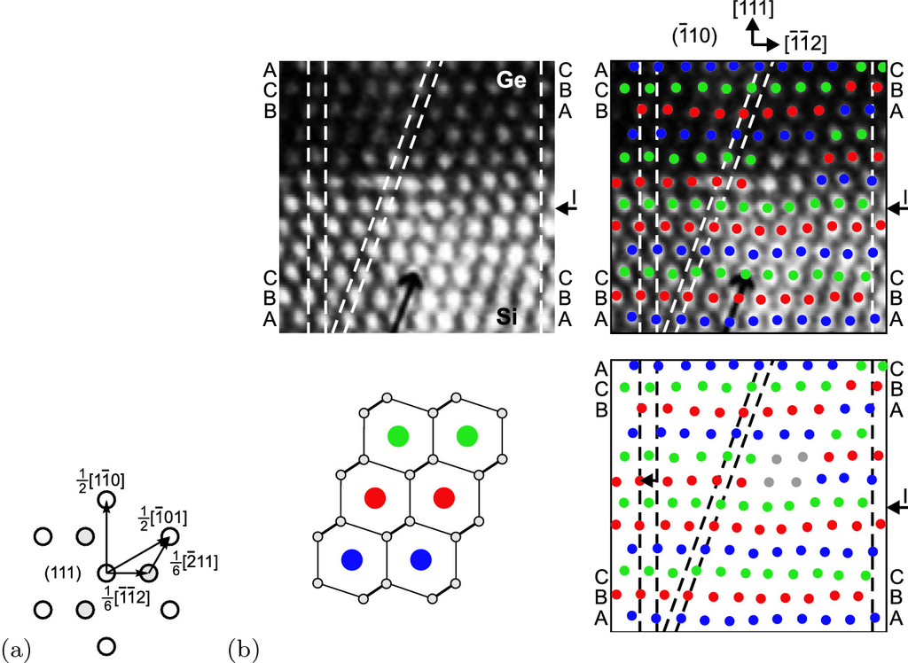

Fig. 4.20

**a** Graphical representation of the dislocation reaction of ([4.​22](#u116076_4_En_4_Chapter)). **b** TEM image of the interface of a Ge/Si heterostructure with a

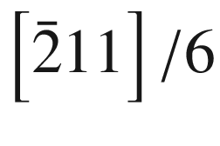

Shockley partial dislocation. The image is overlayed with empty rod positions (as schematically shown in the *lower left* part of the figure) colored according to the stacking position (A: *blue*, B: *red*, C: *green*). The *arrows* labeled ‘I’ denote the position of the interface. Based on [327]

#### 4.3.2 Visualization of Dislocations by Etching

Defects can be made visible using etching techniques. This is particularly popular for finding dislocations. Many etches are anisotropic, i.e. the etch velocity varies for different crystal directions. As an example the result of etching a silicon sphere in molten KOH and a germanium sphere in a HNO

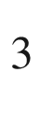

/HF solution are shown in Fig. [4.​21](#u116076_4_En_4_Chapter-Fig21). The remaining bodies exhibit those planes with low etching velocity. The etch velocity of various etch solutions has been investigated in detail in particular for silicon (Fig. [4.​22](#u116076_4_En_4_Chapter-Fig22)).

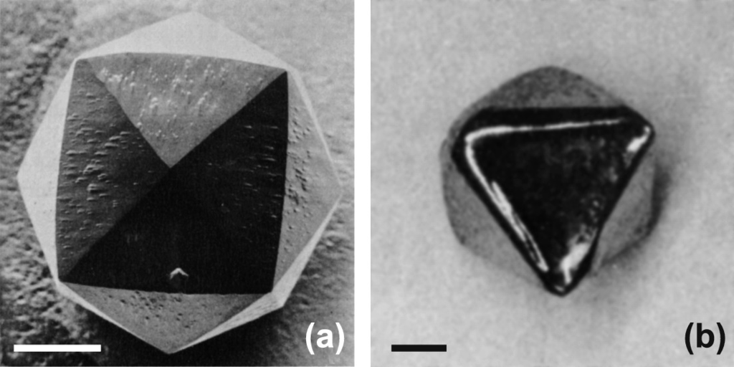

Fig. 4.21

**a** Resulting shape of Si sphere (‘Lösungskörper’) after 3 h at 100



C in molten KOH. **b** Resulting shape of Ge sphere after etching in HNO



:HF:CH



COOH, 35:30:35 weight percent. The octaedric form indicates

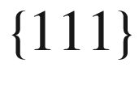

faces. Markers are 1 mm.

Adapted from [328]

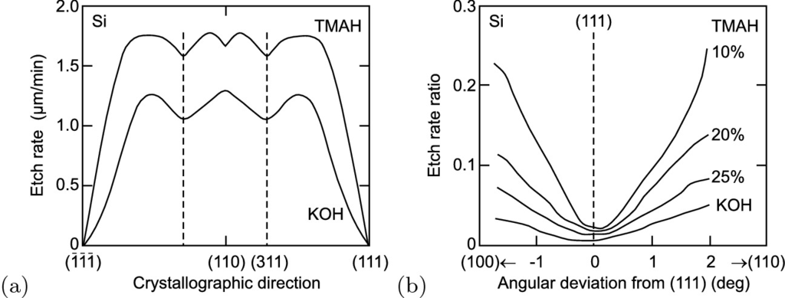

Fig. 4.22

**a** Etch rate of silicon for tetramethyl-ammonium-hydroxide (TMAH) water solution (25%) at 86



C and 40% KOH at 70



C as a function of crystallographic direction. **b** Detail of the anisotropy around the (111) direction for TMAH solutions with three different concentrations and 40% KOH, all at 86



C.

Adapted from [329]

In a planar geometry, etch pits indicate the presence of dislocations, as shown in Fig. [4.​23](#u116076_4_En_4_Chapter-Fig23) for Ge of different orientation. The anisotropic etch prepares

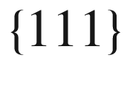

planes. The dislocation core is at the intersection of the planes. In Fig. [4.​24](#u116076_4_En_4_Chapter-Fig24) hexagonal etch pits stretched along

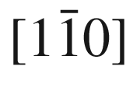

are developed by molten KOH [330, 331]. The sides of the base are along [110],

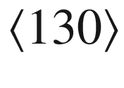

and

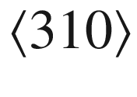

. The depth and width of the pits increases with increasing etching time. On the

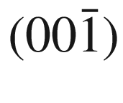

surface, the orientation of the pits is rotated by 90



because of the polar [111]-axis of the zincblende structure [330]. Such etch pit develops at a dislocation with Burger’s vector

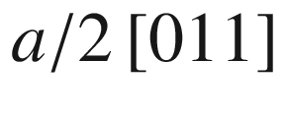

(inclined to the (001) surface) [332]. Other types of etch pits indicate dislocations with other Burger’s vectors [332, 333]. Recipies how to wet chemically etch various semiconductors can be found in [328, 334–337]. Other etching techniques include dry processes such as plasma etching or reactive ion etching (RIE) [338–341].

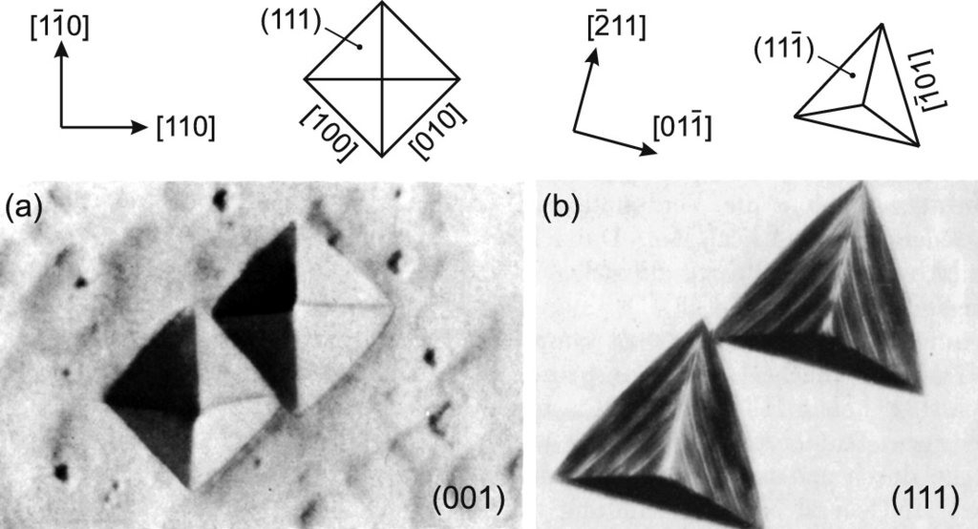

Fig. 4.23

Etch pits on germanium with (**a**) (001) and (**b**) (111) surface orientation. In both cases

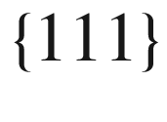

facets are prepared by the etch. As etch in (**b**) a HNO



/HF/CH



COOH solution with AgNO



additive has been used. Width of the triangular etch pits is about 100

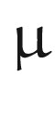

m.

Adapted from [334]

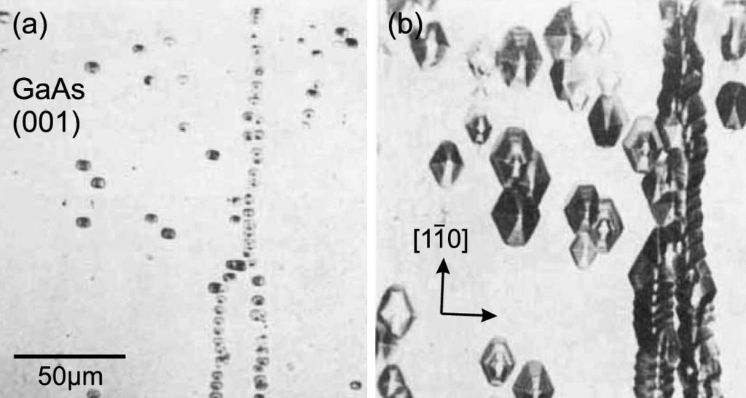

Fig. 4.24

Etch pits on GaAs (001) after **a** 3 min and **b** 10 min etch time in molten KOH at 300



C.

Adapted from [330]

#### 4.3.3 Impurity Hardening

It has been found that the addition of impurities can lead to a substantial reduction of the dislocation density. This effect is known as impurity hardening and is caused by a hardening of the lattice due to an increase of the so-called critical resolved shear stress [342]. In Fig. [4.​25](#u116076_4_En_4_Chapter-Fig25) the dependence of the dislocation density in GaAs and InP is shown as a function of the carrier density that is induced by the incorporation of (electrically active) group-II or group-VI atoms (acceptors or donors, cf. Sect. [7.​5](The_Physics_of_Semiconductors00003.docx#u116076_4_En_7_Chapter)). The high carrier concentration is unwanted when semi-insulating substrates (cf. Sect. [7.​7.​8](The_Physics_of_Semiconductors00003.docx#u116076_4_En_7_Chapter)) or low optical absorption (cf. Sect. [9.​9.​1](The_Physics_of_Semiconductors00004.docx#u116076_4_En_9_Chapter)) are needed. Thus the incorporation of isovalent impurities, such as In, Ga or Sb in GaAs and Sb, Ga or As in InP, has been investigated and found to be remarkably effective. Material containing such impurities in high concentration (

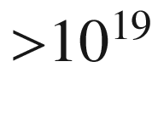

 cm

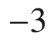

) must be considered a low-concentration alloy. The lattice constant is thus slightly changed, which can cause problems in the subsequent (lattice-mismatched) epitaxy of pure layers.

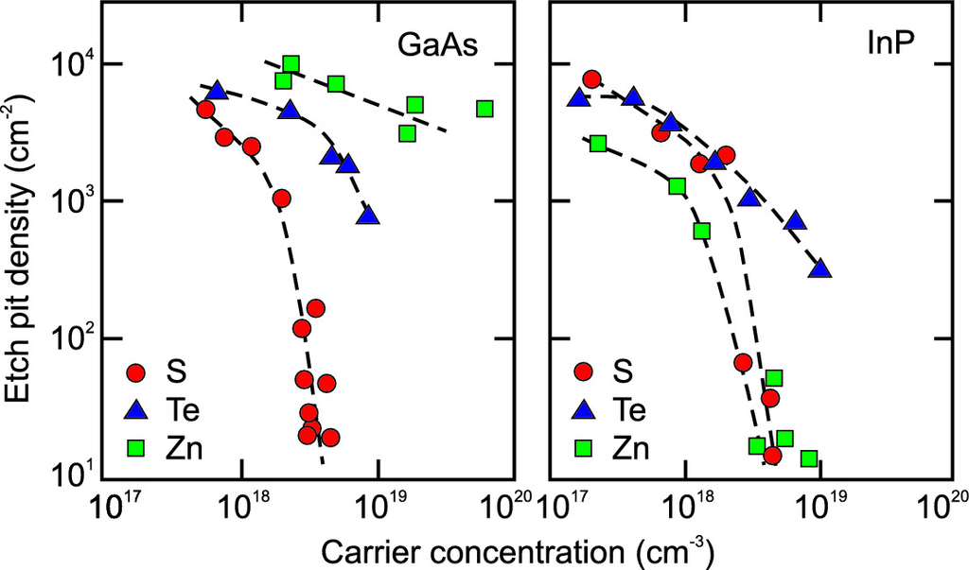

Fig. 4.25

Dislocation density (as revealed by etch pits) for GaAs and InP as a function of the carrier concentration for various concentrations of impurities (S, Te, and Zn).

Adapted from [343]

### 4.4 Extended Defects

#### 4.4.1 Micro-cracks

If the stress in a material becomes too big to be accommodated by dislocations, cracks may form to release strain energy.[8](#u116076_4_En_4_Chapter-Fn8) In Fig. [4.​26](#u116076_4_En_4_Chapter-Fig26) an example is shown. In this case, micro-cracks have formed in a bulk mercury indium telluride crystal upon incorporation of residual stress and thermal stress during cooling of the material from growth temperature (about 1000 K) to room temperature. See also Fig. [12.​19](The_Physics_of_Semiconductors00005.docx#u116076_4_En_12_Chapter-Fig19) for micro-cracks in an epitaxial layer.

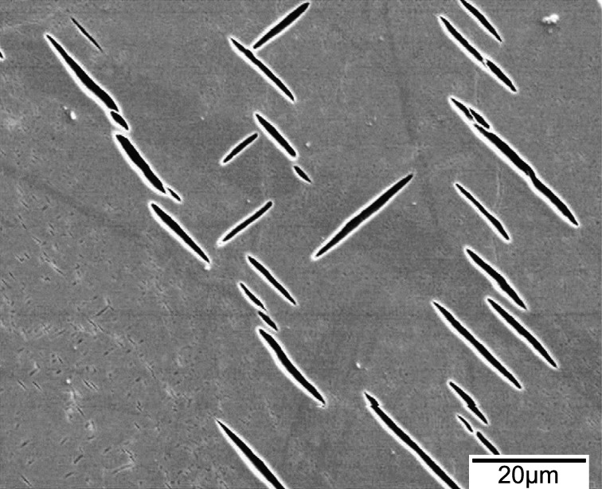

Fig. 4.26

Micro-cracks in a mercury indium telluride crystal.

Adapted from [344]

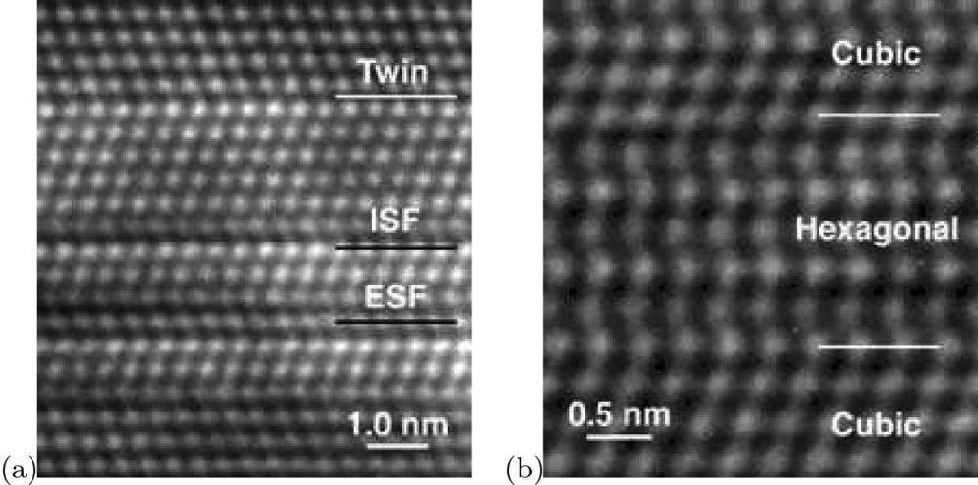

Fig. 4.27

HRTEM images of **a** thin-film silicon with intrinsic (labeled ‘ISF’) and extrinsic (‘ESF’) stacking faults and twin boundary (‘Twin’). **b** Six monolayer thick hexagonal (wurtzite) CdTe layer in cubic (zincblende) CdTe. Stacking order (from bottom to top) is: ABCABABABABC

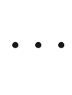

Reprinted with permission from [345]

#### 4.4.2 Stacking Faults

The ideal stacking of (111) planes in the zincblende structure, ABCABC



, can be disturbed in various ways and creates area defects. If one plane is missing, i.e. the stacking is ABC*AC*ABC, an *intrinsic* stacking fault is present. If an additional plane is present, the defect is called an *extrinsic* stacking fault, i.e. ABCAB*A*CABC. An extended stacking fault in which the order of stacking is reversed is called a twin lamella, e.g. ABCABC*BACB*ABCABC. If two regions have inverted stacking order they are called twins and their joint interface is called a twin boundary, e.g.

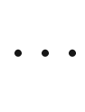

ABCABCAB*C*BACBACBA



(Fig. [4.​29](#u116076_4_En_4_Chapter-Fig29)). The various types of stacking faults are shown in Fig. [4.​27](#u116076_4_En_4_Chapter-Fig27). In Fig. [4.​28](#u116076_4_En_4_Chapter-Fig28) a cross-sectional image of stacking faults in GaAs on Si is shown. They block each other and thus partially annihilate with increasing thickness.

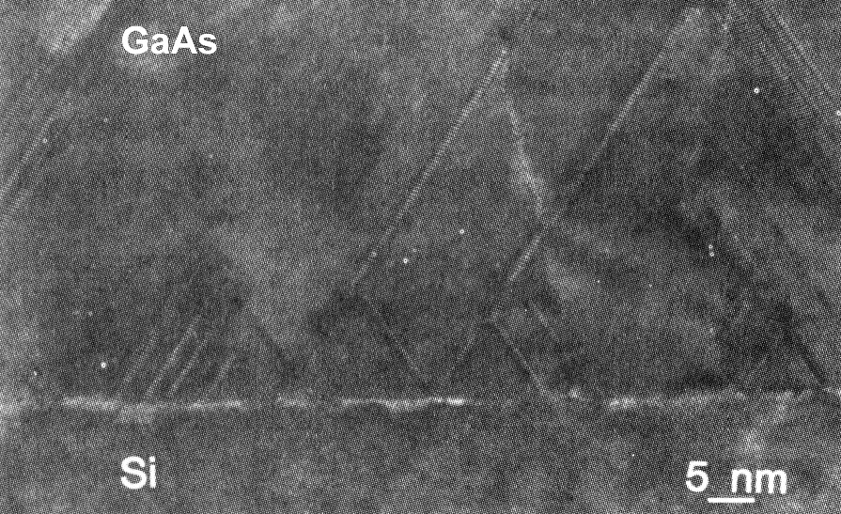

Fig. 4.28

Cross-sectional TEM image showing stacking faults in heteroepitaxial GaAs on Si.

Adapted from [346]

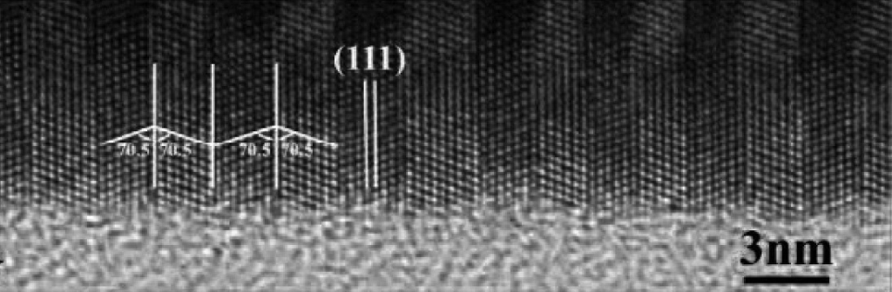

Fig. 4.29

High resolution TEM image of ZnS nanowire exhibiting periodical twin structures.

Adapted from [347]

A stacking fault is bounded by two partial dislocations (Sect. [4.​3.​1.​5](#u116076_4_En_4_Chapter)) formed by the dissociation of a perfect dislocation. A full (or *perfect*) dislocation with Burger’s vector *a*/2[110] in a III–V compound is dissociated into two Shockley partials according to ([4.​22](#u116076_4_En_4_Chapter)) [348]. Since the dislocation energy is proportional to

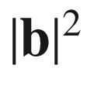

, the dissociation is energetically favored (see Sect. [4.​3.​1.​5](#u116076_4_En_4_Chapter)).

The stacking-fault energy in pure silicon is

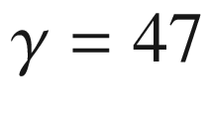

 mJ m

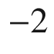

[349]. A similar value is found for Ge,

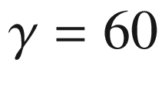

 mJ m

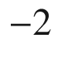

[350] and undoped GaAs,

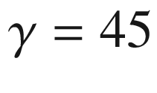

 mJ m



[351]. In diamond a much larger value is found,

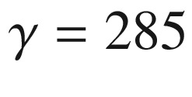

 mJ m

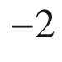

[352]. Impurity incorporation typically reduces the stacking fault energy. The systematics of stacking fault energy for various III–V and II–VI compounds has been discussed [185, 353, 354]. It can be correlated with the *s*-parameter ([2.​11](The_Physics_of_Semiconductors00001.docx#u116076_4_En_2_Chapter)) as depicted in Fig. [4.​30](#u116076_4_En_4_Chapter-Fig30).

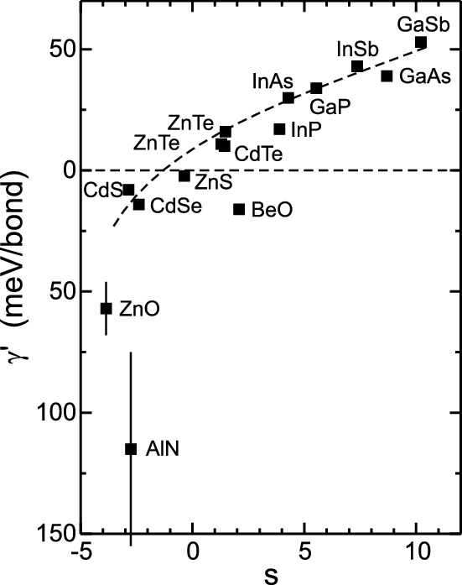

Fig. 4.30

Reduced stacking fault energy (stacking fault energy per bond)

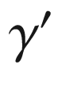

for various compound semiconductors plotted as a function of the *s*-parameter. *Dashed line* is guide to the eye.

Data from [185]

#### 4.4.3 Grain Boundaries

The boundaries of crystal grains are called *grain boundaries*. They are defined by five parameters, three rotation angles (e.g. Euler angles) to describe how the orientation of grain II results from grain I and two parameters to define the boundary plane of the two grains in the coordinate system of reference grain I.

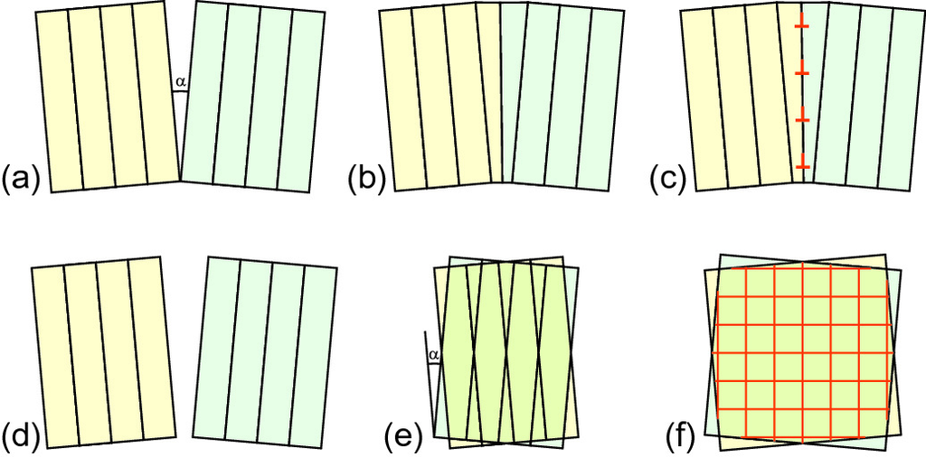

Fig. 4.31

Schemes of **a**–**c** pure tilt and **d**–**f** pure twist boundary, dislocation formation in (**c**) pure tilt and **f** twist boundaries

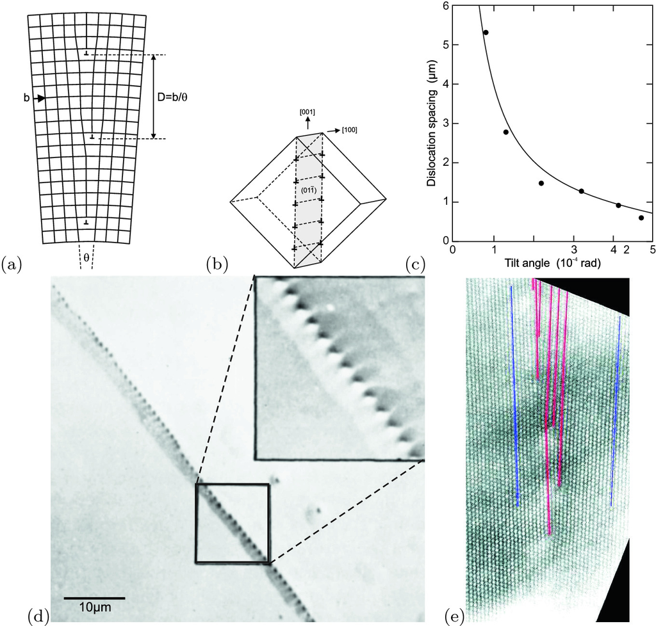

Fig. 4.32

**a** Scheme of a small-angle (pure tilt) grain boundary. **b** Model of edge dislocations in a

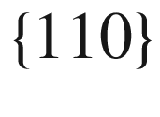

plane in Ge. **c** Relation of dislocation distance *d* and tilt angle

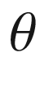

for various small-angle grain boundaries in Ge. *Solid line* is relation

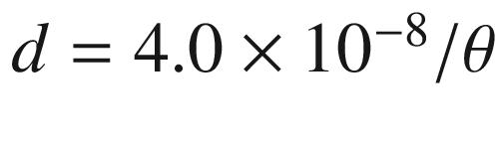

. **d** Optical image of an etched (CP–4 etch) Ge sample with a small-angle grain boundary. Adapted from [359]. **e** HRTEM image of a small-angle grain boundary in Si with dislocations highlighted. From [360]

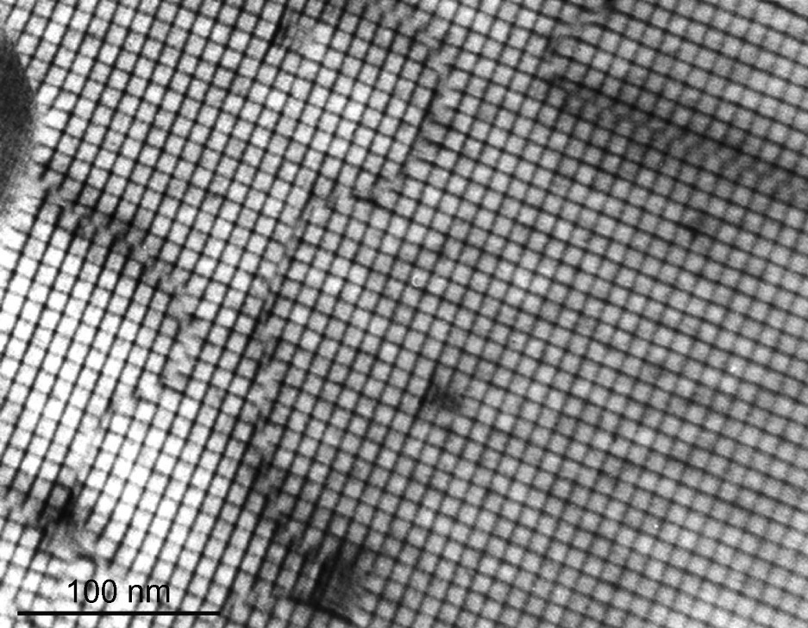

Fig. 4.33

Bright-field TEM image of pure twist boundary with network of pure twist dislocations fabricated by wafer bonding of two Si (001) surfaces with a relative twist.

Adapted from [361]

Such defects can have a large impact on the electric properties. They can collect point defects and impurities, act as barriers for transport (Sect. [8.​3.​8](The_Physics_of_Semiconductors00004.docx#u116076_4_En_8_Chapter)) or as carrier sinks due to (nonradiative) recombination. Details of their structure and properties can be found in [355, 356]. The two crystal grains meet each other with a relative tilt and/or twist. The situation is shown schematically in Fig. [4.​31](#u116076_4_En_4_Chapter-Fig31)a for a small angle between the two crystals. A periodic pattern of dislocations forms at the interface that is called a small-angle grain boundary (SAGB) (Fig. [4.​31](#u116076_4_En_4_Chapter-Fig31)b). In Fig. [4.​32](#u116076_4_En_4_Chapter-Fig32), experimental results for pure tilt SAGB are shown. The dislocation spacing is inversely proportional to the tilt angle

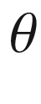

. An image of a twist SAGB is shown in Fig. [4.​33](#u116076_4_En_4_Chapter-Fig33).

Special large angle boundaries possess (for a certain angle) a *coincident site lattice* (CSL). Some of these grain boundaries have a low energy and are thus commonly observed. The ratio of lattice points of the CSL and the lattice unit cell is an odd integer number *n*; the corresponding grain boundary is then labeled

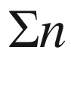

. SAGB are also termed

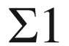

.

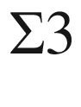

grain boundaries are always twin boundaries. An example with (111) grain boundary is schematically shown in an example in Fig. [4.​34](#u116076_4_En_4_Chapter-Fig34)a. A



(twin) boundary in silicon with

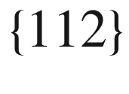

grain boundary [357, 358] is depicted in Fig. [4.​35](#u116076_4_En_4_Chapter-Fig35) together with the atomic arrangement of the grain boundary itself. A

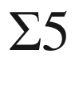

(001) grain boundary is schematically shown in Fig. [4.​34](#u116076_4_En_4_Chapter-Fig34)b; the special angle is

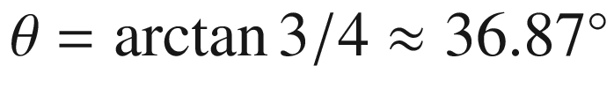

.

Real grain boundaries may not be flat, contain impurities or precipitates and even consist of a thin amorphous layer.

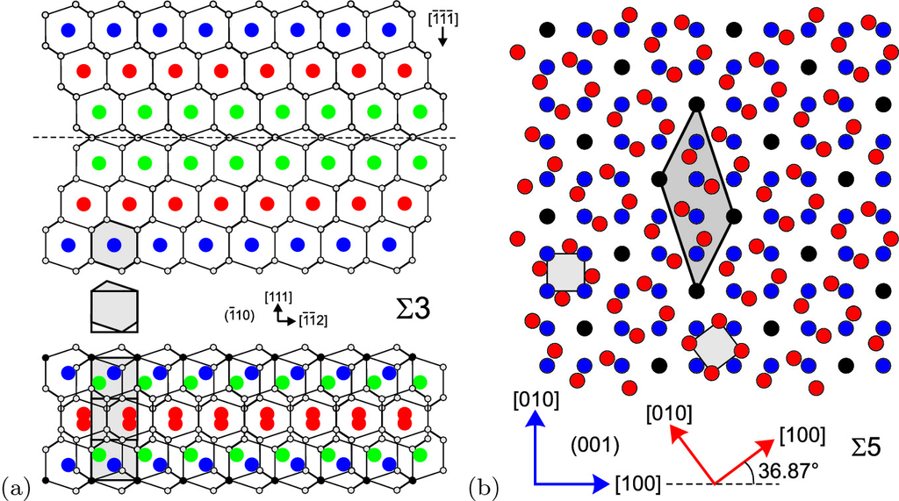

Fig. 4.34

**a** Schematic of

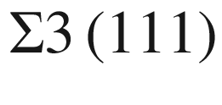

twin boundary in a diamond or zincblende structure (cmp. Fig. [4.​29](#u116076_4_En_4_Chapter-Fig29)). The grain boundary is marked by a *dashed line* shown in side-view. The hexagonal and rectangular *grey boxes* have the same area. The lattice points of the coincident site lattice (CSL) are shown with *black circles* in the lower part of the figure. The unit cell of the CSL has three times the volume of the unit cell of the fcc lattice. **b** Schematic of a

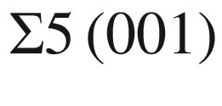

grain boundary in a (simple) cubic crystal shown in plane-view. The *blue* and the *red* lattice are rotated by

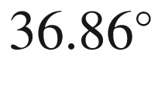

, the lattice points of the CSL are shown in *black*. The unit cell of the CSL lattice (*dark grey*) has five times the volume of the cubic unit cell (*light grey*)

#### 4.4.4 Antiphase and Inversion Domains

Antiphase domains occur when one part of the crystal is shifted with respect to another by an antiphase vector

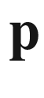

. This does not form a twin. If the polar direction changes between two domains they are called inversion domains.

In the zincblende structure the [110] and

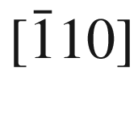

directions are not equivalent. In one case there is a Zn-S lattice and in the other a S-Zn lattice. Both lattices vary by a 90



rotation or an inversion operation (which is not a symmetry operation of the zincblende crystal). If, e.g., a zincblende crystal is grown on a Si surface with monoatomic steps (Fig. [4.​36](#u116076_4_En_4_Chapter-Fig36), cmp. Fig. [11.​6](The_Physics_of_Semiconductors00005.docx#u116076_4_En_11_Chapter-Fig6)), adjoint regions have a different phase; they are called antiphase domains (APD). The antiphase vector is

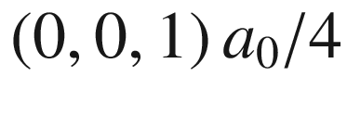

. At the boundaries a two-dimensional defect, an antiphase domain boundary, develops. The APD boundary contains bonds between identical atom species. In Fig. [4.​37](#u116076_4_En_4_Chapter-Fig37), intertwining APD boundaries are shown on the surface of InP layers on Si. The antiphase domains can be visualized with an anisotropic etch.

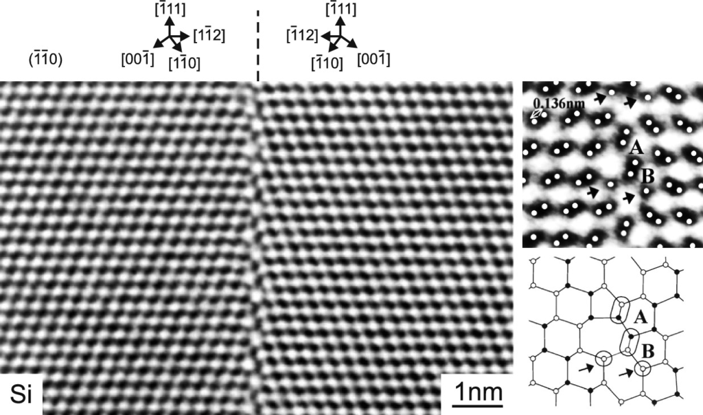

Fig. 4.35

TEM images in two magnifications of a

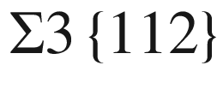

boundary in silicon together with a schematic of the atomic arrangement.

Adapted from [358]

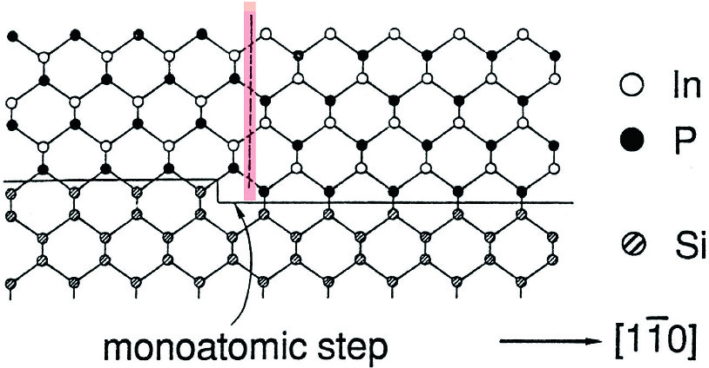

Fig. 4.36

Monoatomic step on the Si (001) surface and subsequent formation of an antiphase boundary in InP (zincblende)

In Fig. [4.​38](#u116076_4_En_4_Chapter-Fig38)a, inversion domains in iron-doped ZnO are shown. Between domains the direction of the *c*-axis is reversed. The iron is found preferentially in the inversion domain boundary (IDB) (Fig. [4.​38](#u116076_4_En_4_Chapter-Fig38)b) and plays an important role in its formation [364, 365].

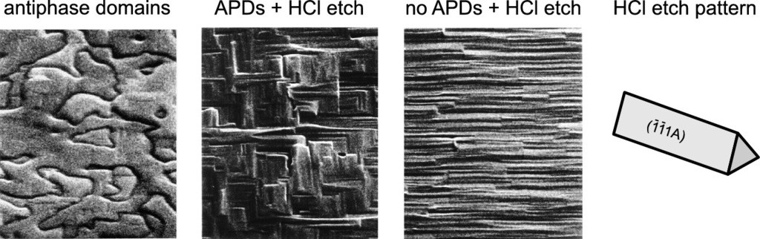

Fig. 4.37

Antiphase domains in InP on Si. HCl etchs InP anisotropically and prepares (111)A planes. The etch patterns of layers with (without) APDs are cross-hatched (linear).

Adapted from [362]

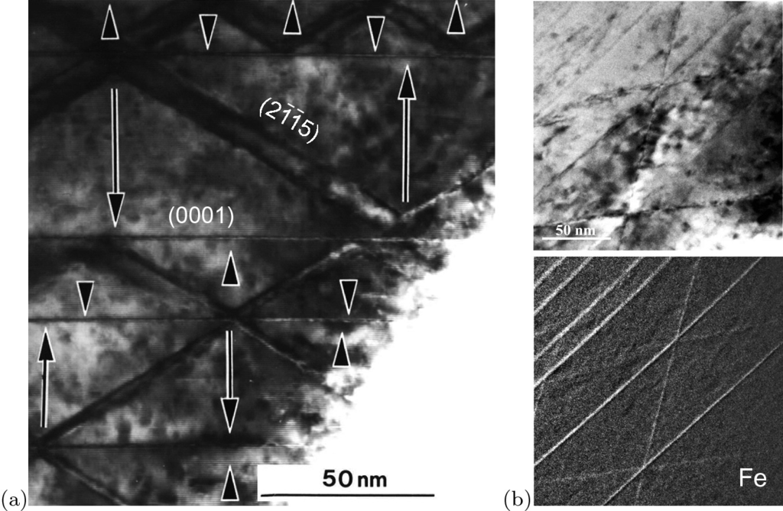

Fig. 4.38

Transmission electron microscopy of inversion domains in ZnO:Fe. **a** Inversion domains in iron-doped ZnO (ZnO:Fe

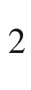

O

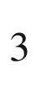

= 100:1). *Arrows* denote the orientation of the *c*-axis in the respective domains. **b** *Top*: bright field TEM, *bottom* Fe distribution from energy-filtered image.

Adapted from [363]

### 4.5 Disorder

Disorder is a general term for deviations from the ideal structure on a microscopic scale. Apart from the various structural defects discussed in the previous chapters, further examples of disorder are

The presence of various isotopes of an element. This introduces disorder with regard to the mass of the atoms and impacts mostly phonon properties (see Fig. [8.​28](The_Physics_of_Semiconductors00004.docx#u116076_4_En_8_Chapter-Fig28)).

The occupation of lattice sites in alloys (Sect. [3.​7](The_Physics_of_Semiconductors00001.docx#u116076_4_En_3_Chapter)) ranging from a random alloy, clustering to (partially) ordered phases.

The (unavoidable) thermal and zero-point motion of atoms around their equilibrium position.

Footnotes

[1](#u116076_4_En_4_Chapter-Fn1_source)

At higher temperatures a silicon atom can occasionally acquire sufficient energy from lattice vibrations to leave its lattice site and thus an interstitial and a vacancy are generated.

[2](#u116076_4_En_4_Chapter-Fn2_source)

The positive charge state is stable, the neutral charge state is metastable since the defect is a negative-U center (see Sect. [7.​7.​5](The_Physics_of_Semiconductors00003.docx#u116076_4_En_7_Chapter)).

[3](#u116076_4_En_4_Chapter-Fn3_source)

Mass preservation of the impurities can be written at any time

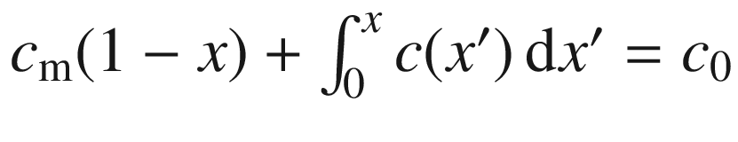

, where

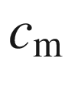

is the (remaining) concentration in the melt. At the beginning

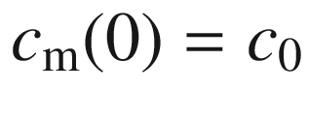

. At the interface

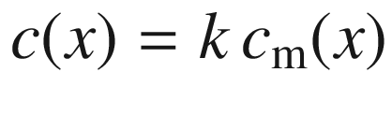

. Putting this into the mass preservation, building

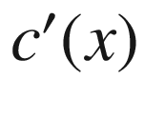

and solving the resulting differential equation

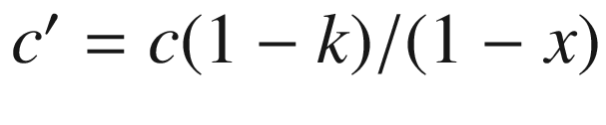

with

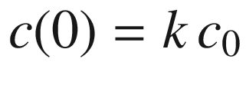

leads to ([4.​18](#u116076_4_En_4_Chapter)).

[4](#u116076_4_En_4_Chapter-Fn4_source)

When the float zone moves through the crystal, the change of mass of impurities

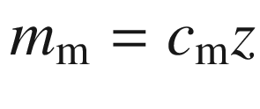

in the liquid is

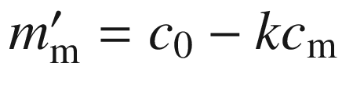

. The first term stems from the melting of the polycrystalline part, the second from the solidification of the crystal. Solving the resulting differential equation

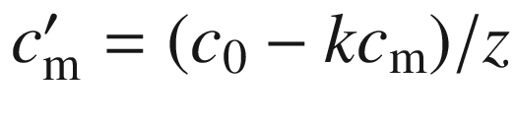

with

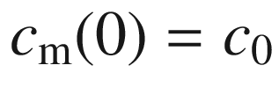

and using

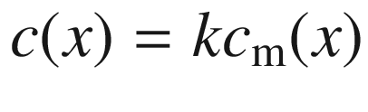

yields ([4.​20](#u116076_4_En_4_Chapter)).

[5](#u116076_4_En_4_Chapter-Fn5_source)

We note that during directed solidification of Si:(B,P) a pn-junction forms due to the different distribution coefficients of boron and phosphorus. This has been used in [89].

[6](#u116076_4_En_4_Chapter-Fn6_source)

The mean path length is the distance integrated along the ion trajectory until its direction deviates by more than 4



from the incident direction.

[7](#u116076_4_En_4_Chapter-Fn7_source)

eight atoms per cubic unit cell of length

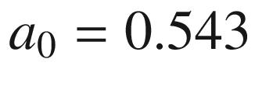

 nm.

[8](#u116076_4_En_4_Chapter-Fn8_source)

We note that in elasticity theory a *continuous* deformation is assumed. Obviously the separation (fracture) into two unstrained blocks is the lowest strain energy state of a stressed piece of material.

© Springer Nature Switzerland AG 2021

M. Grundmann

The Physics of Semiconductors

Graduate Texts in Physics

<https://doi.org/10.1007/978-3-030-51569-0_5>

## 5. Mechanical Properties

Marius Grundmann[1](#u116076_4_En_5_Chapter-Aff11)

(1)

Felix Bloch Institute for Solid State Physics, Universität Leipzig, Leipzig, Germany

Marius Grundmann

Email:

[grundmann@physik.uni-leipzig.de](mailto:grundmann@physik.uni-leipzig.de)

*If you want to find the secrets of the universe, think in terms of energy, frequency and vibration.*

*N. Tesla*

## Abstract

Lattice vibrations and phonons are treated with one-dimensional models and examples for real phonon dispersions for several semiconductors including phonons in alloys and disordered materials are given. Then the theory of linear elasticity and its application to semiconductors with regard to epitaxial strain, substrate bending and sheet-scrolling is given. Finally plastic relaxation effects such as critical thickness and wafer breakage are discussed.

### 5.1 Introduction

The atoms making up the solid have an average position from which they can deviate since they are elastically bonded. The typical atomic interaction potential looks like the one shown in Fig. [2.​1](The_Physics_of_Semiconductors00001.docx#u116076_4_En_2_Chapter-Fig1). The atoms thus perform a vibrational motion (including zero point fluctuations) and the solid is elastic. The potential is essentially asymmetric, being steeper for small distances due to quantum-mechanical overlap of orbitals. However, for small amplitudes around the minimum a harmonic oscillator can be assumed (harmonic approximation). Beyond the elastic regime, plastic deformation occurs such as generation of defects, e.g. dislocations. Eventually also the crystal can break.

### 5.2 Lattice Vibrations

In the following we will discuss the dispersion relations for lattice vibrations, i.e. the connection between the frequency

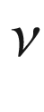

(or energy

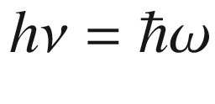

) of the wave and its wavelength

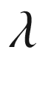

(or *k*-vector

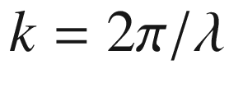

). Acoustic and optical vibrations are introduced in one-dimensional models. A detailed treatment of the physics of lattice vibrations is given in [366].

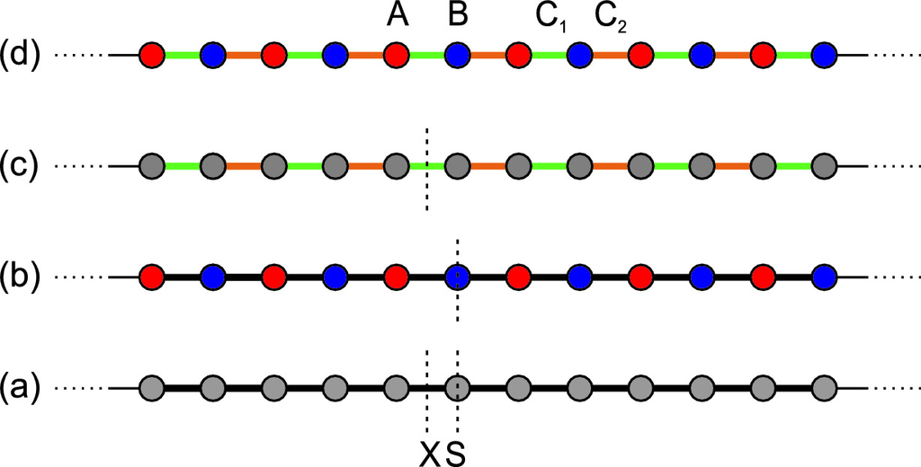

Fig. 5.1

Schematic linear chain models with **a** same masses and spring constants, **b** different masses and same spring constants, **c** same masses and different spring constants, **d** different masses and different spring constants. Mirror operation

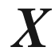

(

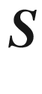

) exchanges the A–B atoms in the dimer (the spring constants)

#### 5.2.1 Monoatomic Linear Chain

The essential physics of lattice vibrations can best be seen from a one-dimensional model that is called the linear chain model. The mechanical vibrations will also be called *phonons*, although technically this term is reserved for the quantized lattice vibrations resulting from the quantum-mechanical treatment.

In the monoatomic linear chain the atoms of mass *M* are positioned along a line (*x*-axis) with a period (lattice constant) *a* at the positions

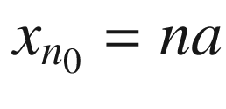

. This represents a one-dimensional Bravais lattice. The Brillouin zone of this system is

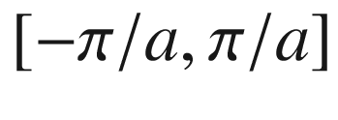

.

The atoms will interact with a harmonic potential, i.e. the energy is proportional to the displacement

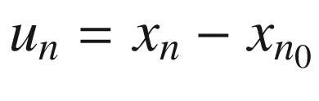

to the second power. This can be thought of as if the atoms are coupled by massless springs (Fig. [5.1](#u116076_4_En_5_Chapter-Fig1)a). The total (mechanical) energy of the system is then:

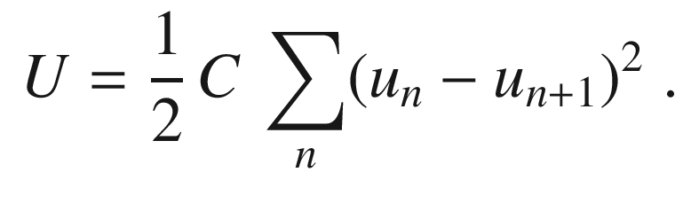

(5.1)

The model assumes that the mass points are connected via massless, ideal springs with a spring constant *C*. If

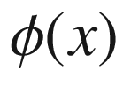

is the interaction energy between two atoms, *C* is given by

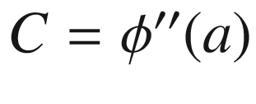

. Again, the harmonic approximation is only valid for small displacements, i.e.

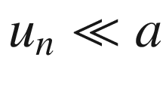

. The displacement of the atoms can be along the chain (longitudinal wave) or perpendicular to the chain (transverse wave), see Fig. [5.2](#u116076_4_En_5_Chapter-Fig2). We note that for these two types of waves the elastic constant *C* must not be the same.

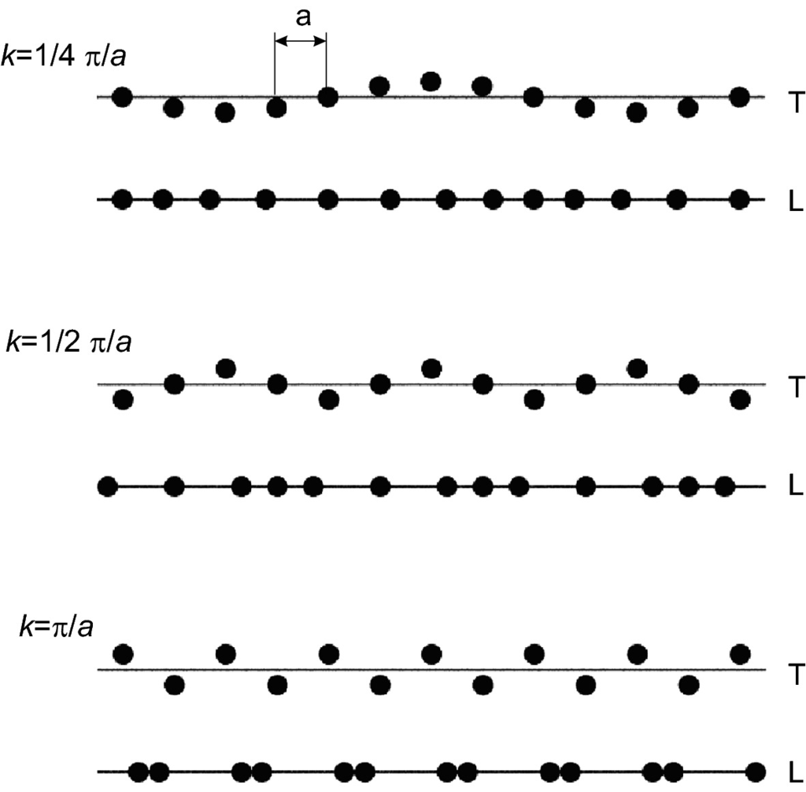

Fig. 5.2

Visualization of transverse (‘T’) and longitudinal (‘L’) waves in a linear monoatomic chain at different wavevectors

When the sum in ([5.1](#u116076_4_En_5_Chapter-Equ1)) has a finite number of terms (

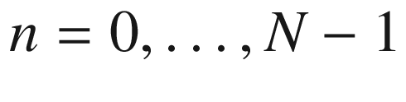

), the boundary conditions have to be considered. There are typically two possibilities: The boundary atoms are fixed, i.e.

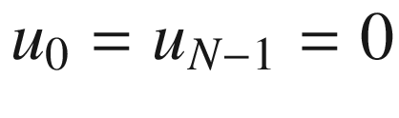

, the boundary conditions are periodic (Born–von Karman), i.e.

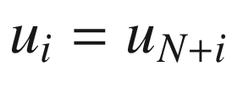

. If

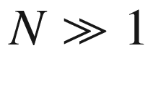

, the boundary conditions play no significant role anyway, thus those with the greatest ease for subsequent math are chosen. In solid-state physics typically periodic boundary conditions  are used. Boundary phenomena, such as at surfaces, are then treated separately (see Sect. [11.​6.​1](The_Physics_of_Semiconductors00005.docx#u116076_4_En_11_Chapter)).

The equations of motion derived from ([5.1](#u116076_4_En_5_Chapter-Equ1)) are

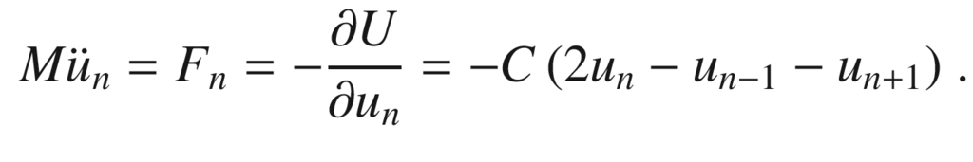

(5.2)

We solve for solutions that are periodic in time (harmonic waves), i.e.

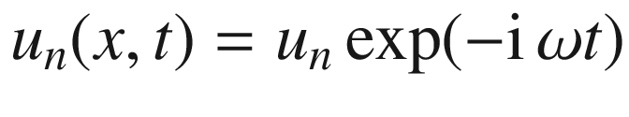

. Then the time derivative can be executed immediately as

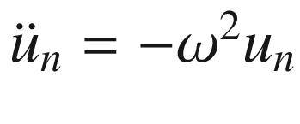

and we obtain:

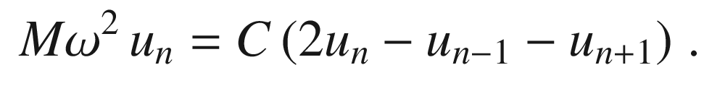

(5.3)

If, also, the solution is periodic in space, i.e. is a (one-dimensional) plane wave, i.e.

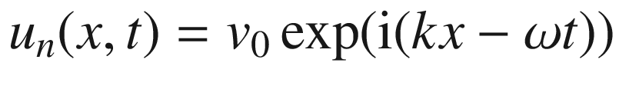

with

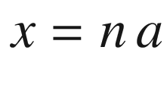

, we find from the periodic boundary condition

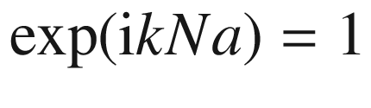

and thus

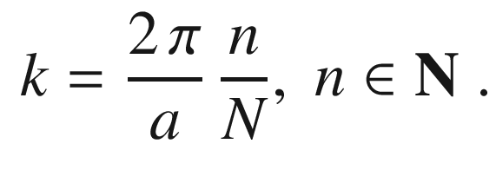

(5.4)

It is important that, when *k* is altered by a reciprocal space vector, i.e.

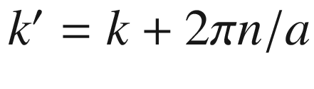

, the displacements

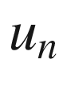

are unaffected. This property means that there are only *N* values for *k* that generate independent solutions. These can be chosen as

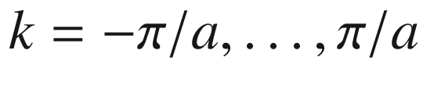

, so that *k* lies in the Brillouin zone of the lattice (Fig. [5.3](#u116076_4_En_5_Chapter-Fig3)). Since the properties are periodic with the Brillouin zone, the *k*-values can be imagined being on a circle as visualized in Fig. [5.3](#u116076_4_En_5_Chapter-Fig3); the angle

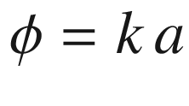

run from 0 to

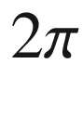

or from

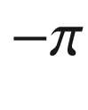

to

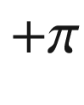

as you like.

In the Brillouin zone there is a total number of *N* *k*-values, i.e. one for each lattice point. The distance between adjacent *k*-values is

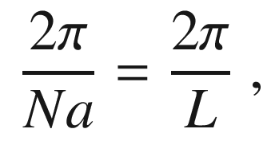

(5.5)

*L* being the lateral extension of the system.

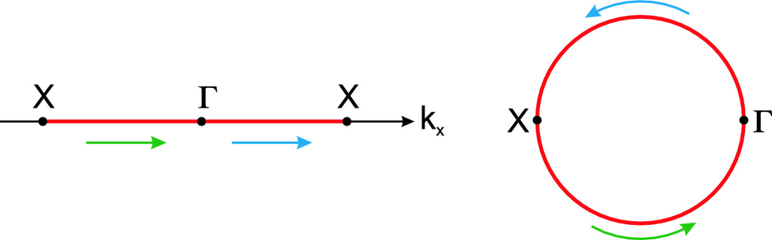

Fig. 5.3

Brillouin zone of a one-dimensional lattice from

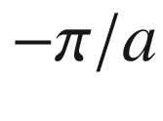

to

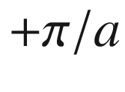

and mapping to a circle with angles from

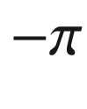

over 0 (at

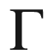

) to

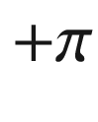

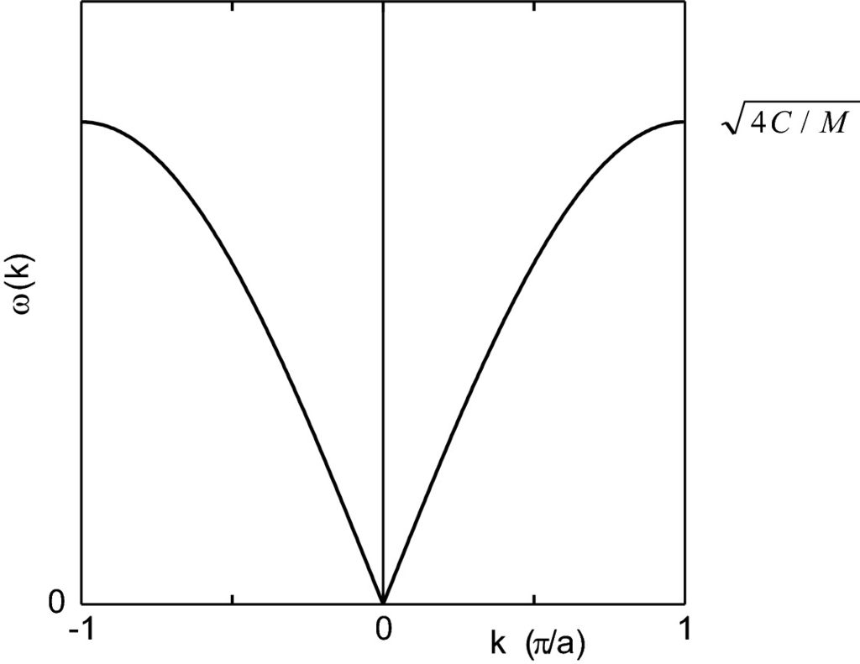

Fig. 5.4

Dispersion relation for a monoatomic linear chain

The displacements at the lattice points *n* and

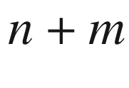

are now related to each other via

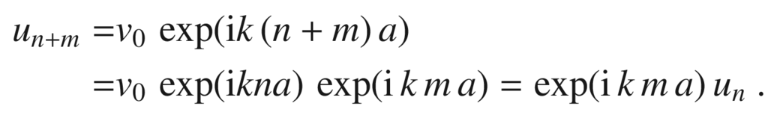

(5.6)

Thus, the equation of motion ([5.3](#u116076_4_En_5_Chapter-Equ3)) reads

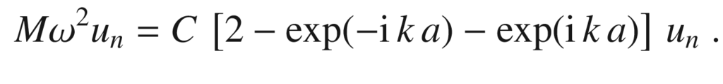

(5.7)

Using the identity

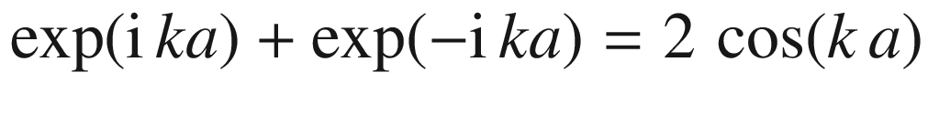

, we find the dispersion relation of the monoatomic linear chain (Fig. [5.4](#u116076_4_En_5_Chapter-Fig4)):

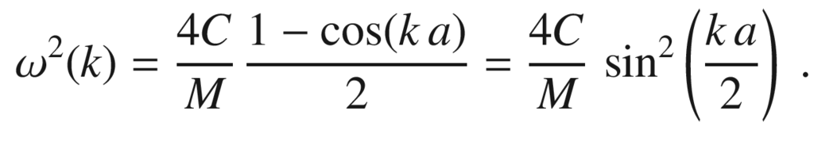

(5.8)

The solutions describe plane waves that propagate in the crystal with a phase velocity

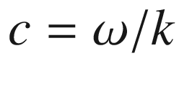

and a group velocity

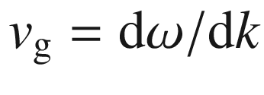

,

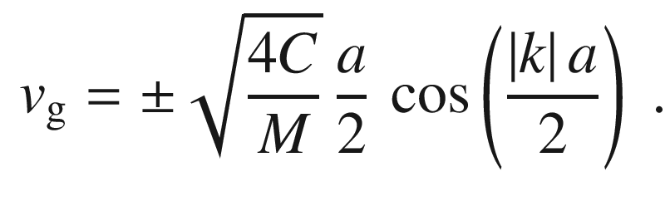

(5.9)

In the vicinity of the

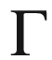

point , i.e.

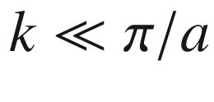

the dispersion relation is linear in *k*

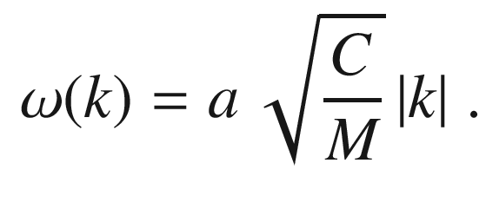

(5.10)

We are used to such linear relations for sound (and also light) waves. The phase and group velocity are the same and do not depend on *k*. Thus, such solutions are called *acoustic*. The sound velocity of the medium (

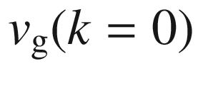

in ([5.9](#u116076_4_En_5_Chapter-Equ9))) is given by

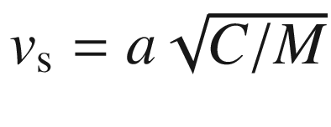

.

It is characteristic of the non-continuous medium that for *k* approaching the boundary of the Brillouin zone, the behavior of the wave is altered. For

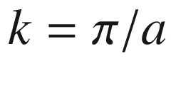

the wavelength is just

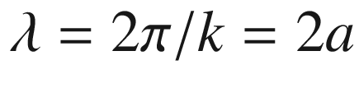

, and thus samples the granularity of the medium. The maximum phonon frequency

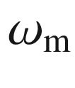

 is

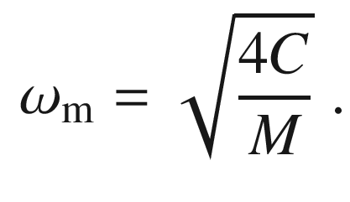

(5.11)

The group velocity is zero at the zone boundary, thus a standing wave is present.

Since the force constants of the longitudinal and transverse waves can be different, the dispersion relations are different. The transverse branch of the dispersion relation is two-fold degenerate when the two directions perpendicular to

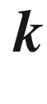

are equivalent.

#### 5.2.2 Diatomic Linear Chain

Now we consider the case that the system is made up from two different kinds of atoms (Fig. [5.5](#u116076_4_En_5_Chapter-Fig5)). This will be a model for semiconductors with a diatomic base, such as zincblende. We note that the diamond structure also needs to be modeled in this way, although both atoms in the base are the same.

The lattice will be the same and the lattice constant will be *a*. Alternating atoms of sort 1 and 2 with a relative distance of *a*/2 are on the chain. The displacements of the two atoms are labeled

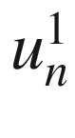

and

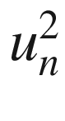

, both belonging to the lattice point *n*. The atoms have the masses

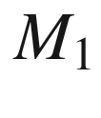

and

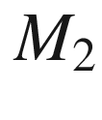

. The force constants are

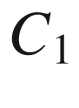

(for the 1–2 bond within the base) and

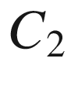

(for the 2–1 bond between different bases) (Fig. [5.1](#u116076_4_En_5_Chapter-Fig1)d).

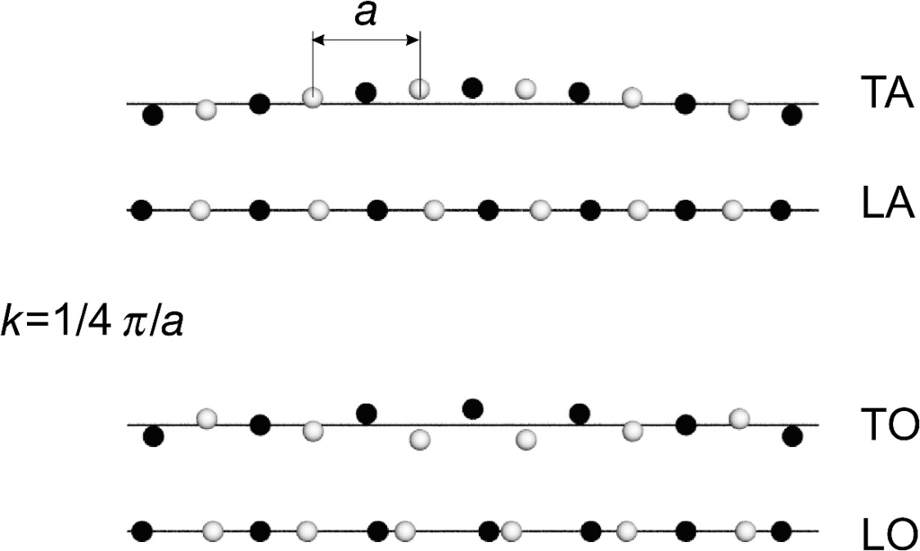

Fig. 5.5

Visualization of acoustic and optical waves in a diatomic linear chain

The total energy of the system is then given as

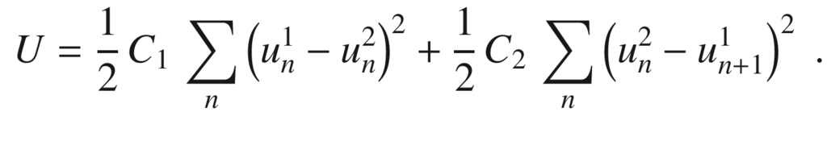

(5.12)

The equations of motion are

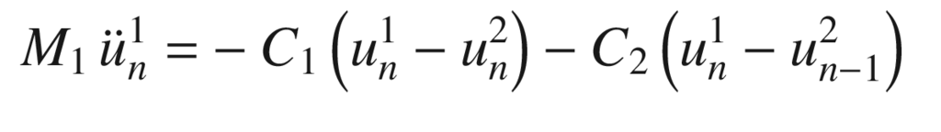

(5.13a)

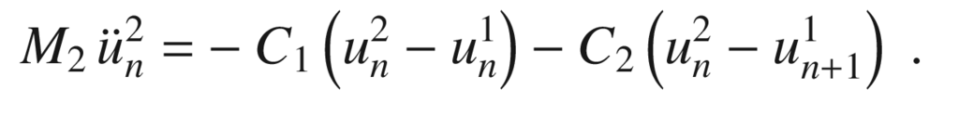

(5.13b)

With the plane-wave ansatz

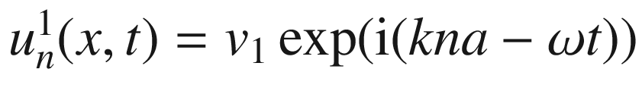

and

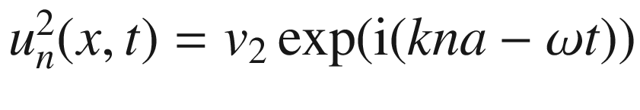

and periodic boundary conditions we find



(5.14a)



(5.14b)

These equations for

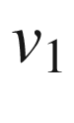

and

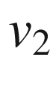

can only be solved nontrivially if the determinant vanishes, i.e.

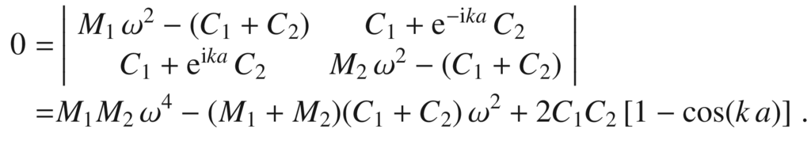

(5.15)

Using the substitutions

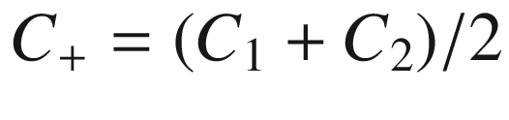

,

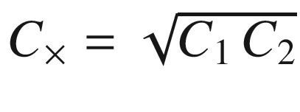

, the arithmetic and geometrical averages, and accordingly for

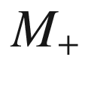

and

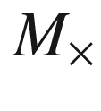

, the solution is

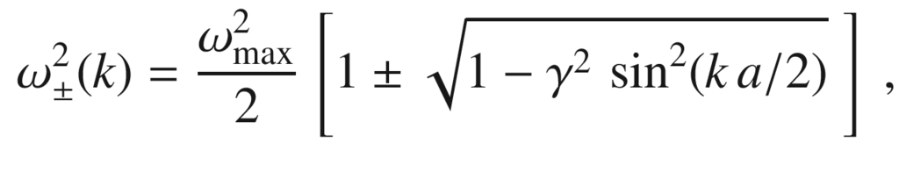

(5.16)

with

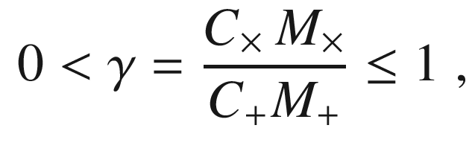

(5.17)

and the maximum frequency

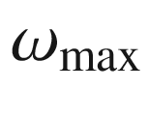

(for the upper branch (‘

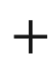

’ sign in ([5.16](#u116076_4_En_5_Chapter-Equ18))) at the zone center (

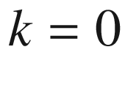

),

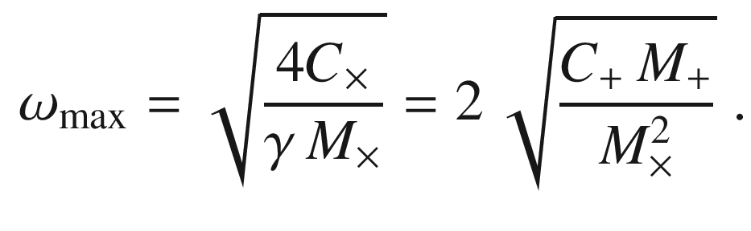

(5.18)

The dispersion relation, as shown in Fig. [5.6](#u116076_4_En_5_Chapter-Fig6), now has (for each longitudinal and transverse mode) two branches. The lower branch (‘−’ sign in ([5.16](#u116076_4_En_5_Chapter-Equ18))) is related to the acoustic mode; neighboring atoms have the same phase for

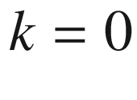

(Fig. [5.5](#u116076_4_En_5_Chapter-Fig5)). For the acoustic mode

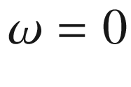

at the

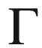

point  and the frequency increases towards the zone boundary.

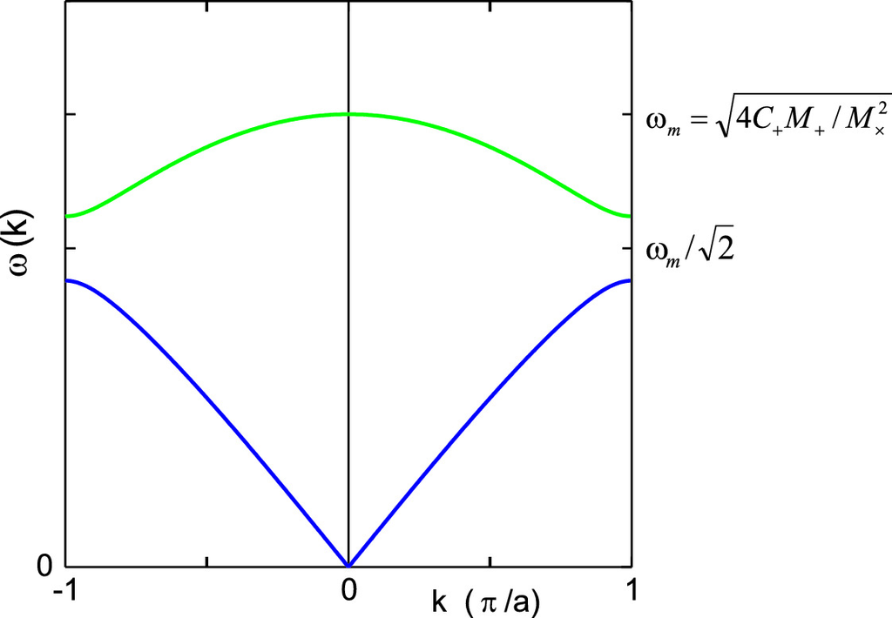

Fig. 5.6

Dispersion relation for a diatomic linear chain with acoustic (*blue*) and optical (*green*) branch

The upper branch is called the optical mode (since it can interact strongly with light, see Sect. [9.​10](The_Physics_of_Semiconductors00004.docx#u116076_4_En_9_Chapter)) and neighboring atoms have opposite phase at

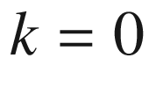

. In the vicinity of the

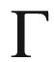

point , the dispersion of optical phonons is parabolic with negative curvature:

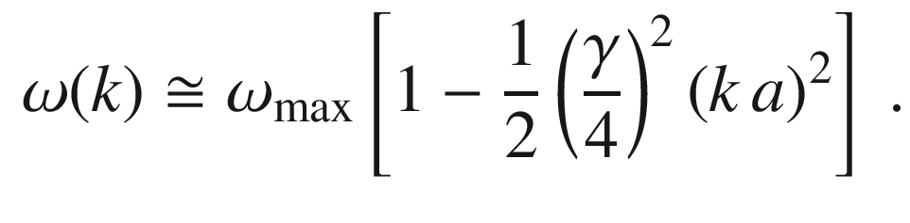

(5.19)

Thus, four different vibrations exist that are labeled TA, LA, TO, and LO. Both the TA and TO branches are degenerate.

At the zone boundary (X point) a frequency gap exists (for

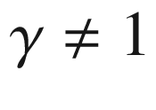

). The gap center is at

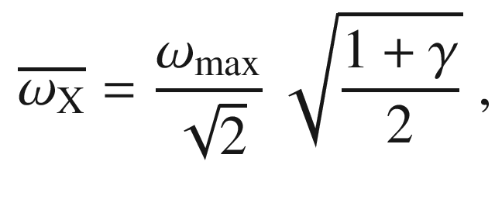

(5.20)

and the total width of the gap is

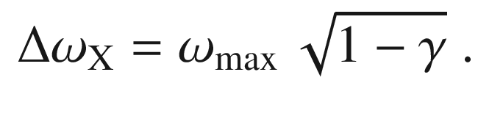

(5.21)

The group velocity is zero for optical and acoustic phonons at

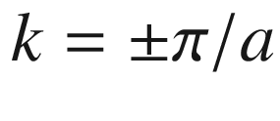

and for optical phonons at the



point .

Usually two special cases are treated explicitly: (i) atoms with equal mass (

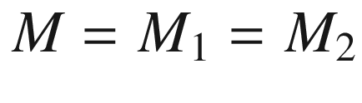

) and different force constants [367] or (ii) atoms with unequal mass and identical force constants

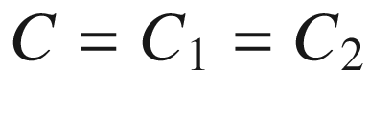

[368]. For the case

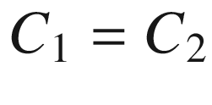

*and*

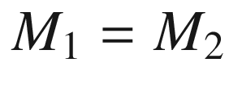

,

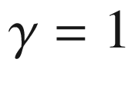

and thus

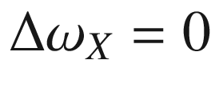

. Then the dispersion relation is the same as for the monoatomic chain, except that the *k* space has been folded since the actual lattice constant is now *a*/2.

#### 5.2.3 Mode Patterns and Topological States

First, we chose

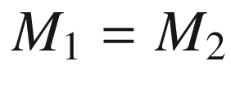

. In this case (Fig. [5.1](#u116076_4_En_5_Chapter-Fig1)c),

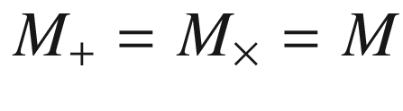

and the dispersion relation is

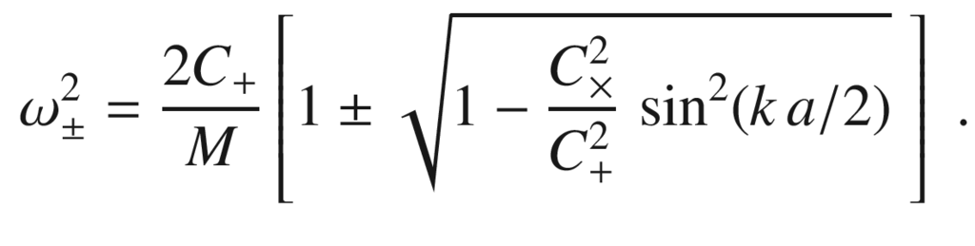

(5.22)

The frequencies for the lower (acoustic) and upper (optical) branch at the zone boundary

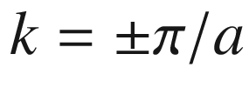

are

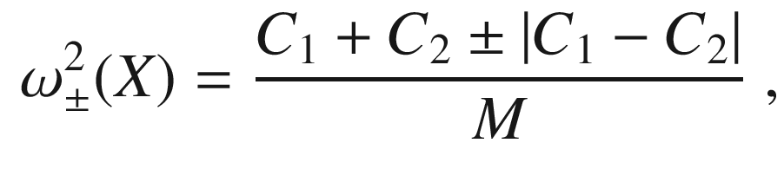

(5.23)

or

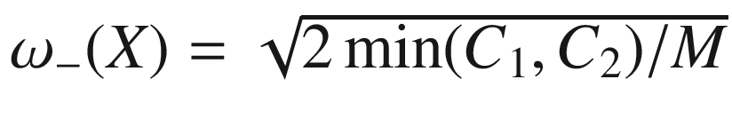

and

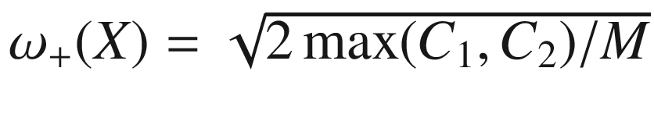

. The softer spring determines the top of the lower branch, the harder spring determines the bottom of the upper branch.

The eigenstates for the lower and upper branch (upper sign for the upper band) are given by (without the

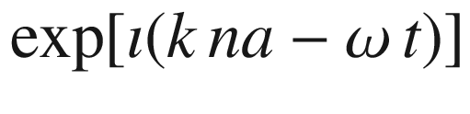

periodicity in time and space),

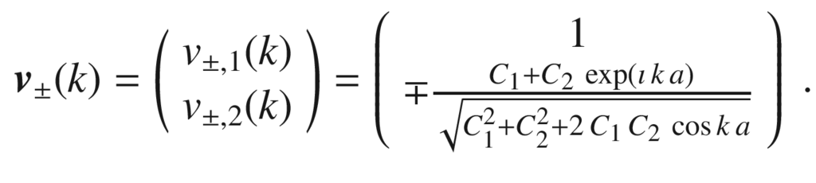

(5.24)

In the zone center, we find

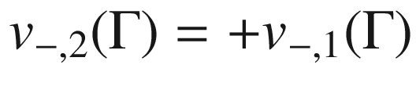

in the lower branch and

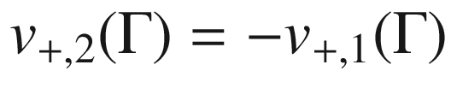

in the upper branch. Thus the two atoms in the base oscillate in phase (out of phase) for long wavelengths in the acoustic (optical) branch as said before.

At the border of the Brillouin zone,



(and for

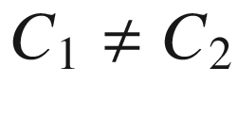

),

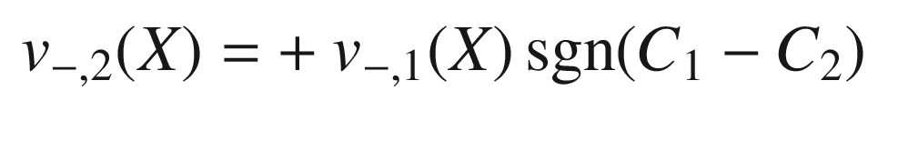

(5.25)

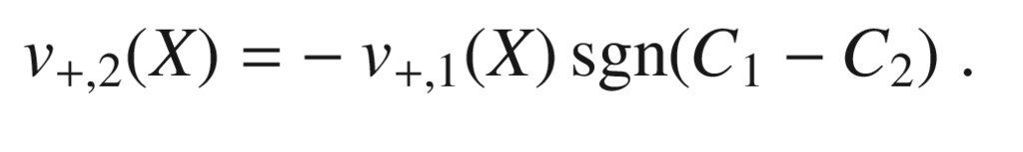

(5.26)

Now, the relative phase of the two atoms in the base depends on the ratio of

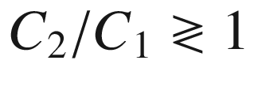

! For

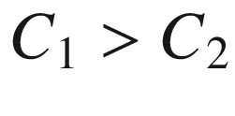

, the top of the acoustic branch has

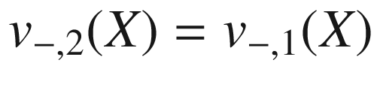

and thus the same as at the

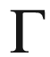

-point, preserving the ‘acoustic’ nature of the band. For

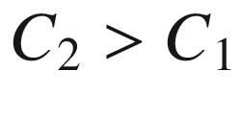

, however,

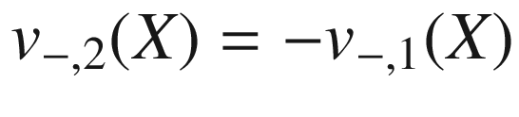

and thus out-of-phase, resembling an optical mode. For the upper branch the situation is vice versa.

The situation can be visualized by plotting the relative phase of

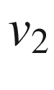

and

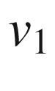

, as expressed by

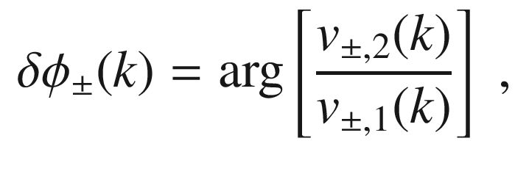

(5.27)

for the two cases

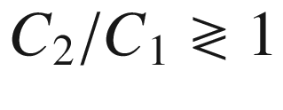

(note that

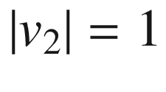

for all cases) for the lower branch in Fig. [5.7](#u116076_4_En_5_Chapter-Fig7). The dispersions for the two cases

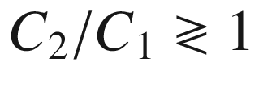

with the phase

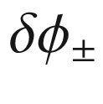

depicted as color are compared in Fig. [5.8](#u116076_4_En_5_Chapter-Fig8).

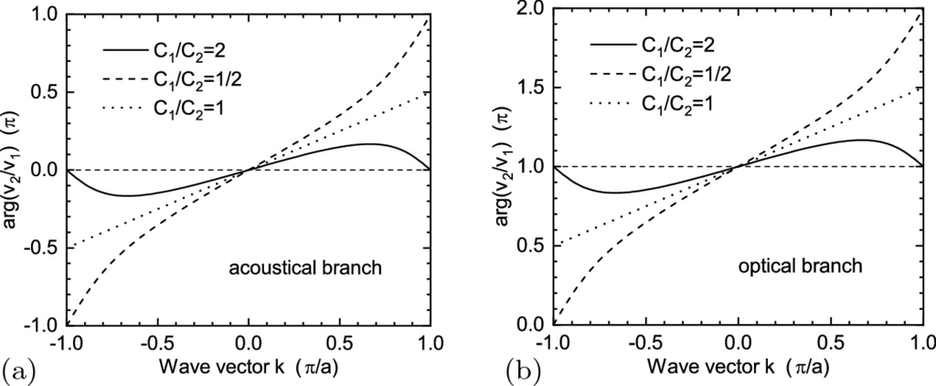

Fig. 5.7

Relative phase of the B-site to the A-site in the **a** lower (acoustic,

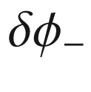

) branch and **b** upper (optical,

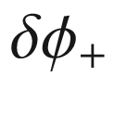

) branch, expressed by

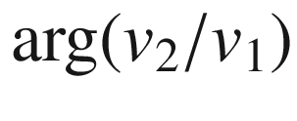

from ([5.27](#u116076_4_En_5_Chapter-Equ29)). The case

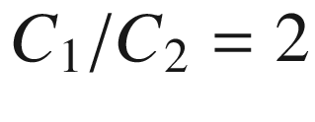

is shown as *solid line*; the inverted case of

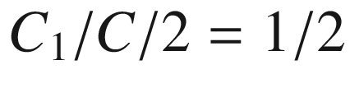

is shown as *dashed line*. The case

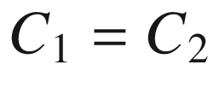

is shown as *dotted lines*

For all cases of

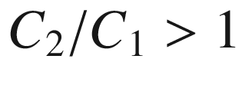

,

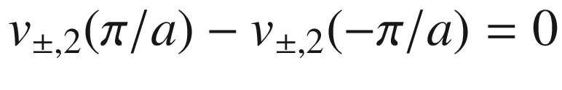

. For all cases of

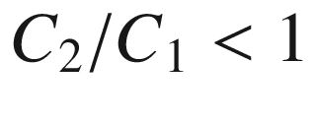

,

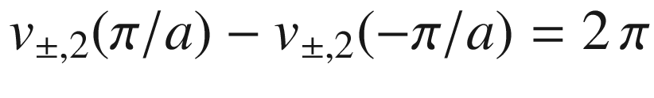

. Thus this number is a ‘topological invariant’ since it cannot be changed by smooth changes of the system, i.e. small and slow variations of

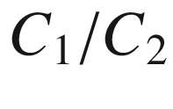

, unless one goes through the gapless state (

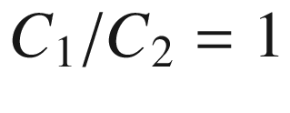

). The case



,

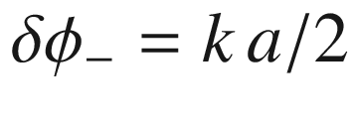

and

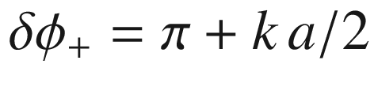

is shown as dotted lines in Fig. [5.7](#u116076_4_En_5_Chapter-Fig7). It should be noted that the phase difference in ([5.27](#u116076_4_En_5_Chapter-Equ29)) and the curves in Fig. [5.7](#u116076_4_En_5_Chapter-Fig7) are independent of the mass ratio.

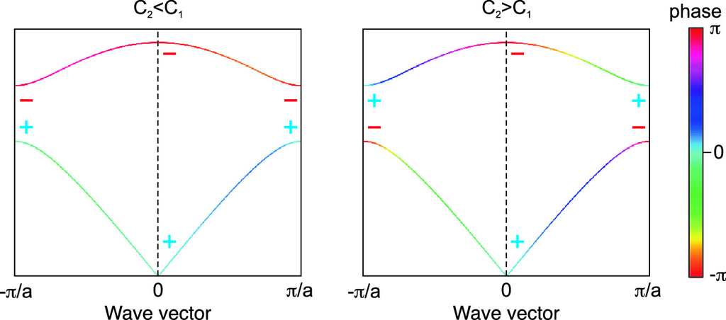

Fig. 5.8

Phonon dispersion with the phase of the wavefunction (relative phase between B- and A-sites) shown in false colors. *Left*:

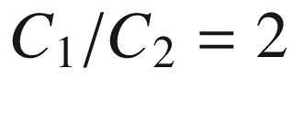

, *right*:

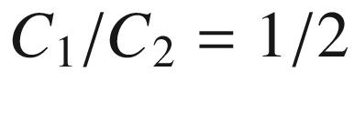

. The parity symmetry of the mode with respect to exchange of A- and B-sites is indicated with ‘

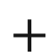

’ (in-phase) and ‘−’ (out-of-phase)

Generally, the symmetry of a mode

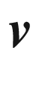

with respect to the operation

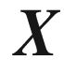

that exchanges A- and B-sites,

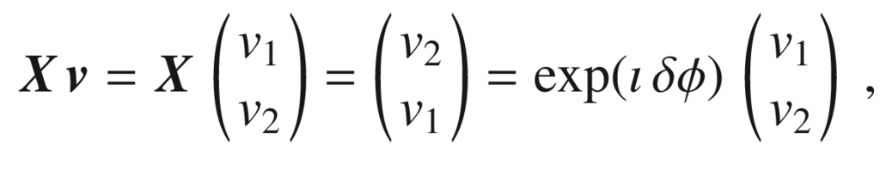

(5.28)

can be expressed by the phase

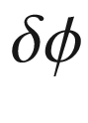

.

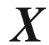

is a unitary transformation since

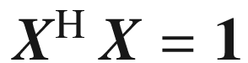

. For a well defined parity-like symmetry, we demand

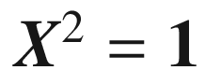

; it is present for a phase factor of 1 (

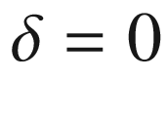

, positive parity) and a phase factor of

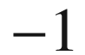

(

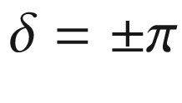

, negative parity). In Fig. [5.8](#u116076_4_En_5_Chapter-Fig8)b, for the non-trivial phase, the parity changes twice within the Brillouin zone, while for the trivial case it does not. In view of later discussions of electronic band structure we remind the reader that electronic s-states (p-states) have positive (negative) parity.

The phase change summed up when going through the entire Brillouin zone must a multiple of

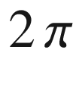

since the physical properties are periodic with the Brillouin zone. The property to calculate for obtaining a proper topological invariant here is the Berry phase [369, 370]

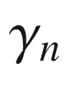

for a branch *n* with the more general recipe,

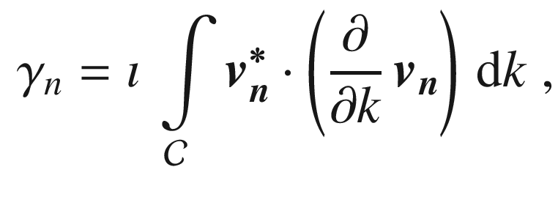

(5.29)

where

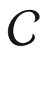

is a closed loop in parameter space, here it is the integral over the entire Brillouin zone. The integrand is the one-dimensional equivalent to the ‘Berry connection’.[1](The_Physics_of_Semiconductors00003.docx#u116076_4_En_5_Chapter-Fn1) For the diatomic linear chain, the integral yields

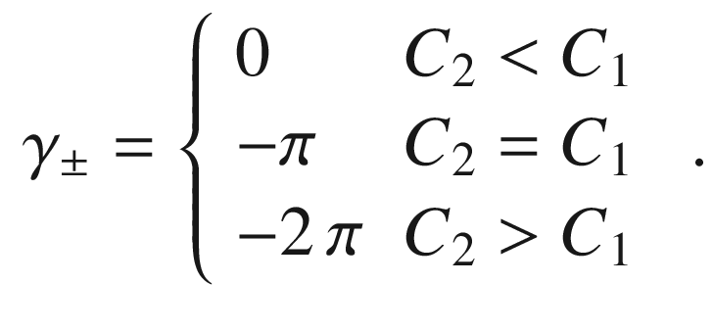

(5.30)

One should think also about the following: The situation for

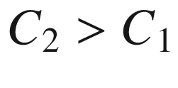

means that the A–B inter-dimer spring constant is *larger* than the intra-dimer one. But our choice of unit cell is free and the situation can be thought of differently in terms of B–A dimers where then, for exactly the same physical situation, the inter-dimer spring constant (now

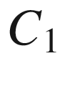

) is *smaller* than the intra-dimer one (

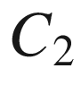

). Thus, the two bulk situations will not be much different per se and cannot be distinguished, in particular when the A- und B-sites are equivalent (here

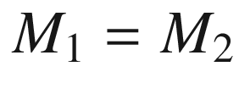

). However, when two media with different topology have an interface, edge states develop according to the bulk-boundary correspondence; this will be shown for the DLCM in Sect. [5.2.10](#u116076_4_En_5_Chapter-Sec12).

In the case



(Fig. [5.1](#u116076_4_En_5_Chapter-Fig1)b),

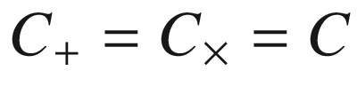

and the dispersion relation can be simplified to

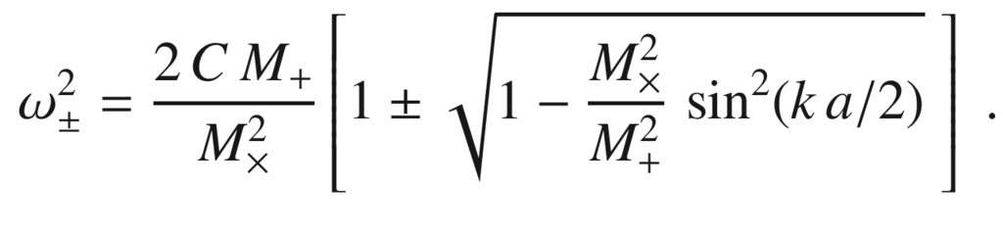

(5.31)

At the zone boundary the frequencies for the acoustic and the optical branch are, assuming

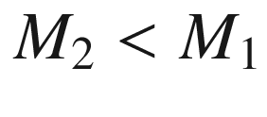

,

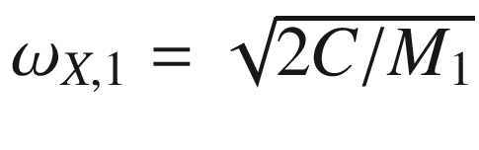

with

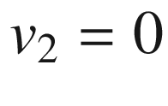

(oscillation of the larger mass) and

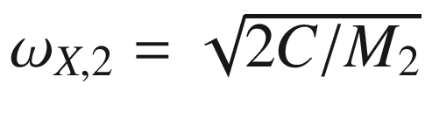

with

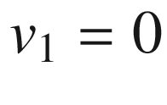

(oscillation of the smaller mass), respectively. In the vibrations at the X-point thus only one atom species oscillates, the other does not move. Close to the

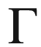

point, the atoms are in phase in the acoustic branch with

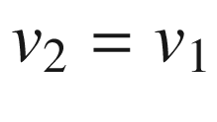

. For the optical branch, the frequency at the



point is given by

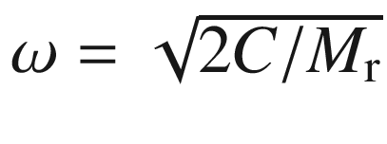

(with the reduced mass

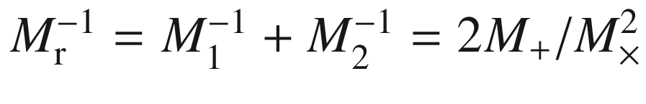

) and the amplitude ratio is given by the mass ratio:

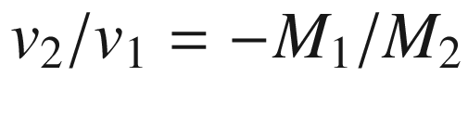

, i.e. the atoms are out of phase and the heavier atom has the smaller amplitude.

It should be repeated that the relative phase of

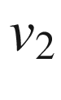

and



, as defined in ([5.27](#u116076_4_En_5_Chapter-Equ29)), is the same for all masses (dotted line in Fig. [5.7](#u116076_4_En_5_Chapter-Fig7)). The situation

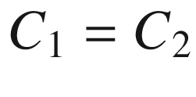

is therefore for all masses topologically the same as the gapless state and the gap has different character when due to different spring constants or due to different masses.

Finally, we consider the symmetry classification looking at Fig. [5.1](#u116076_4_En_5_Chapter-Fig1) again. The monoatomic chain has two mirror-like symmetries, indicated by vertical dashed lines; it is symmetric with respect to exchange

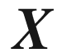

of the A- and B-atoms and to the exchange

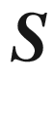

of the springs. The cases Fig. [5.1](#u116076_4_En_5_Chapter-Fig1)b, c preserve only one such symmetry while the general diatomic chain Fig. [5.1](#u116076_4_En_5_Chapter-Fig1)d preserves none of them individually but still possesses the so-called chiral symmetry which is the combination

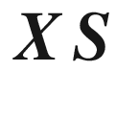

. In terms of the ‘periodic system’ of the CAZ classification of topological systems the diatomic linear chain is a BDI-type system [371] and the topological invariant is, derived from ([5.30](#u116076_4_En_5_Chapter-Equ32)), an integer of the form,

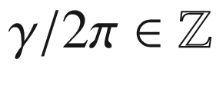

.

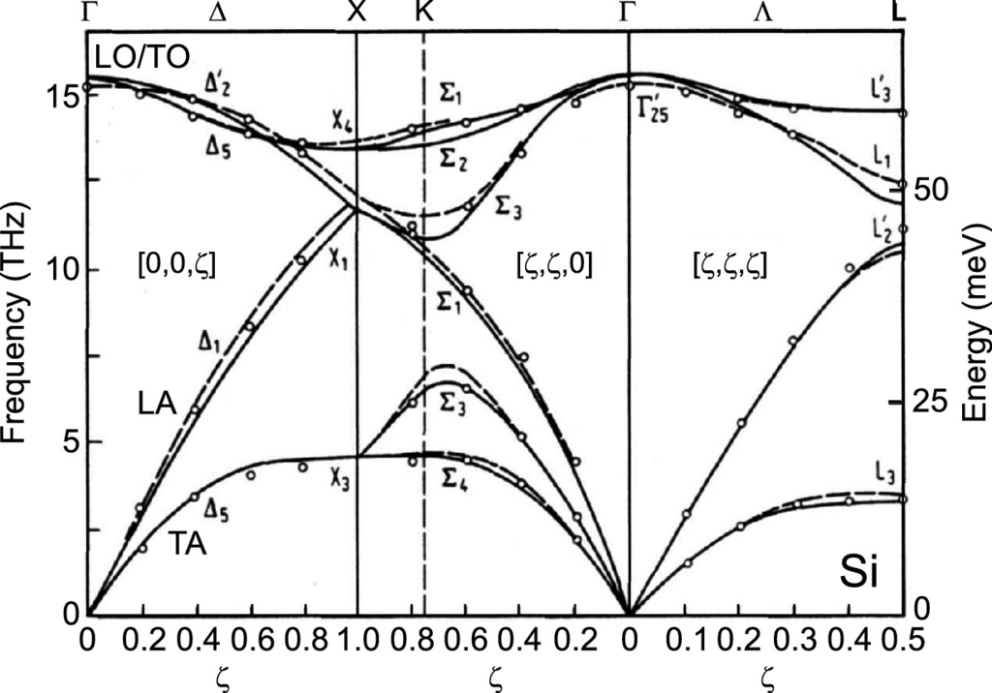

Fig. 5.9

Phonon dispersion in Si, experimental data and theory (*solid lines*: bond charge model, *dashed lines*: valence force field model).

Adapted from [164]

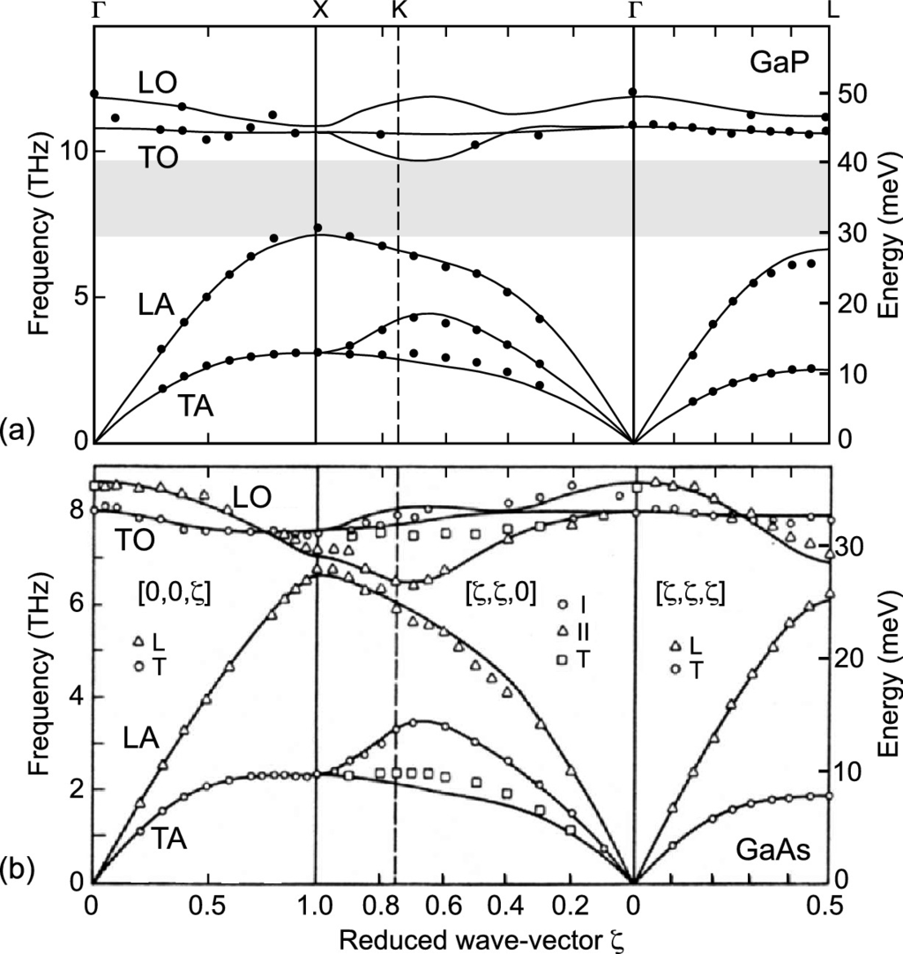

Fig. 5.10

Phonon dispersion in **a** GaP and **b** GaAs. Experimental data (*symbols*) and theory (*solid lines*, 14-parameter shell model). ‘L’ and ‘T’ refer to longitudinal and transverse modes, respectively. ‘I’ and ‘II’ (along

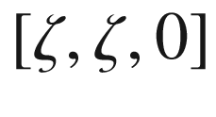

) are modes whose polarization is in the (

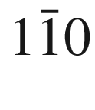

) plane. The *grey area* in (**a**) denotes the gap between acoustical and optical states.

**a** Adapted from [375], **b** Adapted from [373]

#### 5.2.4 Lattice Vibrations of a Three-Dimensional Crystal

When calculations are executed for a three-dimensional crystal with a monoatomic base, there are 3*N* equations of motion. These are transformed to normal coordinates and represent 3 acoustic branches (1 LA phonon mode and 2 TA phonon modes) of the dispersion relation. In a crystal with a base with *p* atoms, there are also 3 acoustic branches and

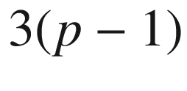

optical branches. For a diatomic base (as in the zincblende structure) there are 3 optical phonon branches (1 LO phonon mode and 2 TO phonon modes). The total number of modes is 3*p*. The dispersion

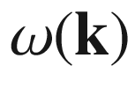

now has to be calculated for all *directions* of



.

In Figs. [5.9](#u116076_4_En_5_Chapter-Fig9) and [5.10](#u116076_4_En_5_Chapter-Fig10), the phonon dispersion in silicon, GaAs and GaP is shown along particular lines in the Brillouin zone (cf. Fig. [3.​38](#u116076_4_En_3_Chapter-Fig38)). A detailed treatment can be found in [372]. The degeneracy of the LO and TO energies at the



point for the covalent group-IV semiconductor is lifted for the III–V semiconductors due to the ionic character of the bond and the macroscopic electric field connected with the long-wavelength LO phonon (see Sect. [9.​5](The_Physics_of_Semiconductors00004.docx#u116076_4_En_9_Chapter)). Comparing GaAs [373] and GaP [374], the quite different mass of Ga- and P-atoms (

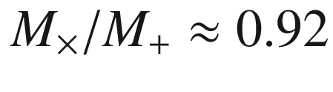

) leads to the formation of a clear gap between the acoustic and optical branches, while for GaAs

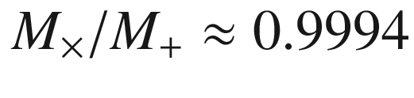

is close to 1 and no gap forms.

We note that the degeneracy of the TA phonon is lifted for propagation along the

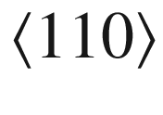

directions (

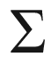

) because the two transverse directions

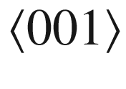

and

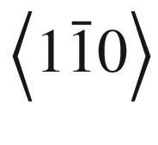

are not equivalent.

In boron nitride the masses of the two constituents are so similar that no gap exists between acoustical and optical branches (Fig. [5.11](#u116076_4_En_5_Chapter-Fig11)). Also the density of states (averaged over the entire Brillouin zone) is depicted (see the next chapter).

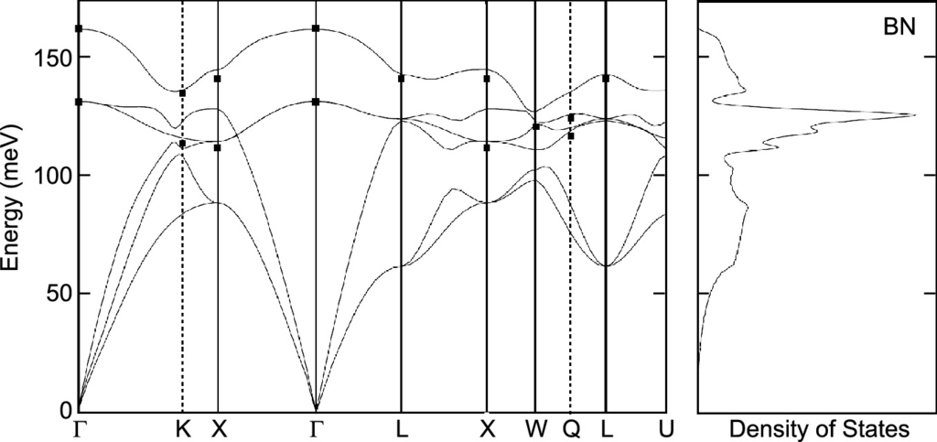

Fig. 5.11

Phonon dispersion in BN (*left panel*), experimental data (*symbols*) and theory (*solid lines*, first principles pseudopotential model). In the *right panel* the density of states is depicted.

Adapted from [376]

The displacement of atoms is shown in Fig. [5.12](#u116076_4_En_5_Chapter-Fig12) for the different phonon modes present in zincblende crystals. In Fig. [5.13](#u116076_4_En_5_Chapter-Fig13) the optical phonon modes for wurtzite crystals are depicted. The *E*-modes with displacement perpendicular to the *c*-axis are double degenerate such that there are nine modes (the primitive unit cell has

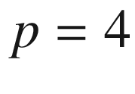

atoms (Sect. [3.​4.​5](The_Physics_of_Semiconductors00001.docx#u116076_4_En_3_Chapter))). The modes are labeled with their symmetry (in molecular notation) according to group theory (see remark in Sect. [6.​2.​5](The_Physics_of_Semiconductors00003.docx#u116076_4_En_6_Chapter)).

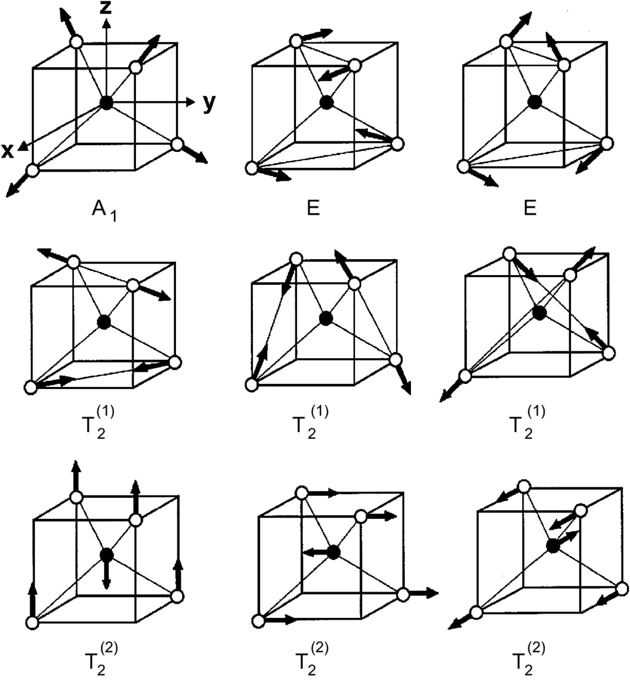

Fig. 5.12

Displacement of atoms for various phonon modes in zincblende crystals.

Adapted from [377]

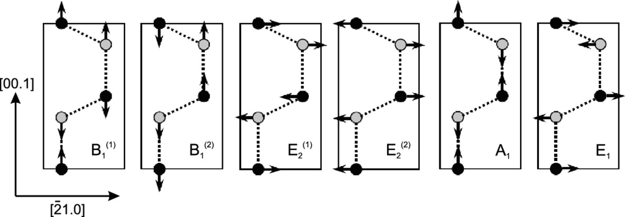

Fig. 5.13

Displacement of atoms for various phonon modes in wurtzite crystals.

Adapted from [378]

The dependence of the phonon frequency on the mass of the atoms (

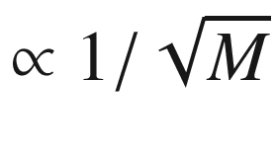

) can be demonstrated with the isotope effect, visualized for GaAs in Fig. [5.14](#u116076_4_En_5_Chapter-Fig14). The dependence of the phonon frequencies on the stiffness of the spring can be seen from Fig. [5.15](#u116076_4_En_5_Chapter-Fig15); the smaller lattice constant provides the stiffer spring.

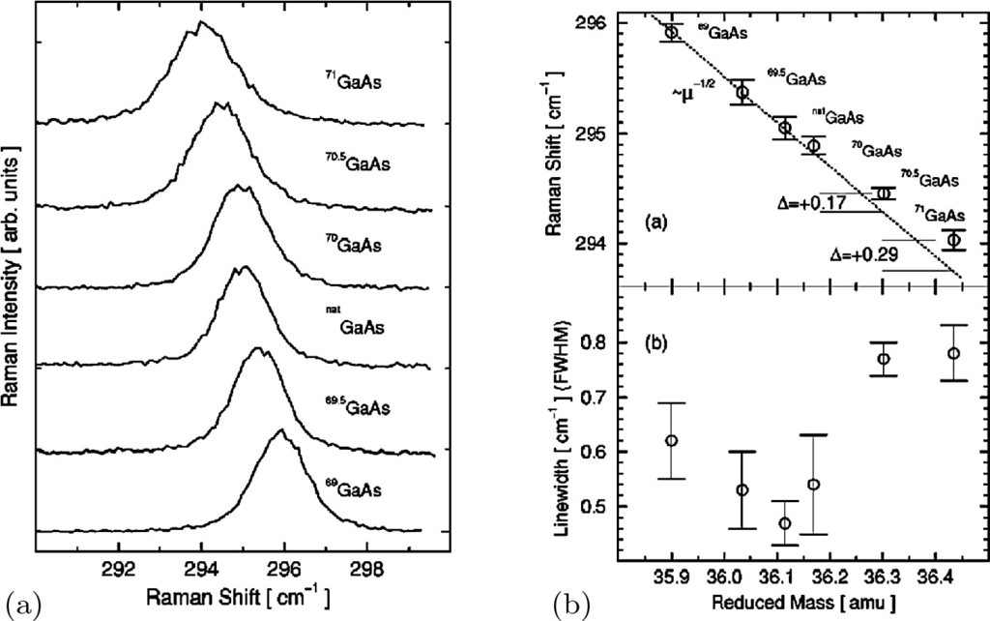

Fig. 5.14

**a** Raman spectra of GaAs with different isotope content as labeled. **b** Energy of optical phonons in GaAs with different isotope content [using the Raman spectra shown in (**a**)].

Reprinted with permission from [379], ©1999 APS

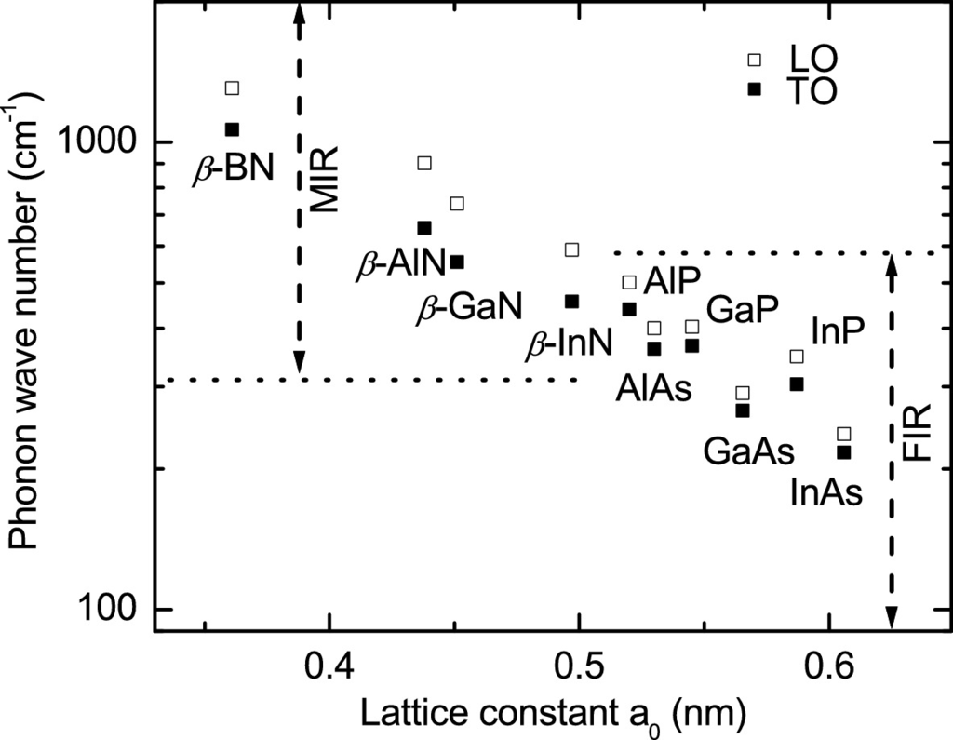

Fig. 5.15

Optical phonon frequencies (TO: *filled squares*, LO: *empty squares*) for a number of III–V compounds with different lattice constant

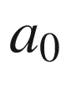

. 1 meV corresponds to 8.065 wave numbers (or cm

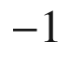

).

Adapted from [380]

#### 5.2.5 Density of States

The *density of states* (DOS) tells how many of the total number of modes are in a given energy interval. The states are spaced equally in



-space but not on the energy scale (see also Sect. [6.​13](The_Physics_of_Semiconductors00003.docx#u116076_4_En_6_Chapter)).

For the monoatomic linear chain model, the number of states

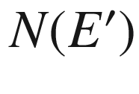

from

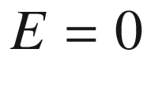

up to

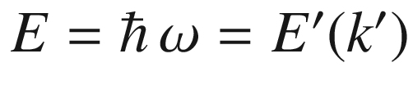

for the dispersion of the acoustic phonons ([5.8](#u116076_4_En_5_Chapter-Equ8)) is given as

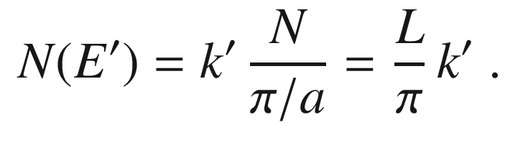

(5.32)

Using ([5.8](#u116076_4_En_5_Chapter-Equ8)), we find for one polarization (

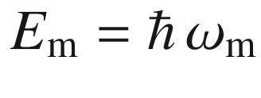

)

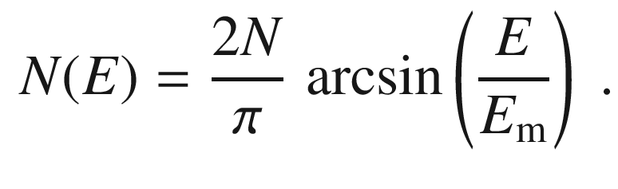

(5.33)

The DOS *D*(*E*) is given by

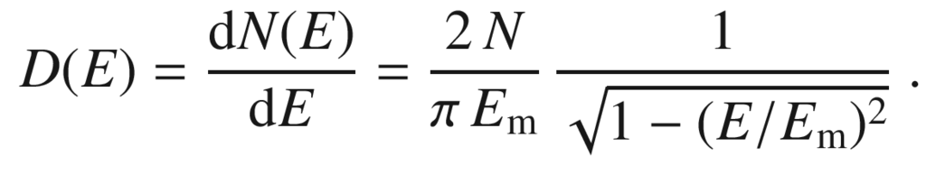

(5.34)

Often the density of states is scaled by the (irrelevant) system size and given per atom (*D*/*N*) or per volume (

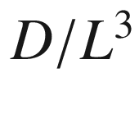

), per area (

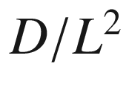

) or per length (*D*/*L*) for three-, two- or one-dimensional systems, respectively.

In the diatomic linear chain model, additionally the optical phonons contribute to the density of states. In Fig. [5.16](#u116076_4_En_5_Chapter-Fig16) the phonon density of states is shown for

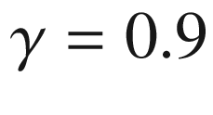

and for comparison for

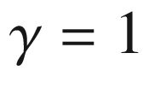

(gapless phonon dispersion). For small wavevector, the density of states is

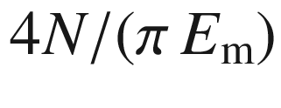

.[2](The_Physics_of_Semiconductors00003.docx#u116076_4_En_5_Chapter-Fn2) Within the gap the density of states vanishes. At the edges of the band gap the density of states is enhanced. The total number of states for both dispersions is the same.

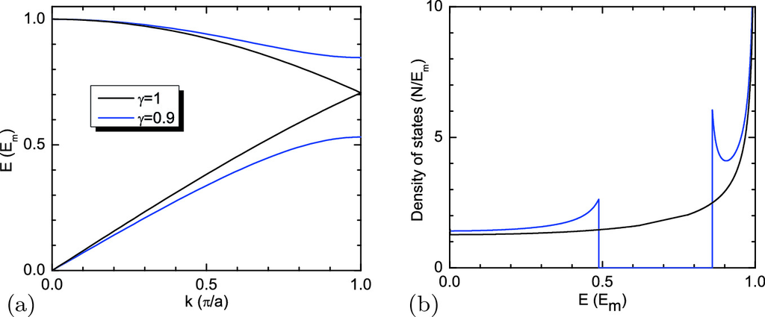

Fig. 5.16

**a** Phonon dispersion for the diatomic linear chain model for

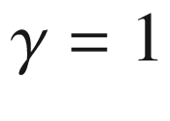

(*black line*) and

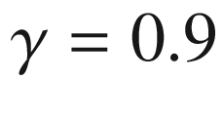

(*blue lines*). **b** Corresponding density of states (in units of

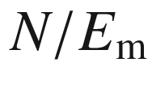

)

In a three-dimensional solid the total number of modes is

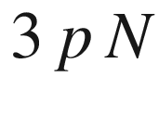

(

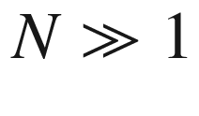

, *p* is the number of atoms in the base). Then ([5.32](#u116076_4_En_5_Chapter-Equ34)) is modified to (for three degenerate polarizations)

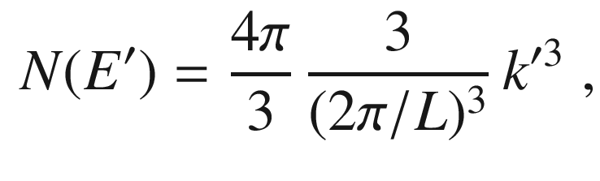

(5.35)

taking into account all states within a sphere in



-space of radius

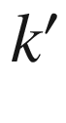

. Assuming a linear dispersion

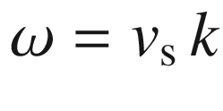

(for sufficiently small wave vector), we obtain

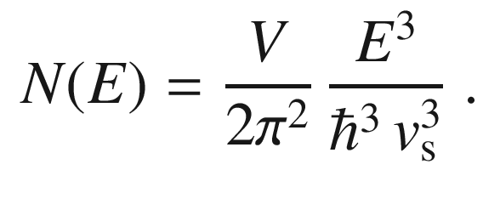

(5.36)

Thus the density of states is approximately[3](The_Physics_of_Semiconductors00003.docx#u116076_4_En_5_Chapter-Fn3) proportional to

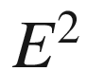

,

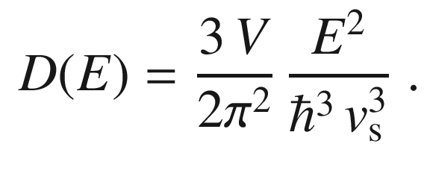

(5.37)

As realistic example for the phonon density of states, the DOS of bulk BN is depicted next to the dispersion in Fig. [5.11](#u116076_4_En_5_Chapter-Fig11).

#### 5.2.6 Phonons

Phonons are the quantized quasi-particles of the lattice vibrations (normal modes). The energy of a phonon can take the discrete values of a harmonic oscillator

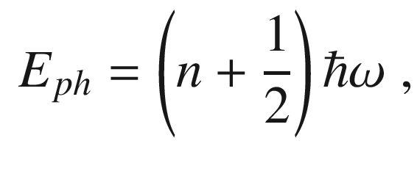

(5.38)

where *n* denotes the quantum number of the state, which corresponds to the number of energy quanta

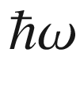

in the vibration. The amplitude of the vibration can be connected to *n* via the following discussion. For the classical oscillation

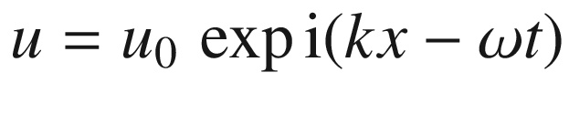

the space and time average for the kinetic energy yields

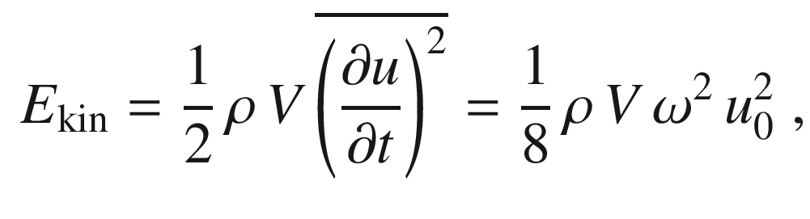

(5.39)

where

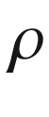

is the density and *V* the volume of the (homogeneous) solid. The energy of the oscillation is split in half between kinetic and potential energy. From

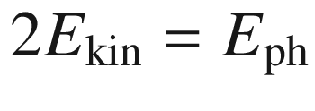

we find

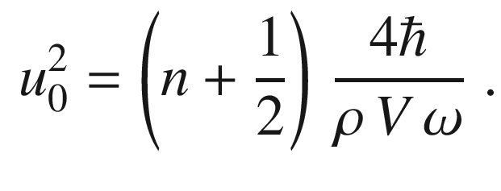

(5.40)

The number of phonons with which a vibrational mode is populated is thus directly related to the classical amplitude square.

Phonons act with a momentum

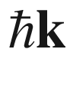

, the so-called crystal momentum. When phonons are created, destroyed or scattered the crystal momentum is conserved, except for an arbitrary reciprocal-space vector

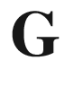

. Scattering with

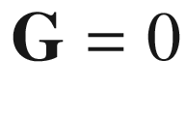

is called a *normal* process, otherwise (for

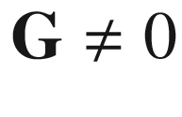

) it is called an *umklapp* process.

#### 5.2.7 Localized Vibrational Modes

A defect in the crystal can induce localized vibrational modes (LVM). The defect can be a mass defect, i.e. one of the masses *M* is replaced by

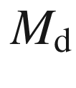

, or the force constants in the neighborhood are modified to

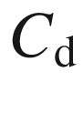

. A detailed treatment can be found in [381]. LVM are discussed, e.g., in [382–384].

First we consider the LVM for the one-dimensional, monoatomic chain. If the mass at lattice point

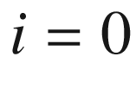

is replaced by

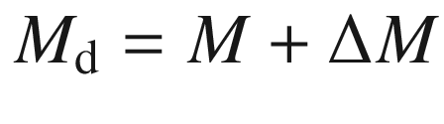

(

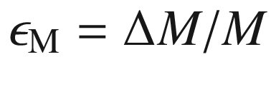

), the displacements are given by

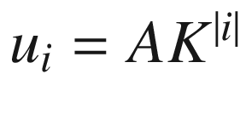

, *A* being an amplitude, with

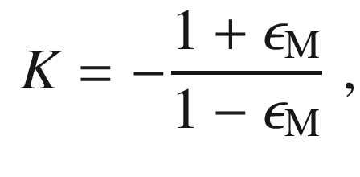

(5.41)

and the defect phonon frequency

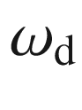

is

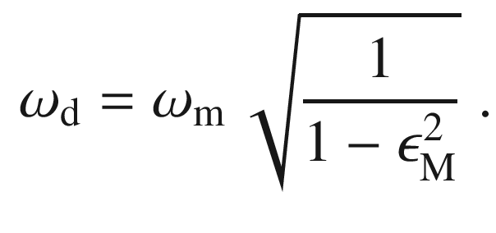

(5.42)

A real frequency is obtained for

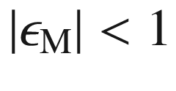

.

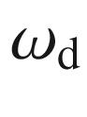

is then higher than the highest frequency of the bulk modes

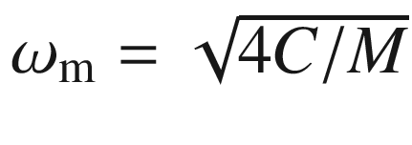

([5.11](#u116076_4_En_5_Chapter-Equ11)). For

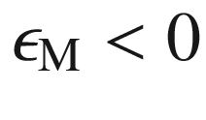

, i.e. the mass of the defect is smaller than the mass of the host atoms, *K* is negative and

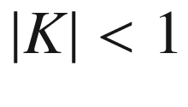

. Thus, the displacement can be written as

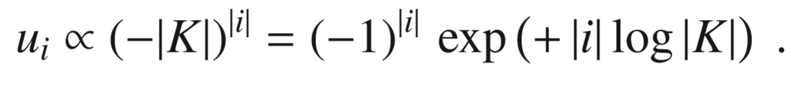

(5.43)

The numerical value of the exponent is negative, thus the amplitude decreases exponentially from the defect and indeed makes a localized vibrational mode. For small mass

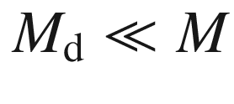

([5.42](#u116076_4_En_5_Chapter-Equ44)) yields approximately

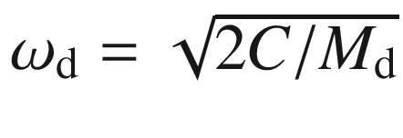

. This approximation is the so-called one-oscillator model. Since typically the extension of the localized mode is only a few lattice constants, the picture of LVM remains correct for impurity concentrations up to

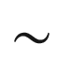

10

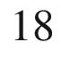

–10

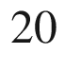

 cm

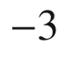

. For higher concentrations the concept of alloy modes has to be invoked (cf. Sect. [5.2.8](#u116076_4_En_5_Chapter-Sec10)).

For the case of group-III or -V substitutional impurities in group-IV semiconductors the change in force constants (treated below) can be neglected to some extent. For silicon (

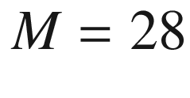

) and germanium (

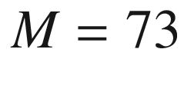

) the effect of various substitutions is shown in Fig. [5.17](#u116076_4_En_5_Chapter-Fig17).

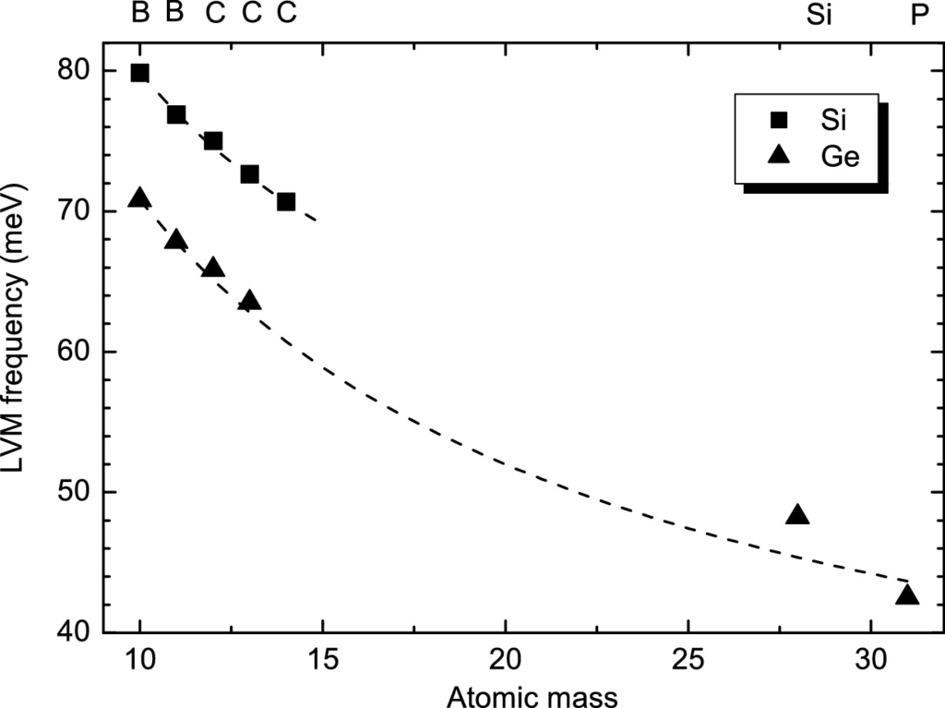

Fig. 5.17

Energy of local vibrational modes in Si and Ge. Experimental values at

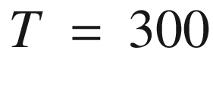

 K (B in Ge:

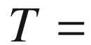

 80 K) taken from [381] and references therein and from [385] (C in Ge). The *dashed lines* are the mass dependence according to ([5.42](#u116076_4_En_5_Chapter-Equ44)) scaled to the experimental frequency of the

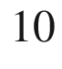

B LVM

Now, additionally the force constants left and right of the defect are replaced by

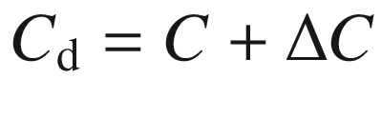

(

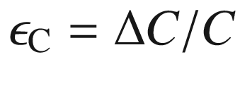

). The displacements are still given by

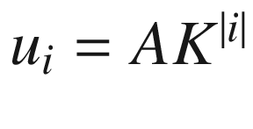

, now with

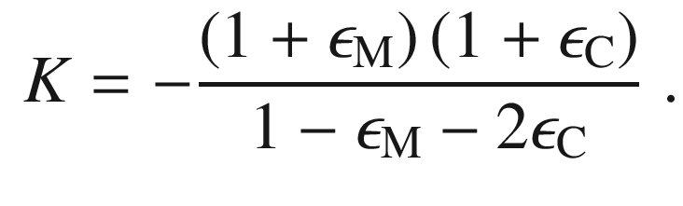

(5.44)

An exponential decrease of the LVM amplitude occurs for negative *K* that is ensured for

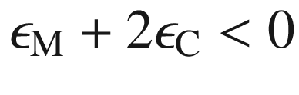

(and

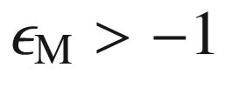

and

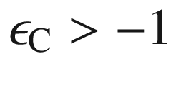

). The defect frequency is given by

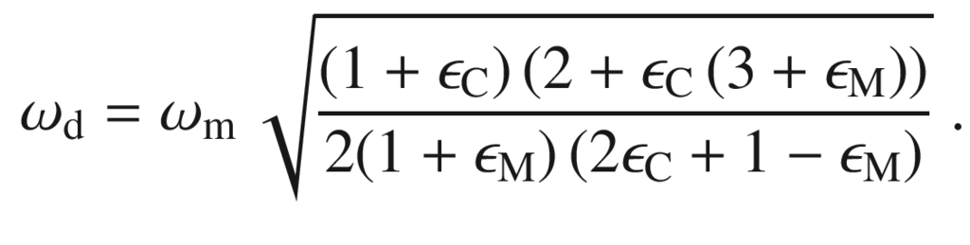

(5.45)

We note that for

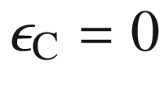

([5.41](#u116076_4_En_5_Chapter-Equ43)) and ([5.42](#u116076_4_En_5_Chapter-Equ44)) are recovered.

For a given mass defect, the change of frequency with

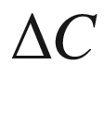

is (in linear order, i.e. for

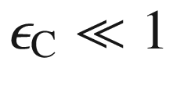

)

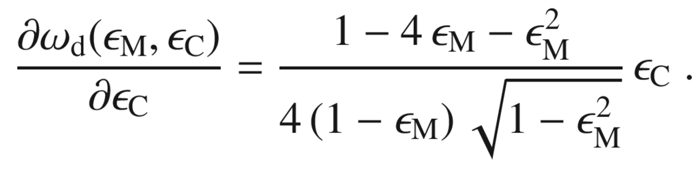

(5.46)

The linear coefficient diverges for

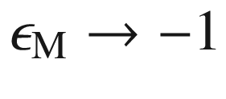

. For

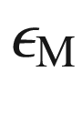

between

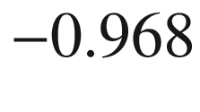

and 0 the linear coefficient varies between 2 and 1/4. Therefore, a larger force constant (

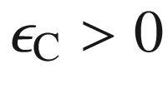

) increases the LVM frequency of the defect, as expected for a stiffer spring.

In a binary compound the situation is more complicated. We assume here that the force constants remain the same and only the mass of the substitution atom

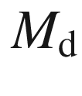

is different from the host. The host has the atom masses

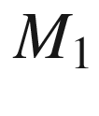

and

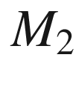

with

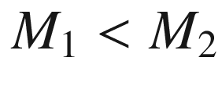

. Substitution of the heavy atom with a lighter one creates a LVM above the optical branch for

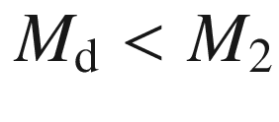

. Additionally, a level in the gap between the optical and acoustic branch is induced. Such LVM is called a *gap mode*. Substitution of the lighter atom of the binary compound induces a LVM above the optical branch for

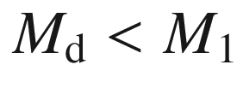

. A gap mode is induced for

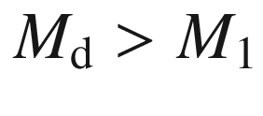

. The situation for GaP is depicted in Fig. [5.18](#u116076_4_En_5_Chapter-Fig18). LVM in GaAs have been reviewed in [382].

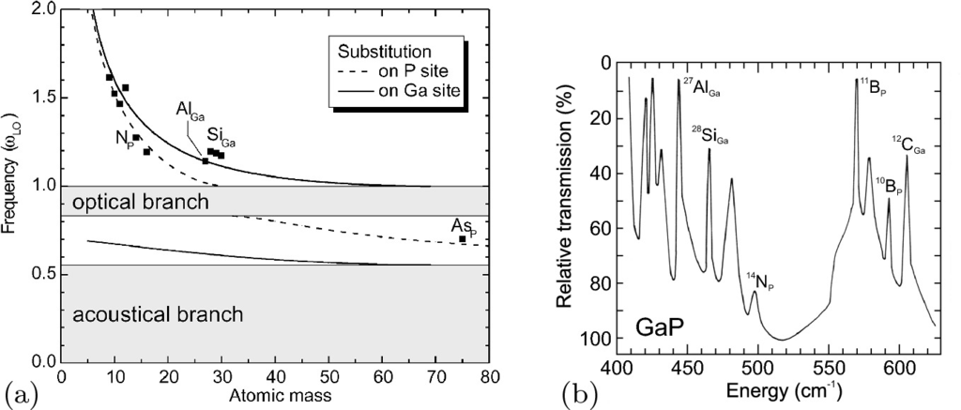

Fig. 5.18

**a** Numerical simulation of a linear chain model for GaP (

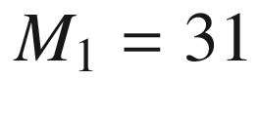

,

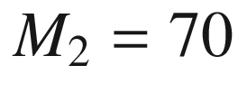

). Energy of local vibrational modes (*dashed* (*solid*) *line*): substitution on P (Ga) site) in units of the optical phonon frequency at



(

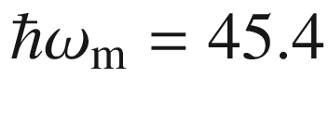

 meV, cf. Fig. [5.10](#u116076_4_En_5_Chapter-Fig10)a). The *grey areas* indicate the acoustic and optical phonon bands. *Solid squares* are experimental data (from [381]), scaled to the theoretical curve for the

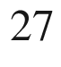

Al

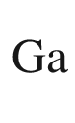

LVM frequency. **b** Differential transmission spectrum of GaP structure (nitrogen-doped layer on zinc-doped compensated substrate) against pure crystal (

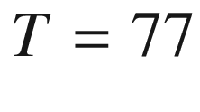

 K).

Data from [386]

The energy position of a local vibrational mode is sensitive to the isotope mass of the surrounding atoms. In Fig. [5.19](#u116076_4_En_5_Chapter-Fig19), a high-resolution (0.03 cm

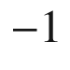

) spectrum of the

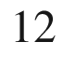

C

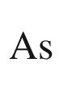

LVM in GaAs is shown together with a theoretical simulation. The various theoretical peak positions are given as vertical bars, their height indicating the oscillator strength. Five experimental peaks are obvious that are due to a total of nine different transitions. The C atom can experience five different surroundings (see Table [3.​8](#u116076_4_En_3_Chapter-Tab8)) with the four neighbors being

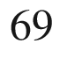

Ga or

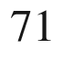

Ga. The natural isotope mix is an ‘alloy’



Ga



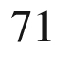

Ga

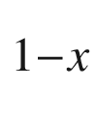

As with

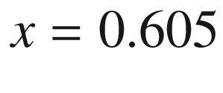

. The configurations with

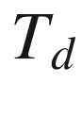

symmetry contribute one peak each, the lowest (

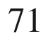

Ga surrounding) and highest (

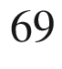

Ga surrounding) energy transitions. The configurations with

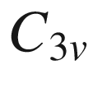

and

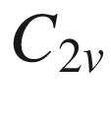

symmetry contribute each with 2 and 3 nondegenerate modes, respectively.

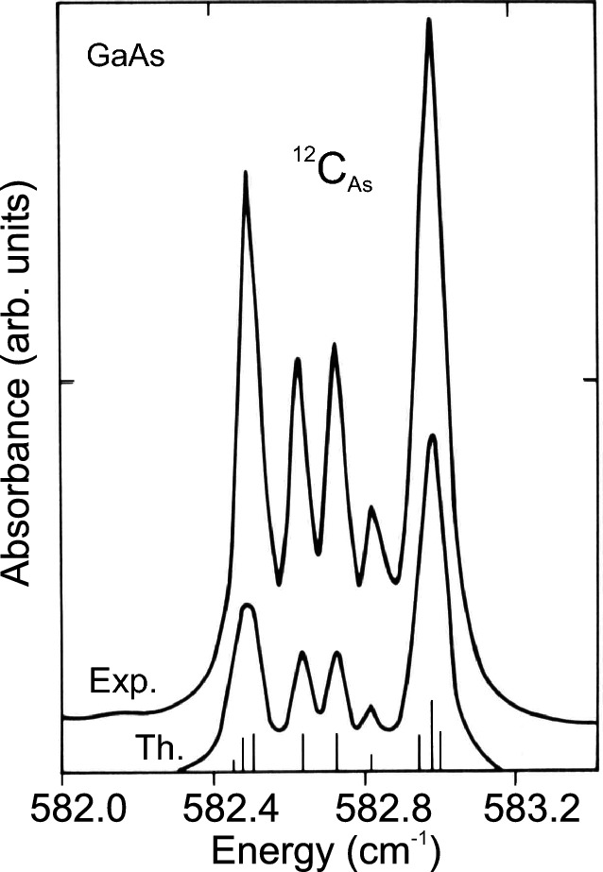

Fig. 5.19

Experimental (Exp.,

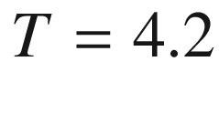

 K, resolution 0.03 cm

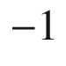

) and theoretical (Th., artificial Lorentzian broadening) infrared spectra of LVM of

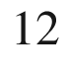

C

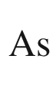

in GaAs. The positions and oscillator strengths of the theoretical transitions involving different configurations with

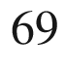

Ga and



Ga isotopes are shown as *vertical bars*.

Data from [382]

The vibrations of impurity complexes have been discussed in [387].

#### 5.2.8 Phonons in Alloys

In an alloy of the type AB

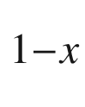

C



, the phonon frequencies will depend qualitatively and quantitatively on the ternary composition [388]. For the binary end materials AB and AC clearly TO and LO frequencies exist. The simplest behavior of the alloy is the one-mode behavior (Fig. [5.20](#u116076_4_En_5_Chapter-Fig20)d) where the mode frequencies vary continuously (and approximately linearly) with the composition. The oscillator strength (LO–TO splitting, ([9.​86](The_Physics_of_Semiconductors00004.docx#u116076_4_En_9_Chapter))) remains approximately constant. In many cases, the two-mode behavior is observed where the LO–TO gap closes (accompanied by decreasing oscillator strength) and a localized vibrational mode and a gap mode occur for the binary end materials (Fig. [5.20](#u116076_4_En_5_Chapter-Fig20)a). Also, a mixed-mode behavior (Fig. [5.20](#u116076_4_En_5_Chapter-Fig20)b, c) can occur.

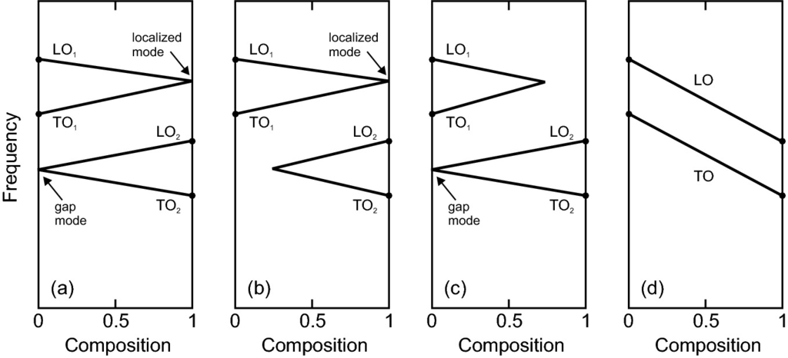

Fig. 5.20

Schematic behavior of phonon modes in an alloy. **a** Two-mode behavior with gap mode and localized mode, (**b**, **c**) mixed-mode behavior, **b** only localized mode allowed, **c** only gap mode allowed, **d** one-mode behavior with neither localized mode nor gap mode allowed

The masses of the three constituent atoms will be

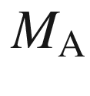

,

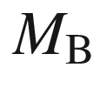

, and

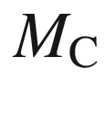

. Without limiting the generality of our treatment, we assume

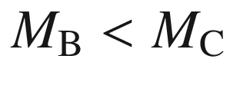

. From the considerations in Sect. [5.2.7](#u116076_4_En_5_Chapter-Sec9) on LVM and gap modes, the condition

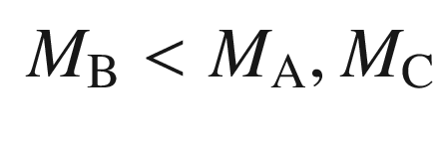

(5.47)

for two-mode behavior can be deduced. This ensures a LVM of atom B in the compound AC and a gap mode of atom C in the compound AB. However, it turns out that this condition is not sufficient, e.g. Na

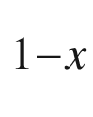

K



Cl fulfills ([5.47](#u116076_4_En_5_Chapter-Equ49)) but exhibits one-mode behavior. From a modified REI[4](The_Physics_of_Semiconductors00003.docx#u116076_4_En_5_Chapter-Fn4) model (for

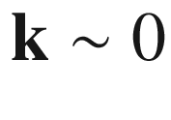

modes) it has been deduced that

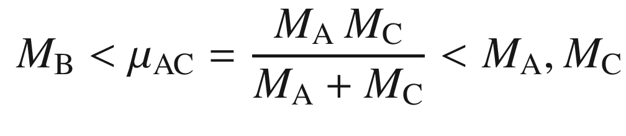

(5.48)

is a necessary and sufficient condition (unless the force constants between A–B and A–C are significantly different) for two-mode behavior [389]. A detailed discussion is given in [390]. Equation ([5.48](#u116076_4_En_5_Chapter-Equ50)) is a stronger condition than the previous one ([5.47](#u116076_4_En_5_Chapter-Equ49)). If ([5.48](#u116076_4_En_5_Chapter-Equ50)) is not fulfilled the compound exhibits one-mode behavior. As an example, we show the mass relations for CdS

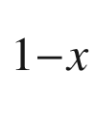

Se



and Cd



Zn

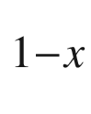

S in Table [5.1](#u116076_4_En_5_Chapter-Tab1) and the experimental phonon energies in Fig. [5.21](#u116076_4_En_5_Chapter-Fig21). Also in Table [5.1](#u116076_4_En_5_Chapter-Tab1) the masses for GaP

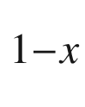

As



(GaAs

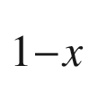

Sb



) exhibiting two- (one-) mode behavior are shown.Table 5.1

Atomic masses (

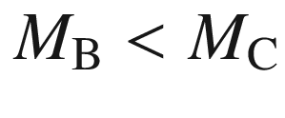

) of the constituents of various ternary compounds of type A(B,C), reduced mass

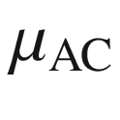

([5.48](#u116076_4_En_5_Chapter-Equ50)), fulfillment of the relation from ([5.48](#u116076_4_En_5_Chapter-Equ50)) (‘



’: fulfilled, ‘−’: not fulfilled) and experimental mode behavior (‘2’: two-mode, ‘1’: one-mode)

| Alloy | A | B | C | $$M_{\mathrm {A}}$$ | $$M_{\mathrm {B}}$$ | $$M_{\mathrm {C}}$$ | $$\mu _{\mathrm {AC}}$$ | Rel. | Modes |
| --- | --- | --- | --- | --- | --- | --- | --- | --- | --- |
| GaP  $$_{1-x}$$  As  $$_x$$ | Ga | P | As | 69.7 | 31.0 | 74.9 | 36.1 | $$+$$ | 2 |
| GaAs  $$_{1-x}$$  Sb  $$_x$$ | Ga | As | Sb | 69.7 | 74.9 | 121.8 | 44.3 | − | 1 |
| CdS  $$_{1-x}$$  Se  $$_x$$ | Cd | S | Se | 112.4 | 32.1 | 79.0 | 46.4 | $$+$$ | 2 |
| Cd  $$_x$$  Zn  $$_{1-x}$$  S | S | Zn | Cd | 32.1 | 65.4 | 112.4 | 25.0 | − | 1 |
| Mg  $$_x$$  Zn  $$_{1-x}$$  O | O | Mg | Zn | 16.0 | 24.3 | 65.4 | 12.9 | − | 1 |
| Al  $$_x$$  Ga  $$_{1-x}$$  N | N | Al | Ga | 14.0 | 27.0 | 69.7 | 11.7 | − | 2(!) |

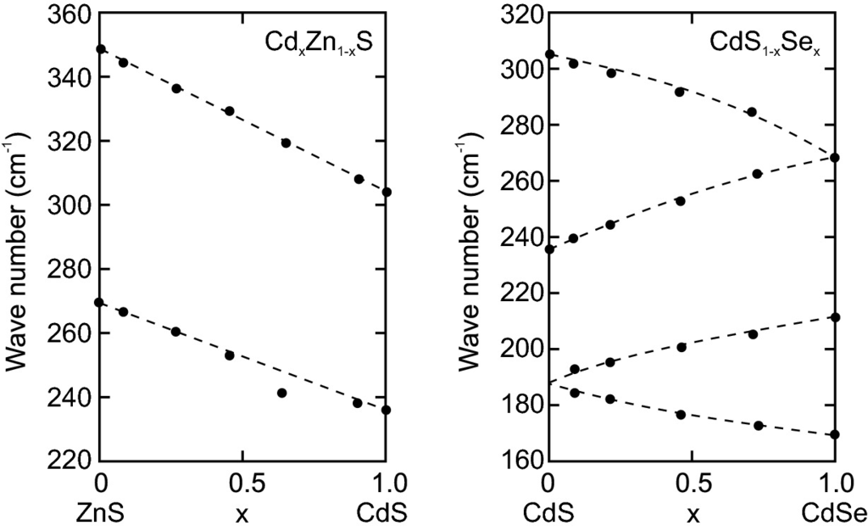

Fig. 5.21

Phonon energies of Cd



Zn



S and CdS

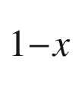

Se



as a function of the ternary composition. Experimental data (*solid circles*) are from [389], *dashed lines* are guides to the eye

If the binary end components of a ternary alloy have different crystal structure, a transition between the two occurs which is reflected in the phonon structure (energies and mode symmetries). As an example, the optical phonon energies of Mg



Zn



O are depicted in Fig. [5.22](#u116076_4_En_5_Chapter-Fig22) (cmp. Fig. [3.​43](#u116076_4_En_3_Chapter-Fig43)).

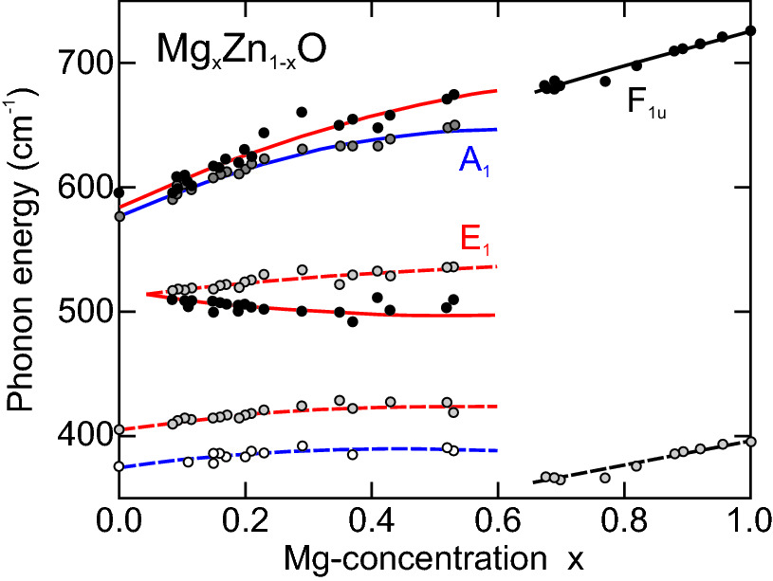

Fig. 5.22

LO (*solid lines*) and TO (*dashed lines*) phonon energies of Mg



Zn



O in the wurtzite structure (A

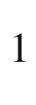

symmetry: *blue lines*, E

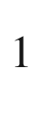

symmetry: *red lines*) and in the rocksalt phase (F

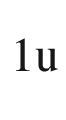

symmetry: *black lines*). Experimental data are shown as *symbols*.

Adapted from data of [391]

An example for the variation of phonon oscillator strength (as defined in ([9.​86](The_Physics_of_Semiconductors00004.docx#u116076_4_En_9_Chapter))) with alloy composition is depicted in Fig. [5.23](#u116076_4_En_5_Chapter-Fig23) for (Al,Ga)N [392].[5](The_Physics_of_Semiconductors00003.docx#u116076_4_En_5_Chapter-Fn5)

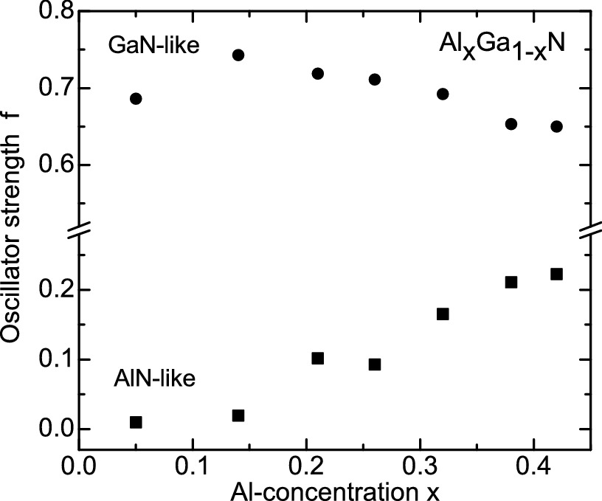

Fig. 5.23

Oscillator strength *f* (cf. ([9.​86](The_Physics_of_Semiconductors00004.docx#u116076_4_En_9_Chapter))) of alloy phonons in (Al,Ga)N thin films on *c*-Al

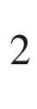

O

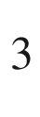

.

Based on data from [392]

#### 5.2.9 Disorder

An example of local disorder are the localized vibrational modes due to a single defect. Here we consider in our one-dimensional model random fluctuations of the model parameters. To that avail we set up a numerical implementation of an one-dimensional chain with masses

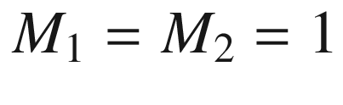

and spring constants



, here

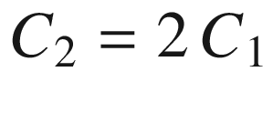

. Now each mass varies randomly by a factor with a statistical distribution of mean

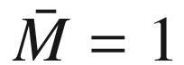

and a standard deviation[6](The_Physics_of_Semiconductors00003.docx#u116076_4_En_5_Chapter-Fn6)

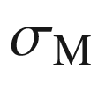

. The density of states is displayed for

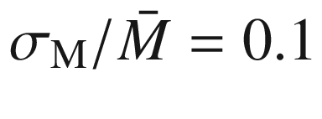

–0.5. The effects as shown in Fig. [5.24](#u116076_4_En_5_Chapter-Fig24) are broadening of the peaks in the DOS, broadening of the band edges, the development of band tails into the gap and eventually a closing of the gap. This is a typical behavior that also exists for electronic states (cmp. Fig. [6.​53](The_Physics_of_Semiconductors00003.docx#u116076_4_En_6_Chapter-Fig53)).

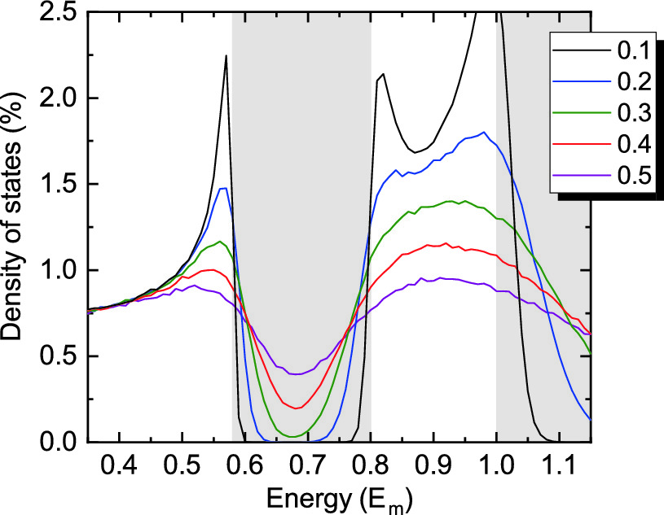

Fig. 5.24

Density of states versus energy (in units of maximum phonon energy

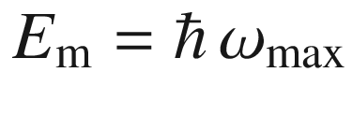

according to ([5.18](#u116076_4_En_5_Chapter-Equ20))) for the diatomic linear chain model (



,

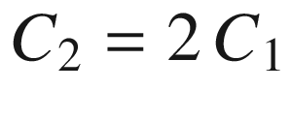

,

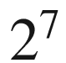

dimers, average over

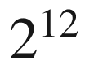

configurations) for various levels of random relative variations of the masses (*solid lines*). The forbidden energy ranges for the ideal chain are shown in *light grey*. The DOS has been normalized such that its integral over all energies is 1 (the energy bins have a width of

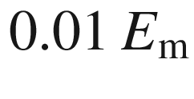

)

#### 5.2.10 Topological Edge States of the Diatomic Linear Chain

Here we treat a finite diatomic linear chain with *N* unit cells, i.e. A–B dimers. In case of periodic boundary conditions, the rightmost B-atom is ‘connected’ to the leftmost A-atom, but now we chose *N* to be finite.

The system of 2*N* equations of the type

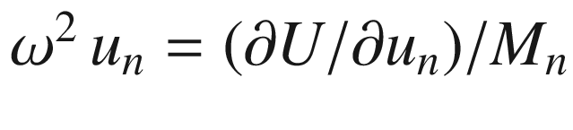

(like ([5.13a](#u116076_4_En_5_Chapter-Equ13)) or ([5.13b](#u116076_4_En_5_Chapter-Equ14))) is written in matrix form and the eigenproblem

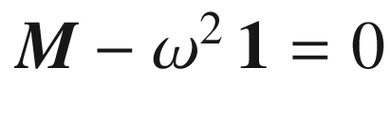

is solved numerically [393]. Also, we fix both ends, i.e. the displacements

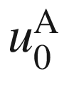

and

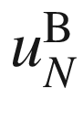

are forced to be zero (Fig. [5.25](#u116076_4_En_5_Chapter-Fig25)). We set

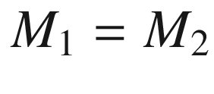

and find two quite different situations for the cases (i)

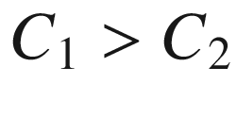

and (ii)

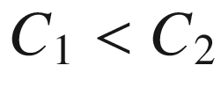

. Case (i) is similar to the bulk case (i.e. for periodic boundary conditions) where a ‘clean’ gap is present; for

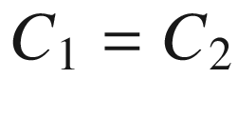

of course no gap appears. In case (ii), two states appear within the gap with energy

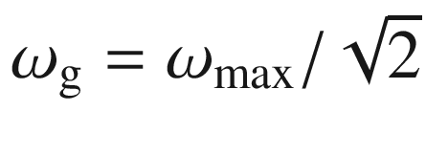

. The eigenvalues of the problem are shown as a function of

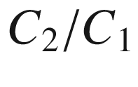

in Fig. [5.26](#u116076_4_En_5_Chapter-Fig26)a. The mode pattern for the two gap states are depicted in Fig. [5.27](#u116076_4_En_5_Chapter-Fig27)a (for

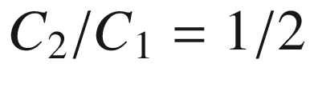

). All other states follow bulk like vibration patterns as expected from a vibrating string. For

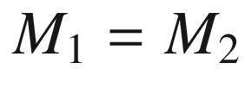

the gap states are degenerate, otherwise split as shown in Fig. [5.26](#u116076_4_En_5_Chapter-Fig26)c. For the case of

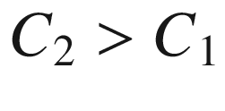

, the patterns for the highest mode of the lower band and the lowest mode of the top band are depicted in Fig. [5.27](#u116076_4_En_5_Chapter-Fig27)b; the are obviously bulk-like as all others and no localized states exist.

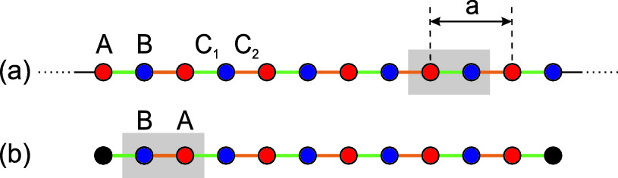

Fig. 5.25

**a** Diatomic linear chain model (DLCM) with A–B dimers (one unit cell shown in grey) in an infinite chain; A-sites (B-sites) are shown in *red* (*blue*); the connecting springs have force constants

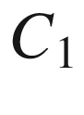

(*green*) and

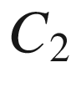

(*orange*), respectively. **b** DLCM with finite number of dimers (shown for

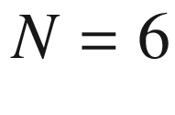

) with both end sites fixed (shown in *black*). The movable sites now consist of B–A dimers (one unit cell shown in grey)

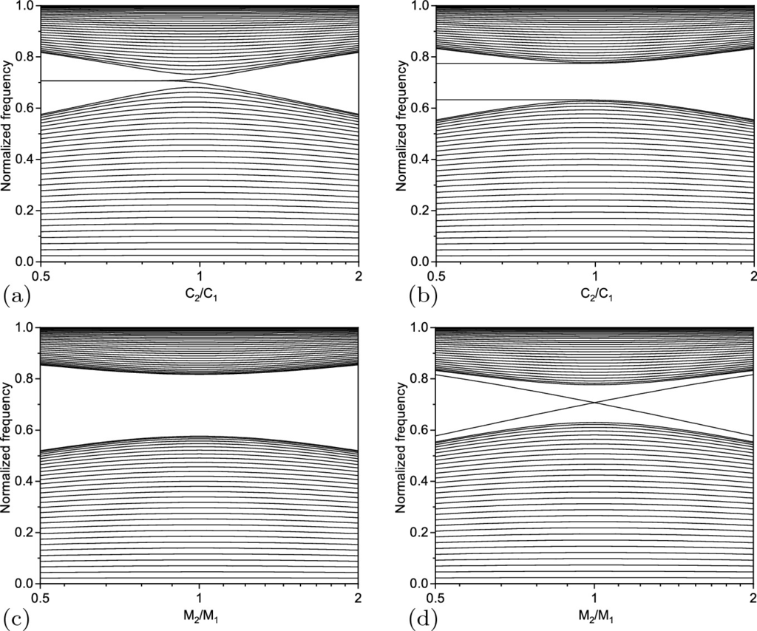

Fig. 5.26

**a** Eigenvalues of a diatomic chain with

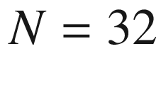

unit cells (64 atoms) as a function of the ratio

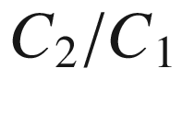

(



). The frequency is normalized (to

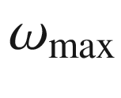

from ([5.18](#u116076_4_En_5_Chapter-Equ20))). The abzissa is logarithmic. **b** Same calculation as for panel (**a**) but

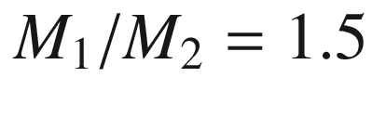

(would look the same for

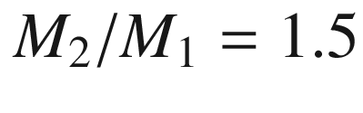

). **c** Same calculation as for panel (**a**) but as a function of

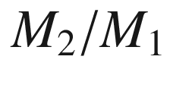

(for

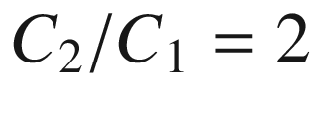

). **d** Same calculation as for panel (**c**) but for

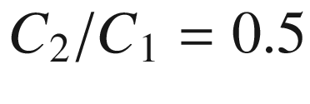

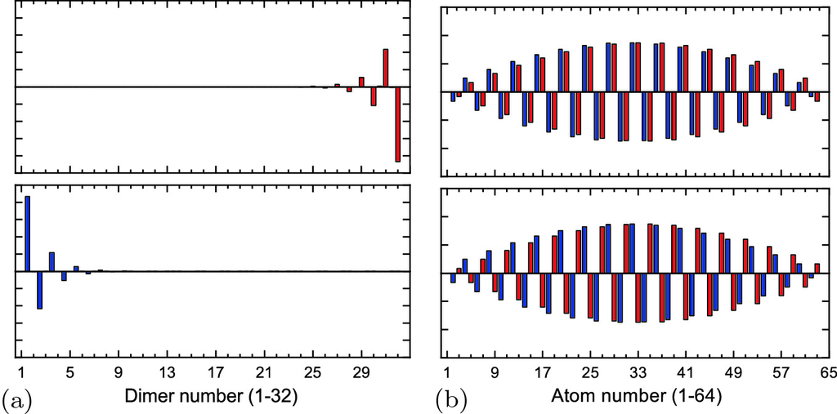

Fig. 5.27

Mode patterns for two states of the diatomic linear chain (

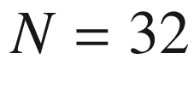

unit cells,



) **a** within the gap for

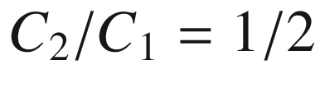

and **b** closest to the gap for

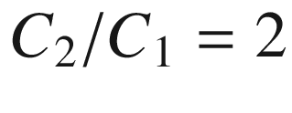

. The amplitudes of A-sites (B-sites) are shown in *red* (*blue*)

The appearance of end states in one of the cases is the expression of the fact that the two bulk band structures for

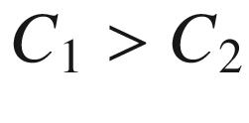

and

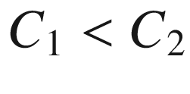

are *topologically* different[7](The_Physics_of_Semiconductors00003.docx#u116076_4_En_5_Chapter-Fn7) (cmp. Sect. [5.2.3](#u116076_4_En_5_Chapter-Sec5)). The general effect is the so-called ‘bulk-boundary’ correspondence where edge states appear at the interface between different topological phases (one of these phases can be the topologically trivial vacuum outside the solid). Such edge states are termed more precisely *end*-states for (quasi-) one-dimensional systems.

### 5.3 Elasticity

The elastic properties of the semiconductor are important if the semiconductor is subjected to external forces (pressure, temperature) or to lattice mismatch during heteroepitaxy.

#### 5.3.1 Thermal Expansion

The lattice constant depends on temperature. The (linear) thermal expansion coefficient is defined as

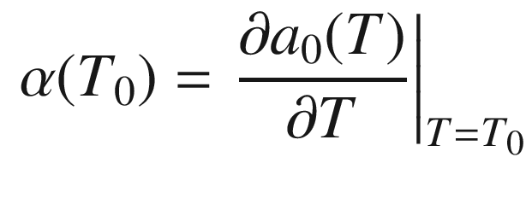

(5.49)

and is temperature dependent. The temperature dependence of

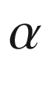

for silicon and germanium is shown in Fig. [5.28](#u116076_4_En_5_Chapter-Fig28).

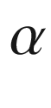

is approximately proportional to the heat capacity (

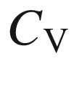

) except at low temperatures. The negative values are due to negative Grüneisen parameters [394]. These anharmonicity effects are discussed in detail in [366].

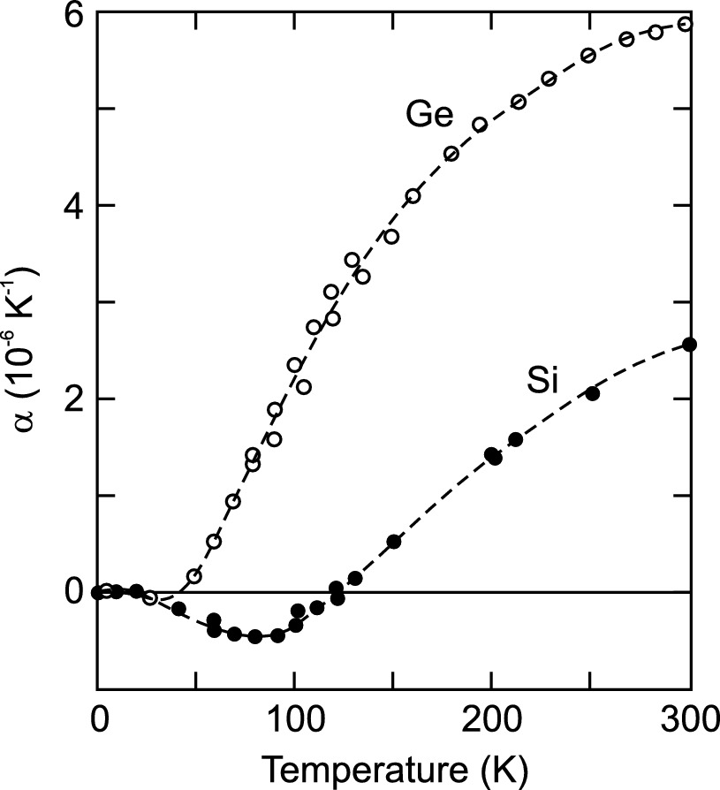

Fig. 5.28

Linear thermal expansion coefficient of silicon (*solid circles*) and germanium (*open circles*). Adapted from [394] based on experimental data from various sources. *Dashed lines* are guide to the eye